Topic: Volume of Cube And Cuboid (Introduction)

Level : Primary 5

Instructional Objectives
At the end of the lesson, pupils will be able to:
- build solids with unit cubes
- count the number of unit cubes in a solid made up of unit cubes
- see a pattern and come up with a rule for finding the volume of a cube and cuboid
Duration | Development | Resources
5 mins  30 mins | Tuning-In:  Whole Class Activity  - Show pupils examples of cubes and cuboids. Review with pupils that the faces of a cube are all squares and those of a cuboid are rectangles or rectangles and squares.  - Relate the terms length, breadth and height to the relevant edges of the cuboid.  - Introduce the term unit cube, that is, a single cube. Show the students a small box and some 1-cm cubes. Ask them to estimate how many 1-cm cubes will fit in the box.  - Record the estimations on the board.  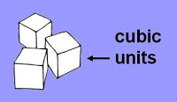  Development:  Group Work (Student-only activity)  1. Divide the class into groups of five. Ask the students to fill the bottom  of the box with a layer of cubes. Count the number of cubes used.  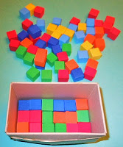  Give them a chance to change their estimate of how many cubes they  think will fit in the box. | Samples of cubes and cuboids.  A unit cube  A small box (made by teacher)  A box of  1-cm cubes  A small box  (made by teacher)  A box of  1-cm cubes
 | 2. Have the students add another layer of cubes.  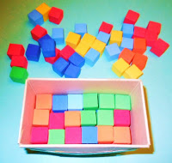  3. Ask students to continue adding layers until the box is filled. They will  keep count of the number of cubes in the box with each layer added.  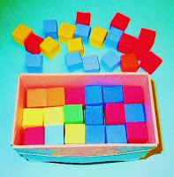  4. Have the students construct the same shape without the box to better  visualize all the cubes and layers.  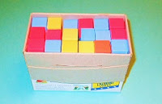  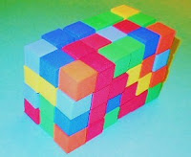  5. Ask the students to record in the table provided the number of cubes  that they used for the length, breadth, height and the volume of the  figure formed.  6. Have the students repeat the activity with two other boxes and record  their findings.  7. With the data, the students are to come up with a rule for finding the  volume of a cube and cuboid. Lead pupils to see that a cube is a  cuboid whose length, breadth and height are equal.  That is,  Volume of a cube = Edge × Edge × Edge  Volume of a cuboid = Length × Breadth × Height  8. Students to verify the rule with the given cube and cuboid. They will  use the formula to find the volume first before counting the number of  1-cm cubes that make up the cube and cuboid. They are to record their  findings in an excel table. Students to use the formula to find the  volume of other cubes and cuboids that they have made. | Task sheet  2 boxes (made by teacher)  A box of  1-cm cubes  A cube  and cuboid  Excel table
25 mins | Closure  - Have students explain their findings.  2. Students to watch a video and note down what they have learnt in their  3-2-1 exit cards. (Individual Work)  Homework  Students to do an illumination activity to explore the volume of a cube  and cuboid further. (Individual Work) | ICT  -Video  (http://studyjams.scholastic.com/studyjams/jams/math/measurement/volume.htm)  -Activity  (http://illuminations.nctm.org/ActivityDetail.aspx?ID=6)

………………………………………………………………………….

Group Members:

…………………………………………………………………………

Volume  (Counting the number of cubes) | Length | Breadth | Height

What is the relationship between the length, breadth, height
and volume?

…………………………………………………………………………………………………………………………………………………………………………………………………………………………
…………………………………………………………………………………………………………………………………………………………………………………………………………………………
……………………………………………………………………………………………………………
……………………………………………………………………………………………………………
………………………………………………………………………………………………………………………………………………………………………………………………………………………………………………………………………………………………………………………………………

Name:
__________________

What are the 3 things you have learnt about Volume?

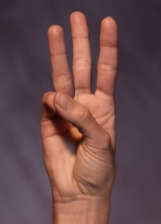

What are the 2 things you are still unclear about?

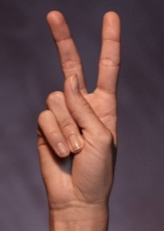
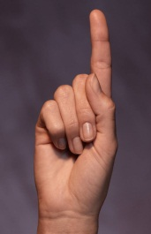

What is the 1 thing you would like to find out more?

