Name:
__________________

What are the 3 things you have learnt about Volume?

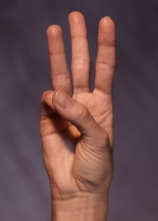

What are the 2 things you are still unclear about?

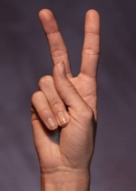
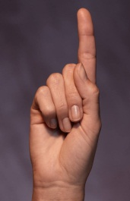

What is the 1 thing you would like to find out more?

