Leitner System App

 | comments
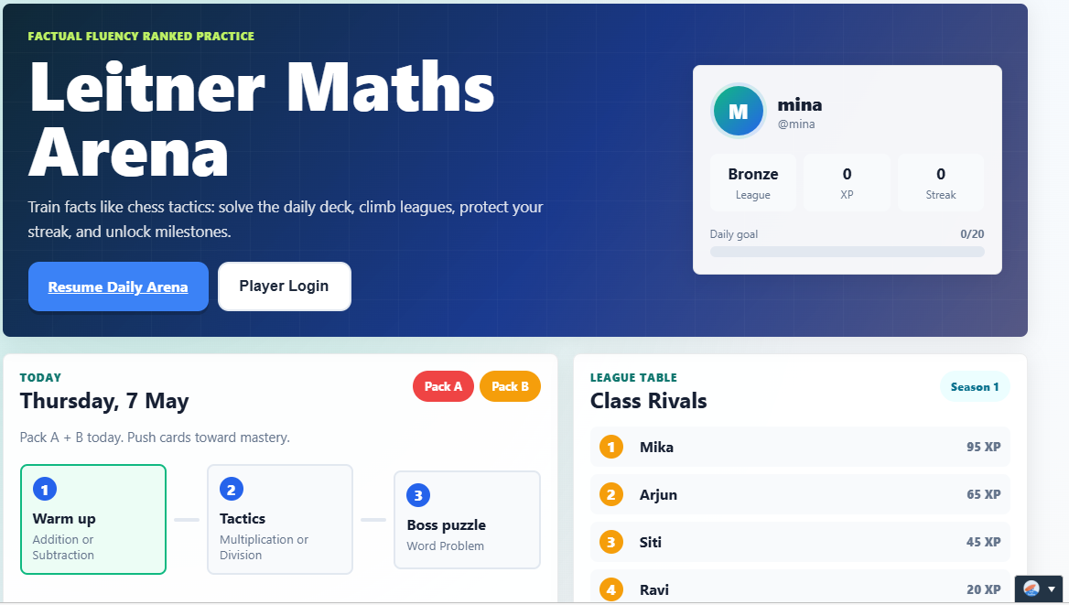 | SE  After the student logs in , to get the student to check in about their feeling for that day?  - This is to check in on student’s social emotional (SE) to help them manage emotion.  E.g  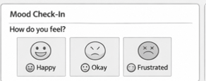  If the student feels sad, is it possible to pop up some message to get students to talk to an adult (e.g teacher) ?  The first screen should be less cluttered, to show the SE check only.  Self-Regulation – Allow choice  Once checked in, student is allowed to check what he wants to learn.  Setting Goal (EF, Self-regulation)  Mission: is to move the cards from Box 1 to Box Mastery  Get the student to set goal: by when they think they can master the math that they want to learn  Addition  - Addition within 10/20  Subtraction  - Subtraction within 10/20  Multiplication  -timetable of 2 to 10  Division  - Timetables of 2 to 10  Word Problems  - Addition  - Subtraction  - Addition and subtraction  - Multiplication  - Division  - Multiplication and Division  - Addition/ subtraction/ Multiplication/ Division (2 operations)  Only the bold headers have a tab ( the subpoint are for the system to move the students up once they have mastered the easier one ) , so for each header – it have at least 2 levels of mastery  Motivation : Taste Little Success  For each level, it should only have 10 questions so that students feel that it is not difficult to learn math
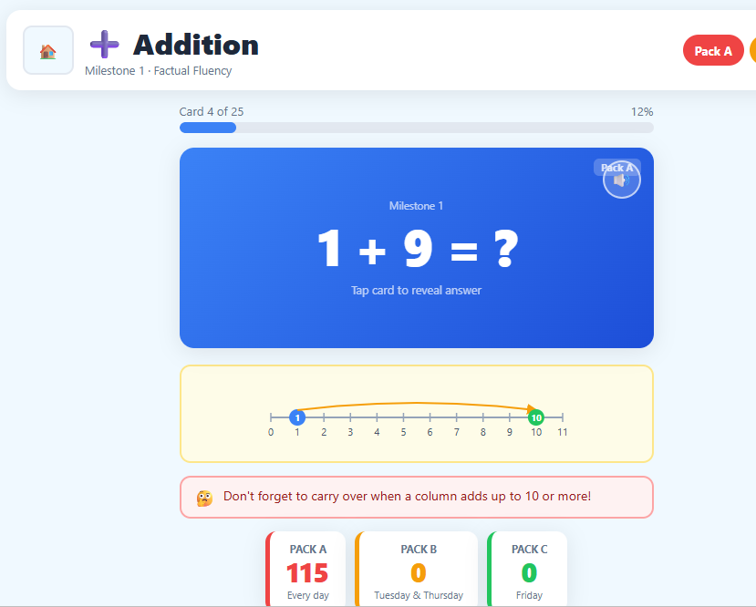 | to allow students to key in the answer.  Remove the answer:  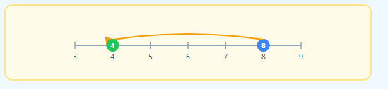  Only see the hint (not the answer) when students ask for help.  To make progress visible (motivation)  When the students get it right, to show the card move from Box 1 to box 2 to Box 3 to Box Mastery:  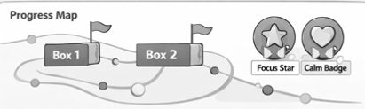  Provide Feedback  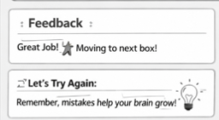  Tracking of Personal Progress (Motivitaion/Self-regulation)  Once students move all cards to Box Mastery, the system rewards the students with a token/star/badge
Reflection (Self -Regulation)

Get students’ to reflect on their learning at the end of the session

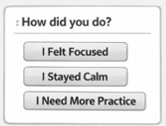

Summary (competencies to develop via this system)

- Mood check-ins at the start (SEL: self-awareness).
- Goal-setting and planning tools (EF: organization, planning).
- Pause & Think / Hint (EF: inhibitory control, working memory strategies).
- Reflection prompts like “I Stayed Calm” or “I Need More Practice” (SEL: self-management).
- Badges for focus and calmness (EF + SEL reinforcement).
This design makes math practice more than just recall — it’s a structured way to help children manage emotions, plan their learning, and build resilience while mastering math facts.
Teacher log | Will the log be able to capture how many time the students log in to master each facts?

