Annex 1: Links to SLS packages
Topic | URL
P2 Volume | https://go.gov.sg/primath-p2volume
P2 Multiplication and Division | https://go.gov.sg/primath-p2multipyanddivide
P2 Length | https://go.gov.sg/primath-p2length
P3 Area | https://go.gov.sg/p3-area
P4 Nets | https://go.gov.sg/primath-p4netsofcube
P4 Line Symmetry | https://go.gov.sg/primath-p4linesymmetry
P4 Line Symmetry (Shading) | https://go.gov.sg/primath-p4linesymmetryshading
Annex 2: List of textbook pages
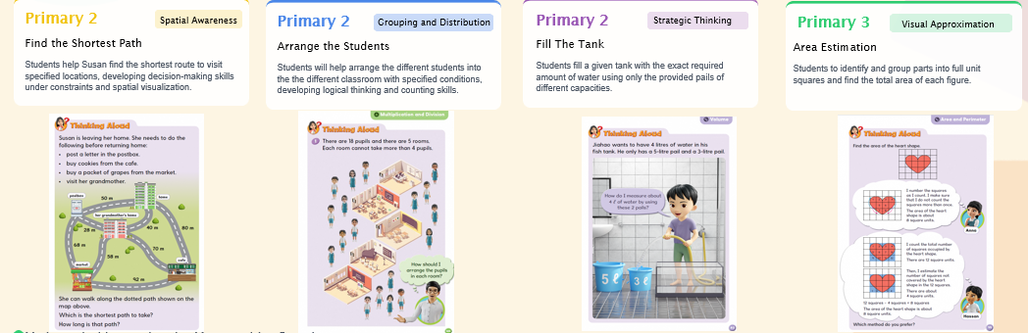
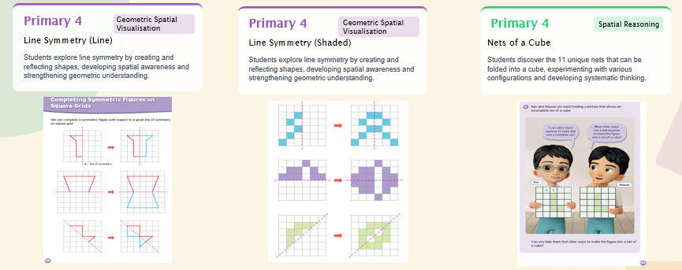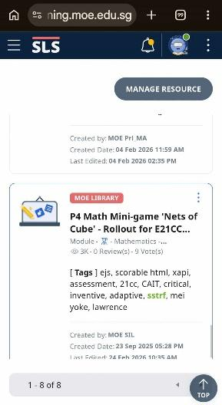
Annex 3: There are more than 3,000 views for P4 Nets Interactive since rollout in September 2025. Nets is the first interactive that was shared on SLS.
Annex 4: Students actively engaging in using the interactives:
For the line symmetry interactive: A student create half a symmetric figure for the 2nd student to complete. This provides opportunities for students to display their creativity and visualisation.
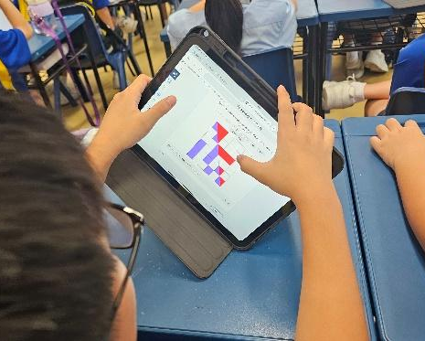 | 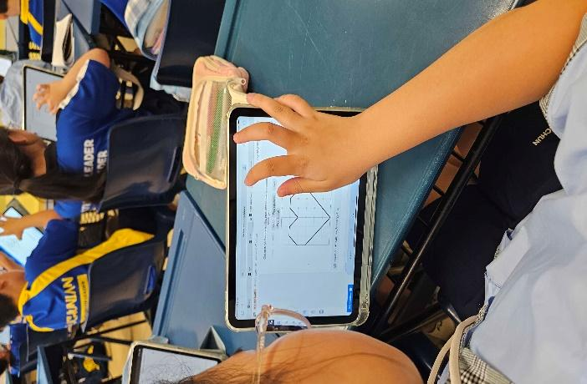
Annex 5: Students’ feedback on the survey question
[Students’ survey results are also shown on each SLS package under ‘Notes for Teachers’]
An example below on ‘Which part of the mini-game did you enjoy?’ for P3 Area Interactive:
P3 Area:
- Enjoying the challenge and learning new things: Many students expressed that they found the mini-game to be challenging and tricky, but that they enjoyed the opportunity to learn new things through playing it.
- Enjoying the shapes and figuring out the solutions: A number of students highlighted their enjoyment of the different shapes and figures they had to work with, as well as the process of figuring out how to solve the challenges presented.
- Enjoying the overall game experience: Some students simply stated that they enjoyed the mini-game overall, finding it to be fun, simple, and a good learning experience.

Students can monitor their own progress as their solutions are being made visible for their reference and consideration for their subsequent action:
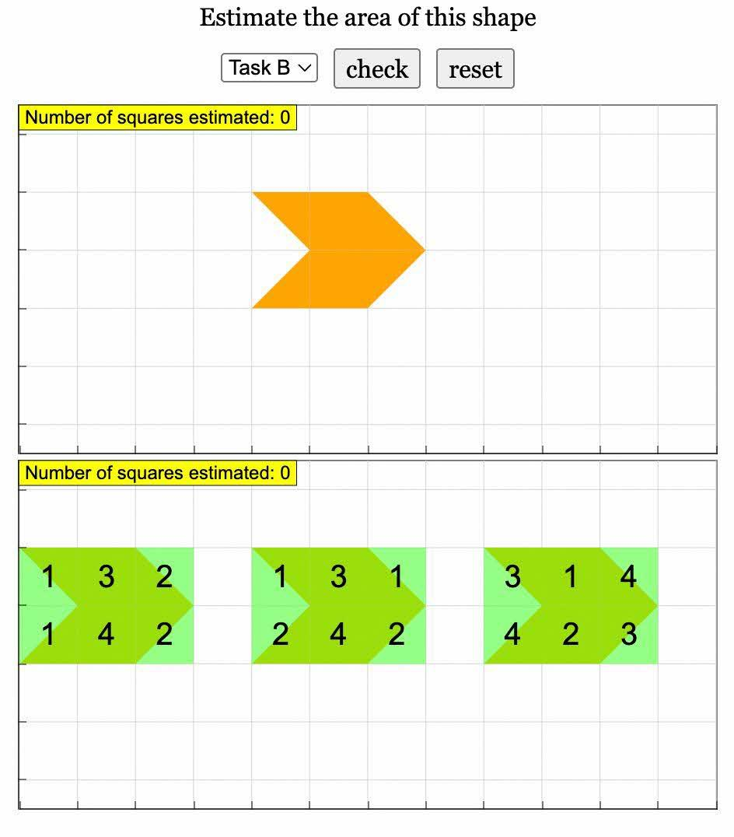  P3 Area | 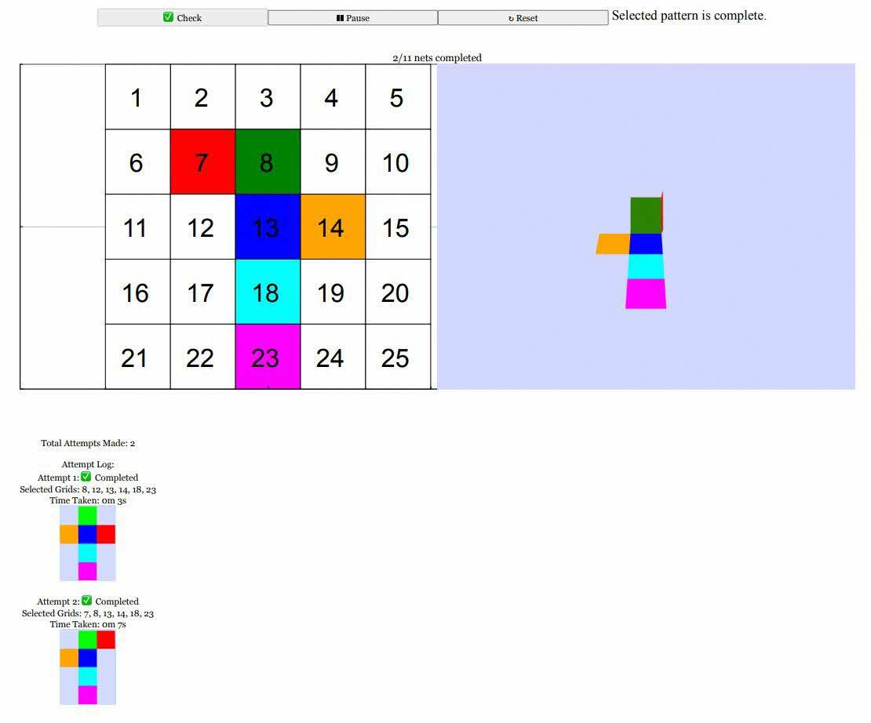  P4 Nets

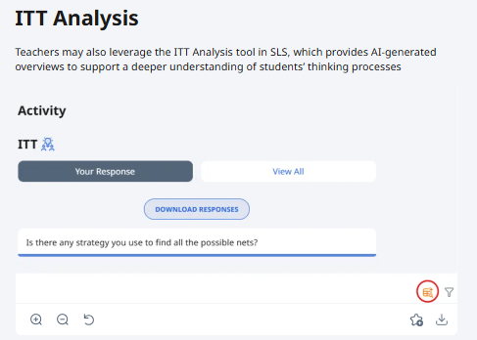
ITT questions are included to prompt students’ thinking:
e.g. for P2 length:
Did you use any method to find the shortest path quickly?
Did you change your method?
Why did you change your method?

e.g. For Nets:
- is there any method you used to find all the possible nets?

Sample of students’ responses below:
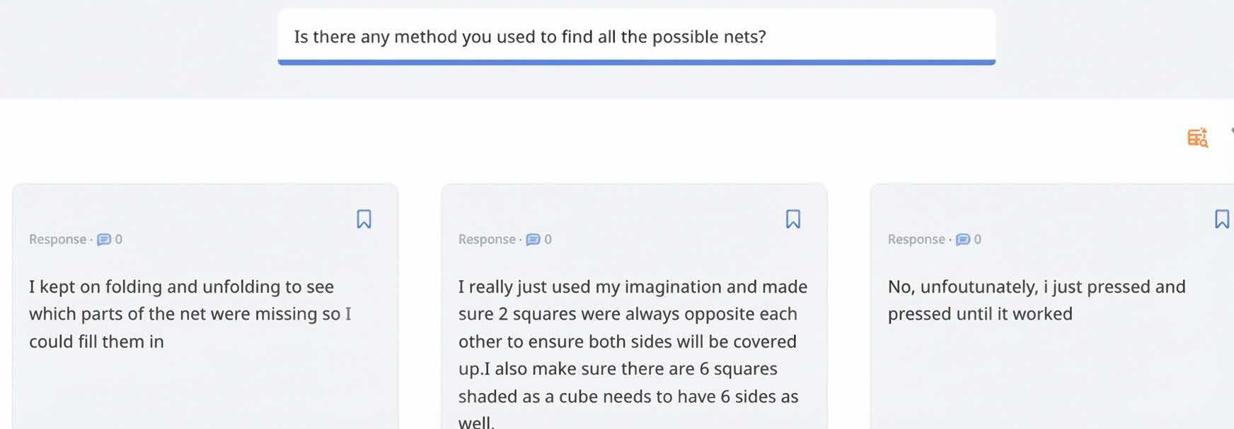
Annex 6: Using Data Assistance to analyse students’ responses according to themes:
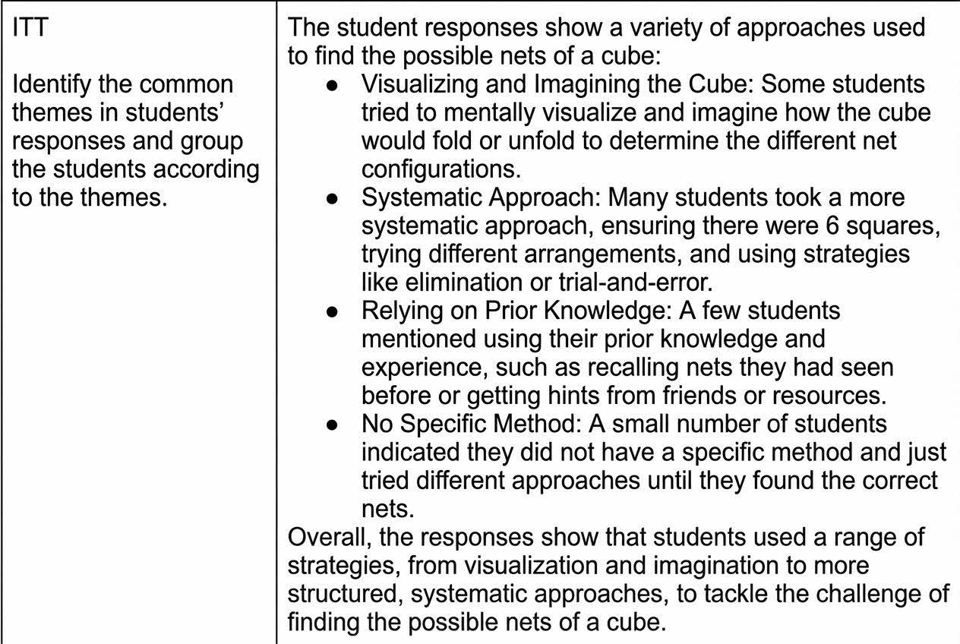
Activity Interactive Data captured using SLS’s xAPI as Teacher Comments stored in SLS, for a holistic data record store of student’s learning
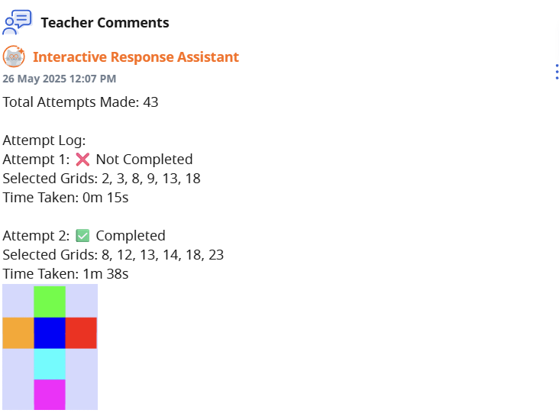 | 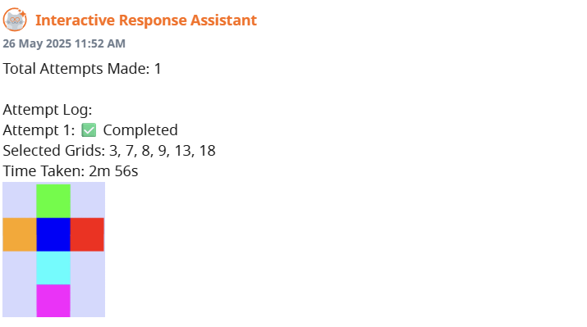

Annex 7: Using AI tools to analyse students’ activity interactive data:
Metacognition
(an example on the analysis by AI tool on Metacognitive Knowledge is shown below):
Metacognitive Knowledge
Declarative Knowledge (knowing what): He demonstrates strong awareness of the task requirements, consistently selecting 6 grids in most attempts and understanding that certain grid combinations lead to completion. His knowledge appears robust given the high success rate (16/22 completed attempts, 73%).
Procedural Knowledge (knowing how): The data shows evolving procedural strategies. Early attempts show rapid execution (4-56 seconds), suggesting either intuitive approaches or well-rehearsed procedures. Grid 13 appears in 18 of 22 attempts, indicating he has identified it as a key strategic element.
Conditional Knowledge (knowing when and why): This appears less developed. The pattern of failed attempts (8, 13, 14, 15, 18, 20) clustered around the middle phase suggests uncertainty about when to apply different strategies or modify approaches.
E21CC Critical, Adaptive and inventive thinking
(an example of an analysis on Critical Thinking skill is shown below):
Critical Thinking Skills
CAIT 1 (Sound reasoning and decision-making): demonstrates strong reasoning abilities. His high success rate (16/22 completed attempts, 73%) suggests he can effectively analyse the grid patterns and make sound decisions about which grids to select. The variety in his grid selections across attempts shows he's not randomly guessing but applying logical reasoning.
CAIT 2 (Metacognition): There's clear evidence of metacognitive thinking. After failed attempts (8, 13, 14, 15, 18, 20), he consistently returns with successful strategies in subsequent attempts. This pattern suggests he's reflecting on what went wrong and adjusting his approach accordingly.

