Installation and configuration of
LA EjsS Moodle plugin
Current Situation
Moodle 4.0 supports new functionalities for plugins
Learning Analytics (LA) EjsS Moodle Plugin updated for Moodle 4.0
References:
- Tutorial: How to write plugins for Moodle, available at https://docs.moodle.org/dev/Tutorial
- LA EjsS Moodle Plugin, available at https://gitlab.com/ejsS/addon-projects/moodle-plugin
Step 1. Installation in Moodle 4.0
As an admin user, install and configure the plugin.
- Download the plugin and generate a zip file with the plugin folder (check that the zip file does not contain hidden folders such as .git or similar)
- Go to Site Administration > Plugins > Install plugins
- Drag and drop the zip file and click "Install plugin from the Zip file"
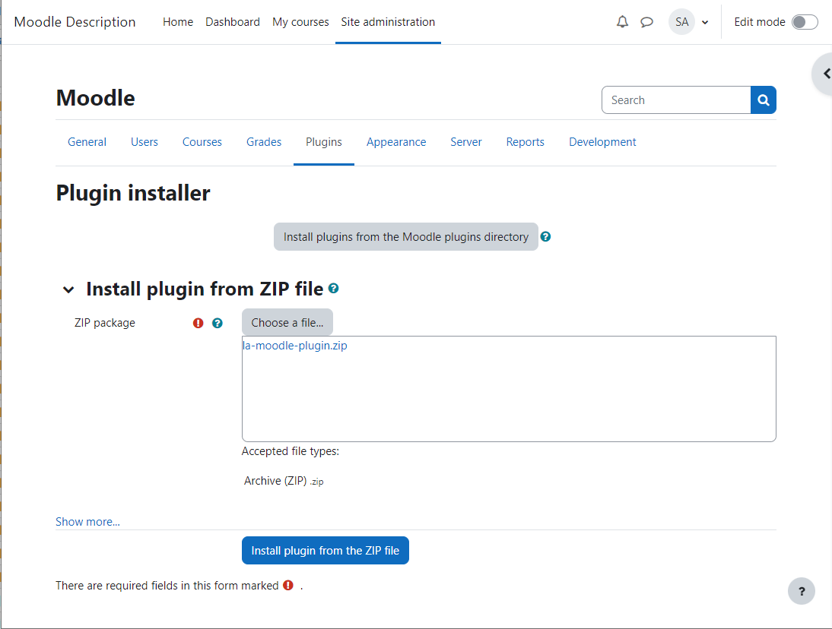
- If the validation of the plugin is successful, click "Continue"
- If the checks of the Moodle server are successful, click "Continue"
- In the window Plugins check, review the plugin information and click "Upgrade Moodle database now"
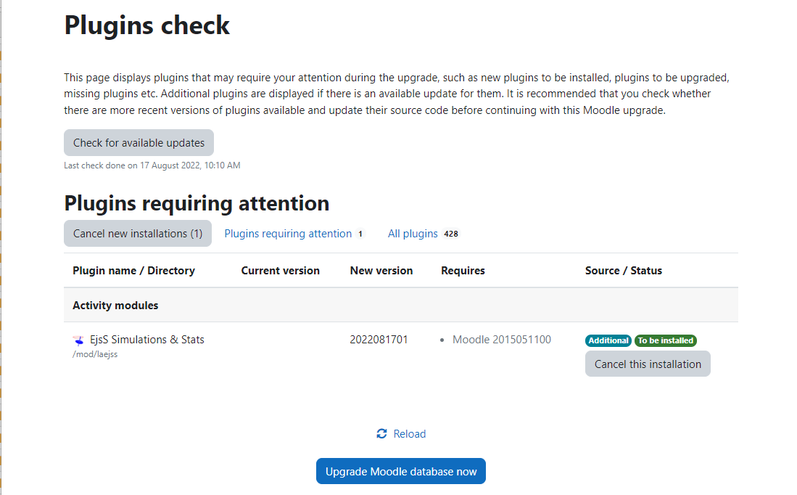
- If the installation is successful, click "Continue"
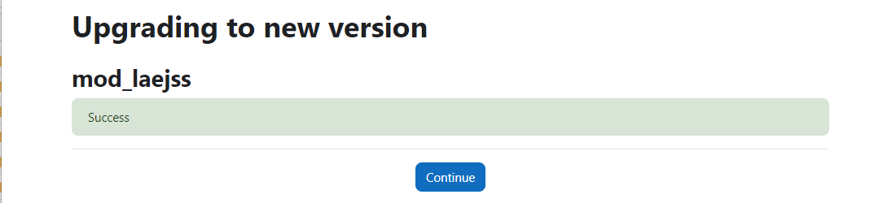
Step 2. Configuration in Moodle 4.0
The plugin requires the configuration of several aspects in Moodle.
- Enable web service advance feature
  - Go to Site Administration > General > Advanced features
  - Enable web services and click "Save changes"
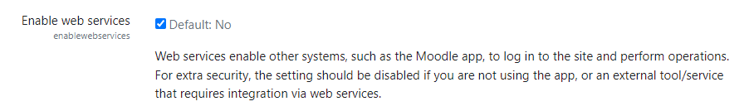
- Enable REST protocol
  - Got to Site Administration > Server > Web services > Manage protocols
  - Enable REST protocol and click "Save changes"
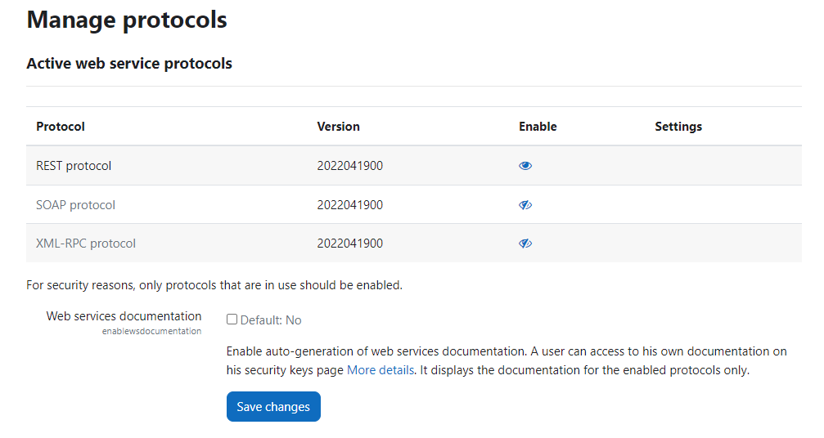
- Allow users to create a web service token and use REST protocol
  - Go to Site Administration > Users > Permissions > Define roles
  - Click the button "Edit" for Authenticated user
  - Filter capabilities with the text "web service"
  - Click "Allow" for the capability "Create a web service token"
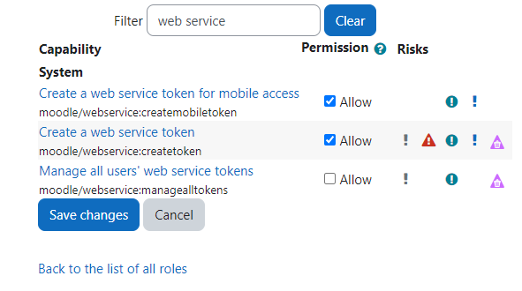
  - Filter capabilities with the text "rest:use"
  - Click "Allow" for the capability "Use REST protocol" and click "Save changes"
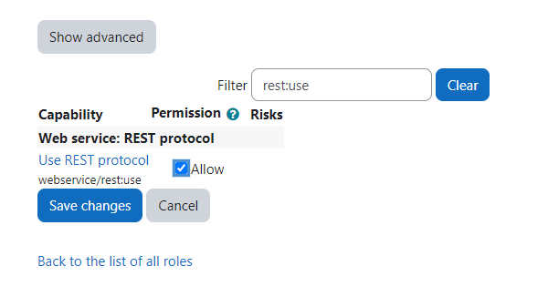
Using the LA EjsS Moodle
Step 1. Creating a course with EjsS simulations
As an admin user, verify which users have the role "Course creator" in Site Administration > Users > Assign roles in System. Note that the course creators, teachers or students cannot be an admin user as well.
As a Course creator user, create a new course as usual.
- Go to Site Administration > Courses > Manage courses and categories
- Click the button "Create new course"
- Fill the course properties
  - Go to Completion tracking > Enable completion tracking, and select No
- Click "Save and display"
- Enable "Edit mode"
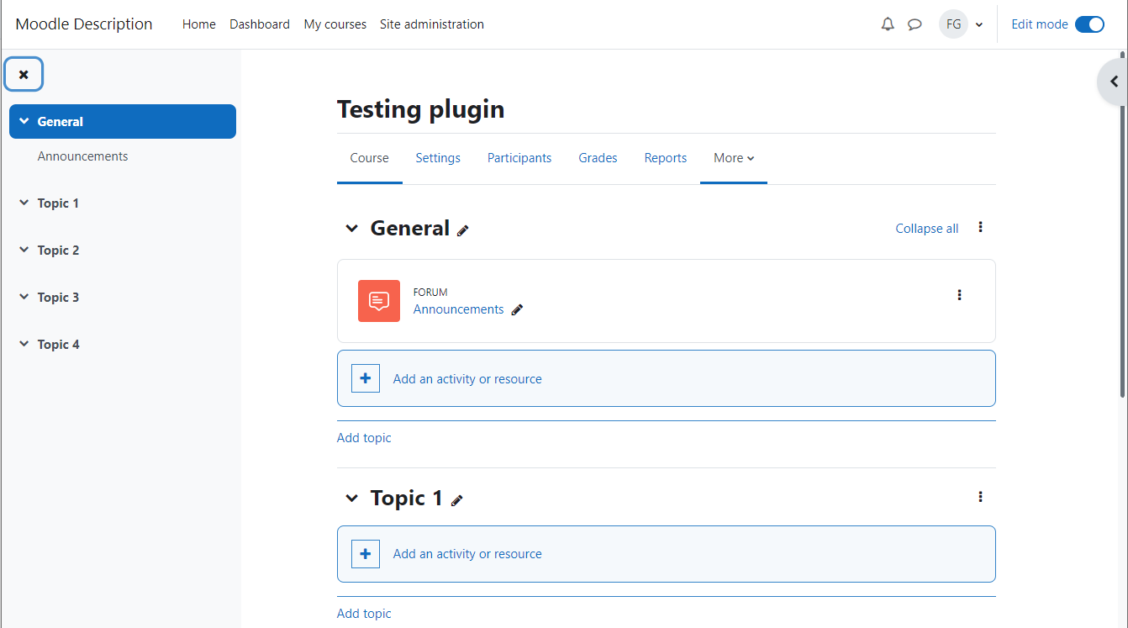
The plugin allows to include EjsS simulations as a resource.
- Click "Add an activity or resource" and select EjsS Simulation
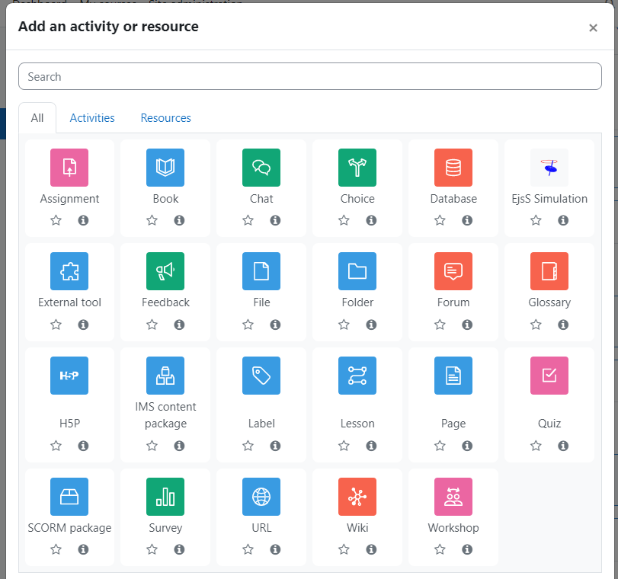
- Enter a name and description, and then upload the simulation zip file
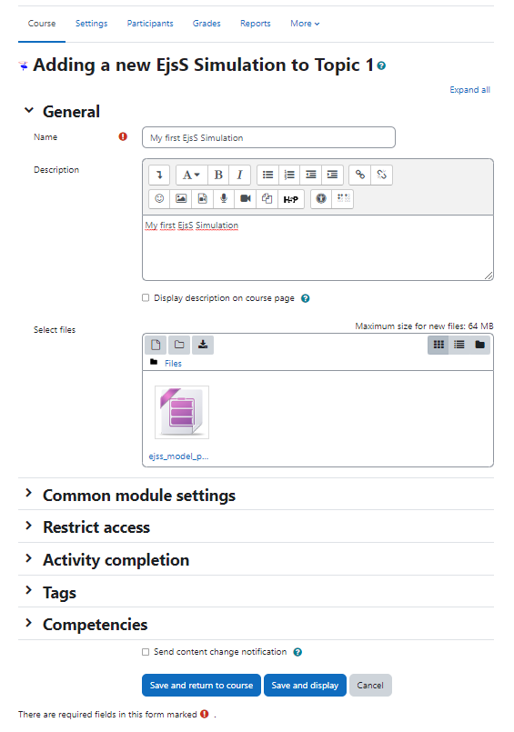
- Select the zip file and click Unzip
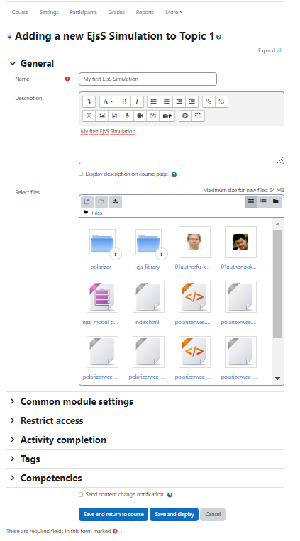
- Select the file index.html and click Set main file
- Click the button "Save and display"
Note that you can find a repository of EjsS simulations at https://iwant2study.org/ospsg/
References:
- Open Source Physics @ Singapore, available at https://iwant2study.org/ospsg/
Step 2. Accessing a course with EjsS simulations
As a course creator user, enroll users as teachers or students.
- Go to the Participants page in the course and click the button "Enrol users"
- Search for the teacher and select Teacher as role to assign, and click the button "Enrol users"
- Search for the teachers and select Student as role to assign, and click the button "Enrol users"
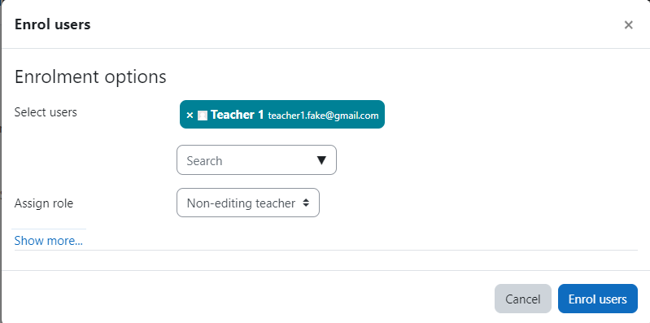
As a student user, access the course and try the EjsS simulation.
As a teacher or course creator user, access the course and see the LA EjsS plugin reports.
- Go to the specific course and then go to More > EjsS Analytics
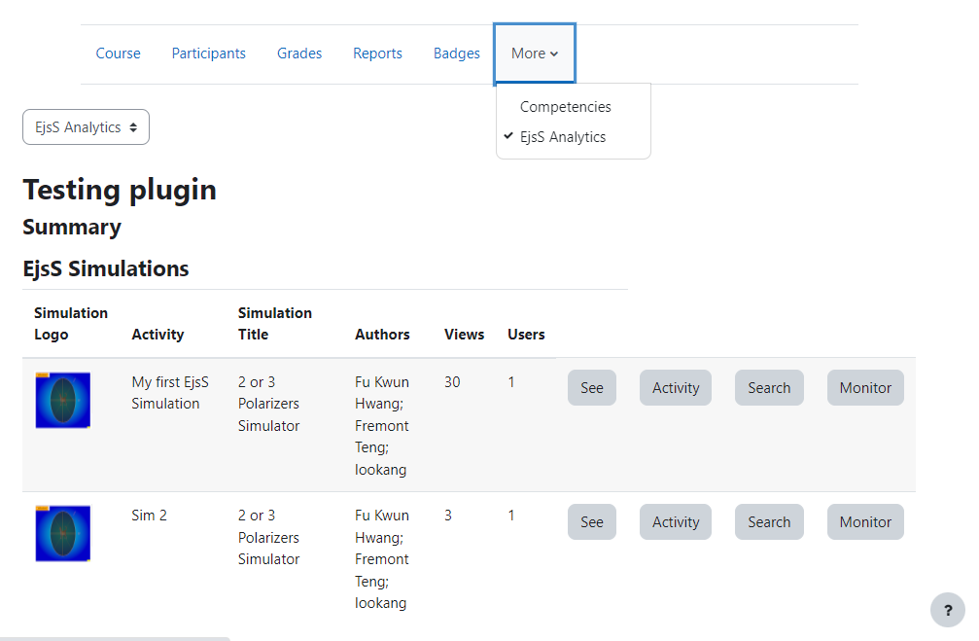
- Click the button "See" of the EjsS simulation that you want to see
- Click the button "Activity" of the EjsS simulation to see the activity report
- Click the button "Search" of the EjsS simulation to see an activity report for a specific action
- Click the button "Monitor" of the EjsS simulation to see a real-time activity report
As an admin user, list the courses with EjsS simulations.
- Go to Site Administration > Reports > EjsS Simulation & Stats
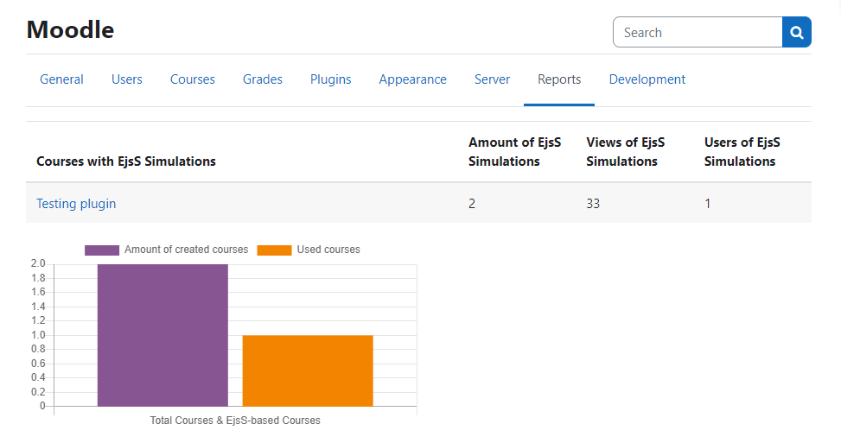
- Click the link of the course to see its report as a teacher user

