Integration [patched] Moodle 4.0 with SLS
Current Situation
Moodle 4.0 supports LTI 1.3 and LTI Advantage
Moodle 4.0 patched to allow integration with SLS
SLS partially supports LTI 1.3 and does not support LTI Advantage
References:
- Publish as LTI tool in Moodle, available at https://docs.moodle.org/400/en/Publish_as_LTI_tool#Custom_launch_parameters
- List of LTI Advantage certified products, available at https://www.imsglobal.org/ltiadvantage
- Integration with SLS, available at https://docs.learning.moe.edu.sg/sls/partners/integration/integrationsls.html
Step 1. Enabling the 'Publish as LTI tool' feature in Moodle
As an admin user, enable the 'Publish as LTI tool' for use across the site:
- Go to Site administration > Plugins > Authentication > Manage authentication, and enable LTI

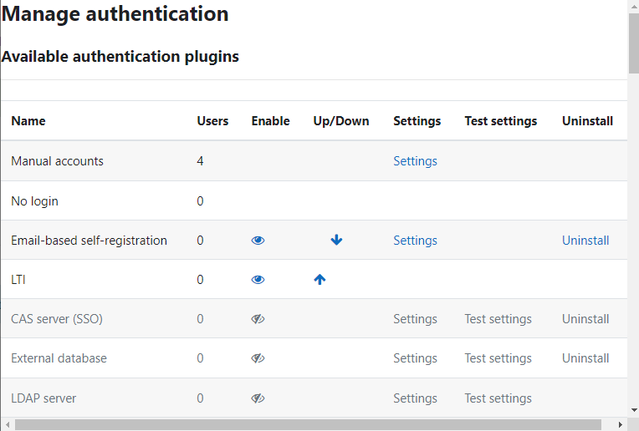

- Go to Site administration > Plugins > Enrolments > Manage enrol plugins, and enable 'Publish as LTI tool'
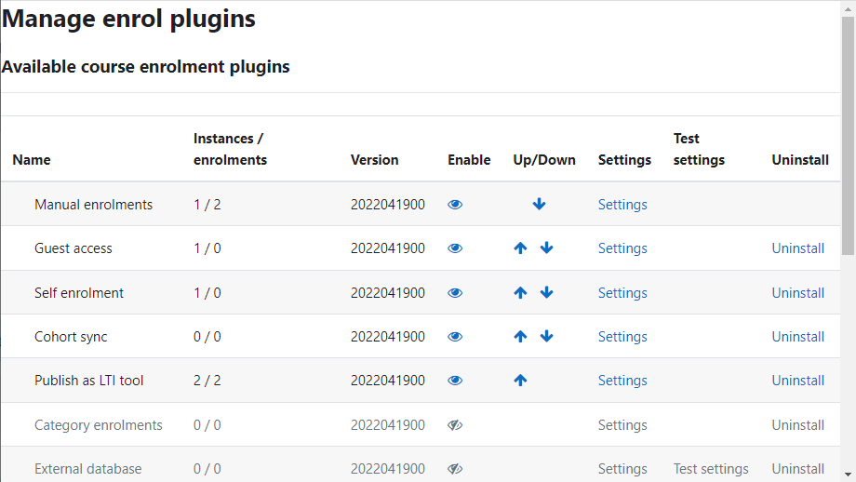
- Optionally, go to Settings of 'Publish as LTI tool' and fill the properties
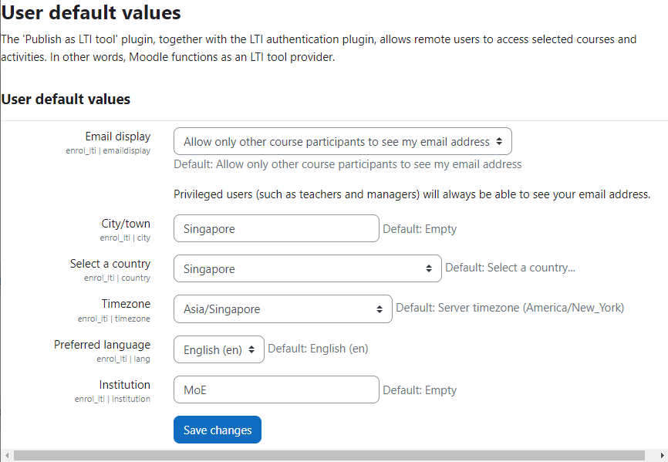
It is recommended that the site administration setting 'Allow frame embedding' is enabled (in "Site Administration > Security > HTTP security") so that tools can be displayed within a frame rather than in a new window, if desired.
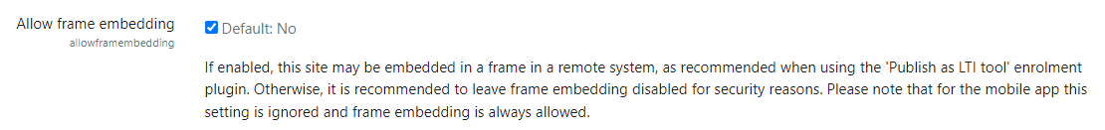
Step 2. Initial manual registration in Moodle
As an admin user, create a new platform registration for SLS:
- Go to "Site administration > Plugins > Enrolments > Publish as LTI tool > Tool registration"
- Click the "Register a platform" button to create a new platform registration
- Enter the name of the platform and click "Continue"
You'll see a "Tool details" tab with the LTI endpoints.
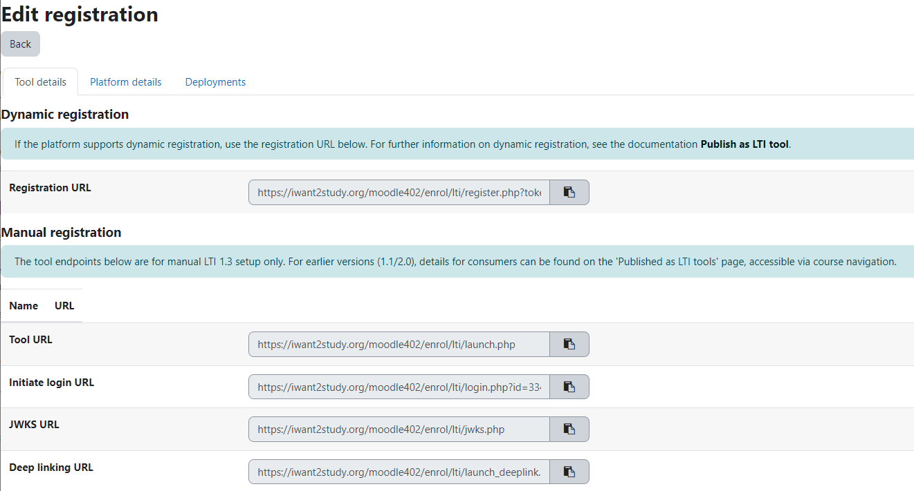
Step 3. Manual registration in SLS
As an App Admin user, add an LTI App using the Moodle information:
- Go to "Administration > App Admin > Manage Apps"
- Click the "Add New App" button to create a new App
- Enter the name, description, division, branch and icon, and optionally the rest of parameters
- Change the tab "App Configuration" and enter the type LTI
- The App configuration depends on the Moodle configuration and your preferences. An example is the following one:
  - Public Key: "ignored"
  - OIDC Login URL: https://iwant2study.org/moodle402/enrol/lti/login.php
  - Searchable in App Library: https://iwant2study.org/moodle402/enrol/lti/launch.php
  - Installable to Class / Group: https://iwant2study.org/moodle402/enrol/lti/launch.php
  - Embeddable to Lesson: https://iwant2study.org/moodle402/enrol/lti/launch.php
  - Whitelisted Domains (Maximum 10 Domains): vle.dev.sls.ufinity.com, dev.sls.ufinity.com, vle.learning.moe.edu.sg, iwant2study.org
- Click "Save" and then click the button "Edit App Availability" in order to make available the App.
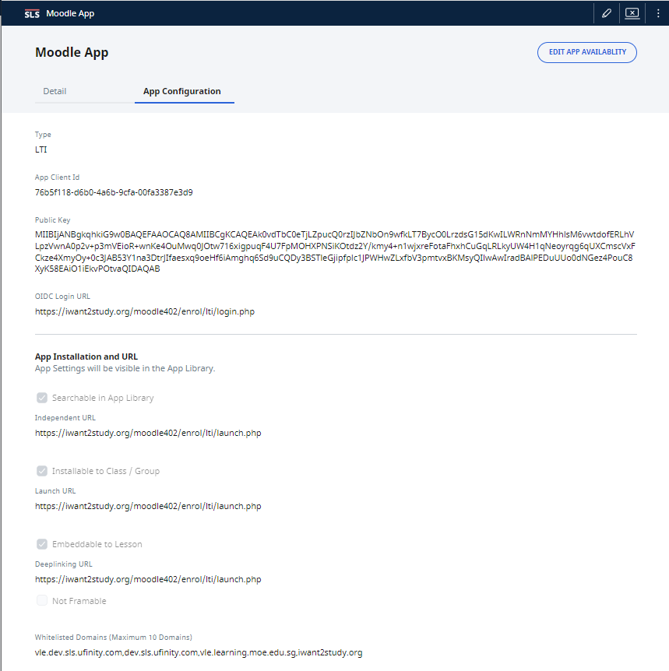
Step 4. Final manual registration in Moodle
As the admin user, complete the registration for SLS:
- Go to "Site administration > Plugins > Enrolments > Publish as LTI tool > Tool registration". If you have the registration open still, simply click the "Platform details" tab. If not, from the registration table, click the "View platform details" action. You'll see a table listing the various platform endpoints and identifiers.
- Click "Edit platform details"
- Copy the following values from SLS:
  - Platform ID (issuer): https://vle.dev.sls.ufinity.com
  - Client ID: 76b5f118-d6b0-4a6b-9cfa-00fa3387e3d9
  - Authentication request URL: https://vle.dev.sls.ufinity.com/lti/authorize/76b5f118-d6b0-4a6b-9cfa-00fa3387e3d9
  - Public keyset URL: https://vle.dev.sls.ufinity.com/lti/key-set/76b5f118-d6b0-4a6b-9cfa-00fa3387e3d9
  - Access token URL: https://vle.dev.sls.ufinity.com/lti/authorize/76b5f118-d6b0-4a6b-9cfa-00fa3387e3d9
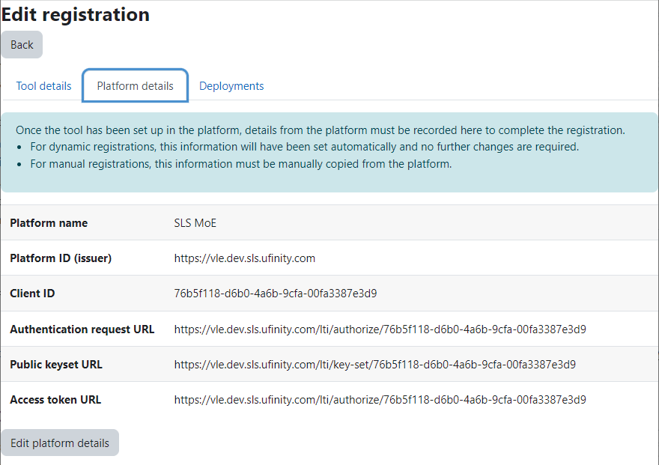
- Save and, next, select the "Deployments" tab
- Click "Add a deployment", enter a deployment name, copy the value Deployment ID provided by the SLS vendor and save.
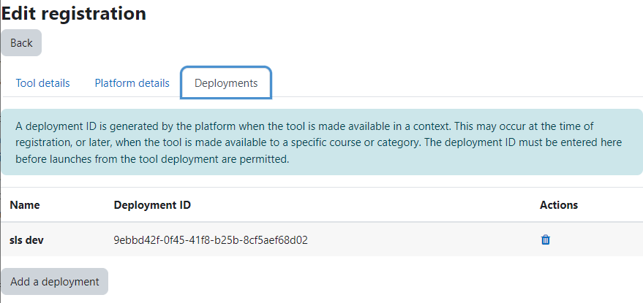
Note that Platform ID and Client ID are obtained from the SLS registration. However, the Deployment ID is not visible at the SLS platform. You must request the Deployment ID to the SLS vendor.
The registration process is now complete. Click the "Back" button or navigate to "Site administration > Plugins > Enrolments > Publish as LTI tool > Tool registration", where you will now see the registration listed as "Active".
Step 5. Sharing access to an EjsS Simulation from Moodle
As a course admin user, share access to your EjsS Simulations:
- From the course navigation, select "Published as LTI tools"
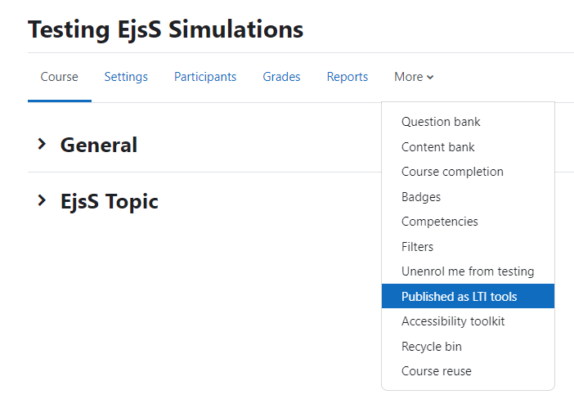
- Under the "LTI Advantage" tab (this is selected by default) click the "Add" button
  - In "Tool to be published" select the EjsS Simulation to be shared
  - In "Teacher first launch provisioning modes" and "Student first launch provisioning mode" select "New accounts only (automatic)”.
  - Disable grade and user sync for the resource
- Click the "Add method" button
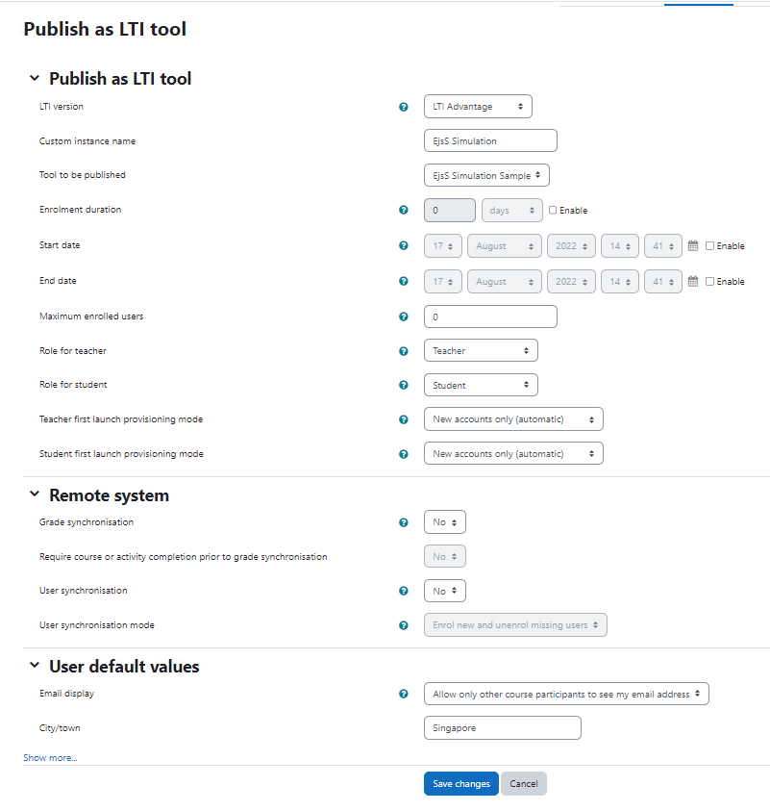
The published activity or course is now ready for use in SLS. Note that Moodle provides an identifier that must be used in the next step.
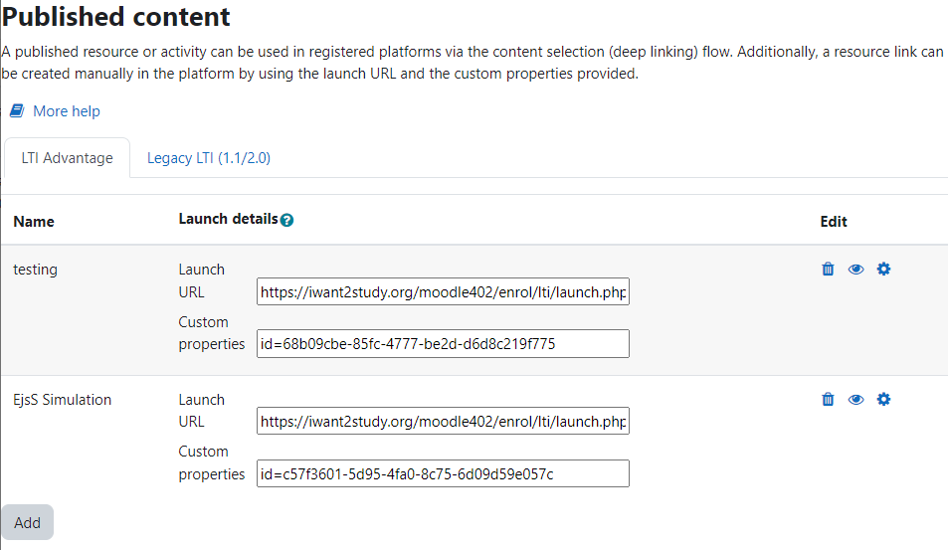
Step 6. Sharing access to an EjsS Simulation from Moodle
As a teacher user, add an EjsS Simulation using the LTI App:
- Add a component as usual into your lesson and add Embed App
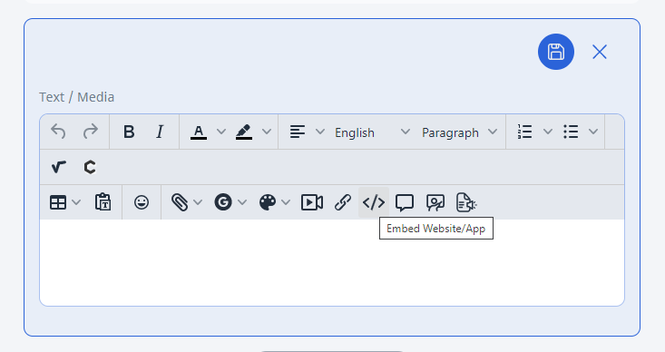
- On the tab "App", select the App created in Step 2 by its name and enter the Resource URL. The Resource URL is the target link uri. Based on the result of the previous step, enter "https://iwant2study.org/moodle402/enrol/lti/launch.php?id= c57f3601-5d95-4fa0-8c75-6d09d59e057c"
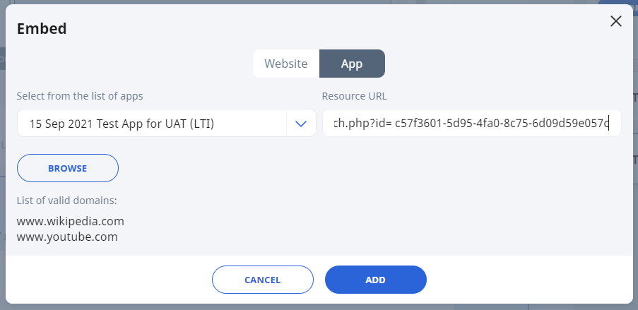
Note that the target link uri has the form "Launch URL" + "Custom properties"
- Click "Add" and save
Finally, the EjsS Simulation will be visible.
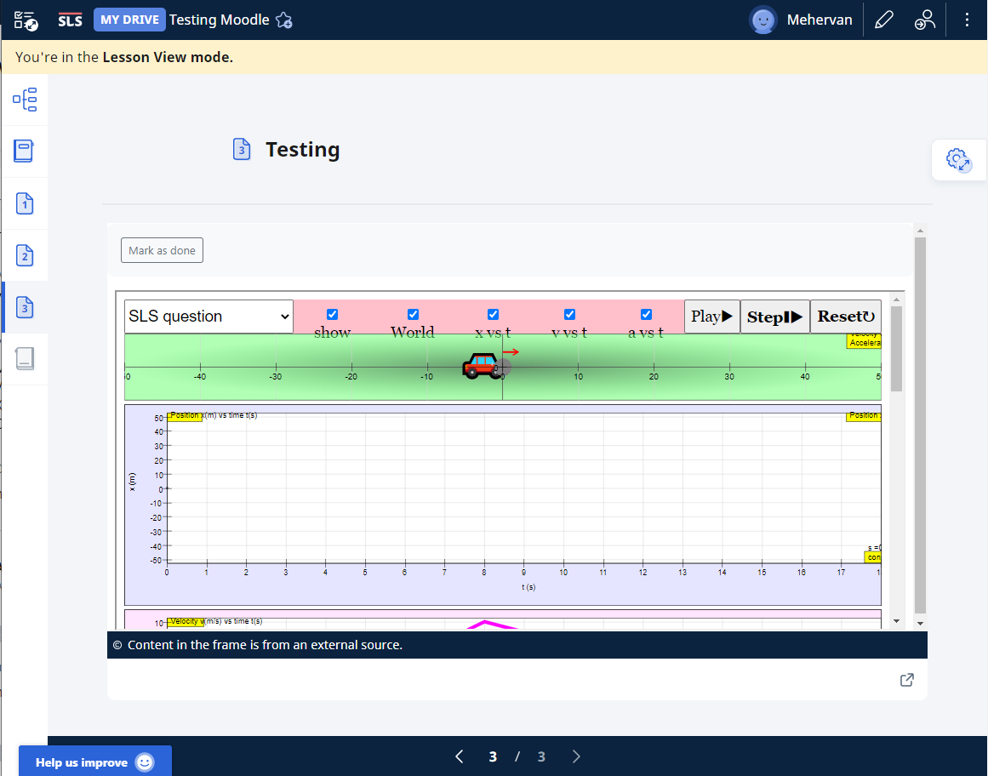
References:
- Publish as LTI tool in Moodle, available at https://docs.moodle.org/400/en/Publish_as_LTI_tool#Custom_launch_parameters
- Integration Guide with SLS, available at https://docs.learning.moe.edu.sg/sls/partners/integration/adpspecifications.pdf

