Analysing Unknown Water Samples
Prior knowledge:  - Stoichiometry and mole concept  - Redox reactions  - Use of spreadsheet to plot graphs | Links to Practices of Sciences:  Understanding the nature of scientific knowledge  Demonstrating ways of thinking and doing in Science  Relating science, technology, society, environment
Emerging 21CC – key focus:
Adaptive thinking
Note: Critical thinking and scientific communication skills could also be developed to some extent, but is not the key focus in this lesson example.
Lesson objectives:
Students are able to:
- devise a suitable experimental technique using given information and equipment to determine concentrations of nitrates and/pr phosphates in an unknown water sample
- prepare solutions of required concentrations
- present and interpret data obtained from experiments
- identify limitations and possible sources of error in the experimental design, and suggest improvements
- appreciate that Science is a unique way of knowing which uses empirical standards, logical arguments, and sceptical reviews
- apply the assumption that events in nature occur in consistent patterns that are understandable through measurement and observation
- appreciate analytical techniques as powerful, technologically advanced, complementary tools to what is experienced in school science practical
Key questions:
To develop adaptive thinking so that students learn to remain flexible when problems arise, think about observations and assumptions in different ways, and reflect on learning processes whilst making connections to broader applications.

Problem analysis questions - to help students systematically examine and understand the nature of scientific problems or challenges they encounter during experiments
- What do you predict will happen and why?
- If your results are not matching expectations, what might be causing this?
- How could you investigate this question using a completely different method?
- What alternative explanations could account for what you're observing?
- In an alternate universe, where you do not follow the plan:
  - Divergent experimental designs, e.g. If you had to design five completely different experiments to test the same hypothesis, what would they look like?
  - Effects of changing a variable or conditions, e.g. what would happen if you used 10 ml of sample instead of 5 ml for the test?
  - Reorder or swop sequence, e.g. What would you think you will observe if the order of the test reagents added were swopped? Explain your reasoning.
  - Provide constraints and alternative scenarios, e .g. What would you do if you only had 5 ml of unknown water sample? What if the API test kits are not available to you?

Critical evaluation questions - to help students assess the quality, validity, and reliability of their scientific work
- What are all the possible explanations for what you are observing?
- What other deductions or conclusions can you make from your observations? Explain your reasoning.
- What assumptions are you making that might not be correct?
- How many different sources of error can you identify in your method? Any ways to overcome them?
- If your experiment is proceeding smoothly as planned, what could you do to confirm the results you have obtained?
- What are multiple ways the data could be interpreted?
- What variables might be affecting your results that you have not considered earlier? How could you test this out?

Metacognitive or transfer questions - to help students think about their own thinking processes during scientific investigations, and connect their current scientific learning to other contexts, situations, and knowledge domains.
- How does this investigation relate to what you have learned in other topics or connect to the real-world?
- What principles from this experiment could help solve other scientific problems?
- What different questions could emerge from your findings?
- How might different scientists from various disciplines approach this same problem?
- What connections could you make to other subjects?

How does the API nitrate test kit work:

The API nitrate test kit is a liquid-based test kit that measures nitrate concentration in aquarium water through chemical reactions. The user collects a precise volume of water sample in the provided vial, adds fixed volumes of specific reagents, and waits for a few minutes for nitrate ions to react with the chemicals, producing a colour change. The key reactions involve the reduction of nitrate (NO₃⁻) to nitrite (NO₂⁻), and the nitrite reacting with sulfanilamide in acidic conditions to form a diazonium salt, which subsequently reacts with a coupling agent (likely N-(1-naphthyl)ethylenediamine) to produce a coloured azo dye (read more about the Griess test).

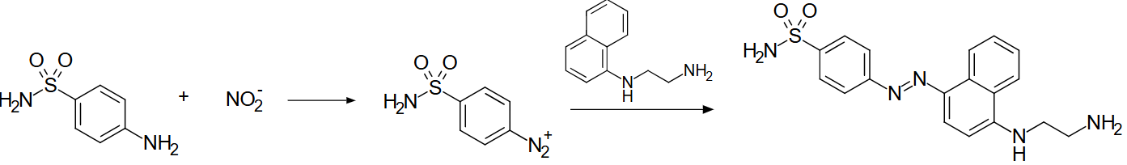

This colour is then compared against a reference chart to determine nitrate levels. The colour change is proportional to the nitrate concentration. Accuracy of the results can be affected by water temperature and pH, quality of reagents, salinity of water and adherence to instructions.

References:
- API Nitrate Test Kit. Source: https://apifishcare.com/product/nitrate-test-kit
- Griess Test Reaction. Source: By frewall - Own work, Public Domain, https://commons.wikimedia.org/w/index.php?curid=16591451
- What Is a Nitrate Test Kit and Why Is It Essential in Aquaristics? Source: https://mbstore.uk/nitrate-test-kit/?srsltid=AfmBOornBSkSQ6pz1lblcnYMIHfKfYHGY9542LH5lH0eSpPvCRqmJtN9

How does the API phosphate test kit work:

The API phosphate test kit is a liquid-based test kit that measures phosphate ion concentration in aquarium water through a two-stage chemical reaction process. The user collects a precise volume of water sample in the provided vial, adds fixed volumes of specific reagents, and waits for several minutes for phosphate ions to react with the chemicals, producing a blue colouration. In the first step, phosphate reacts with ammonium molybdate in the presence of sulfuric acid to form a 12-molybdophosphoric acid complex. This complex is subsequently reduced by a reducing agent, tin(II) chloride, to form an intensely coloured blue coordination complex known as "molybdenum blue".

PO₄³⁻ + 12MoO₄²⁻ + 27H⁺ ⟶ H₃PO₄(MoO₃)₁₂ + 12H₂O

H₃PMo(VI)₁₂O₄₀ + reducing agent ⟶ [H₄PMo(VI)₈Mo(V)₄O₄₀]³⁻

The intensity of the blue colour is directly proportional to the phosphate concentration and is compared against a reference chart to determine phosphate levels. The test specifically measures reactive orthophosphate and does not detect organic phosphates or polyphosphates unless they undergo prior hydrolysis.

References:
- API Phosphate Test Kit: API® | PHOSPHATE TEST KIT
- A Colorimetric Dip Strip Assay for Detection of Low Concentrations of Phosphate in Seawater: https://pmc.ncbi.nlm.nih.gov/articles/PMC8125474/#:~:text=In%20this%20method%2C%20ammonium%20molybdate,(2)

Teachers’ notes:

Procedures
Preparation of known concentrations through serial dilutions
- Using a micropipette, add 1.0 ml of 1M HNO₃ to well #1. Rinse the micropipette tip with water in the big well. Add 9 ml of water and stir with a spatula to mix well. Rinse the spatula with water in the big well.
- Using a micropipette, transfer 1.0 ml of 0.1M HNO₃ from well #1 to well #2. Rinse the micropipette tip with water in the big well. Add 9 ml of water and stir with a spatula to mix well. Rinse the spatula with water in the big well.
- Using a micropipette, transfer 1.0 ml of 0.01M HNO₃ from well #2 to well #3. Rinse the micropipette tip with water in the big well. Add 9 ml of water and stir with a spatula to mix well. Rinse the spatula with water in the big well.
- By repeating the procedure of transfer and adding water, perform further serial dilutions to obtain at least 6 different solutions of concentrations between 1 x 10⁻³ M to 1 x 10⁻⁶ M.
- Perform serial dilutions of 0.5 M Na₃PO₄ to obtain at least 6 different solutions of concentrations between 1 x 10⁻⁴ M to 1 x 10⁻⁶ M.

Calibration curve for nitrate:
- Using a micropipette, add 5 ml of each prepared concentration of solutions to clean capped vials.
- To each vial, add 10 drops of nitrate test solution #1. To ensure uniformity of drops, hold the dropper bottle upside down in a completely vertical position.
- Shake nitrate test solution #2 vigorously for at least 30 seconds.
- Add 10 drops of nitrate test solution #2 in a similar manner as step 2.
- Cap and shake the vial vigorously for at least 1 minute. Wait for 5 minutes for the colour to develop.
- Determine the absorbance reading using the colorimeter.

Calibration curve for phosphate:
- Using a micropipette, add 5 ml of each prepared concentration of solutions to clean capped vials.
- To each vial, add 6 drops of phosphate test solution #1. To ensure uniformity of drops, hold the dropper bottle upside down in a completely vertical position. Cap and shake vigorously for 5 seconds.
- To each vial, add 6 drops of phosphate test solution #2 in a similar way as step 2. Cap and shake vigorously for 5 seconds. Note that solution #2 is a thick solution requiring more pressure to release the drops.
- Wait for 3 minutes for the colour to develop.
- Determine the absorbance reading using the colorimeter.

Determination of concentration of nitrate and phosphate:
- Repeat the steps above for each test of ion on 5 ml of the provided water sample.

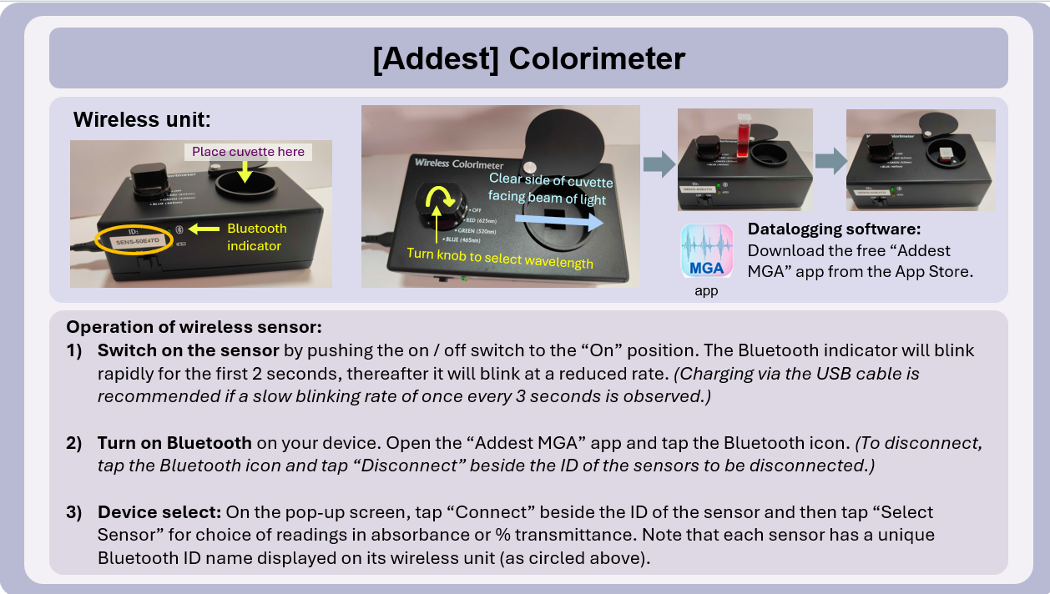

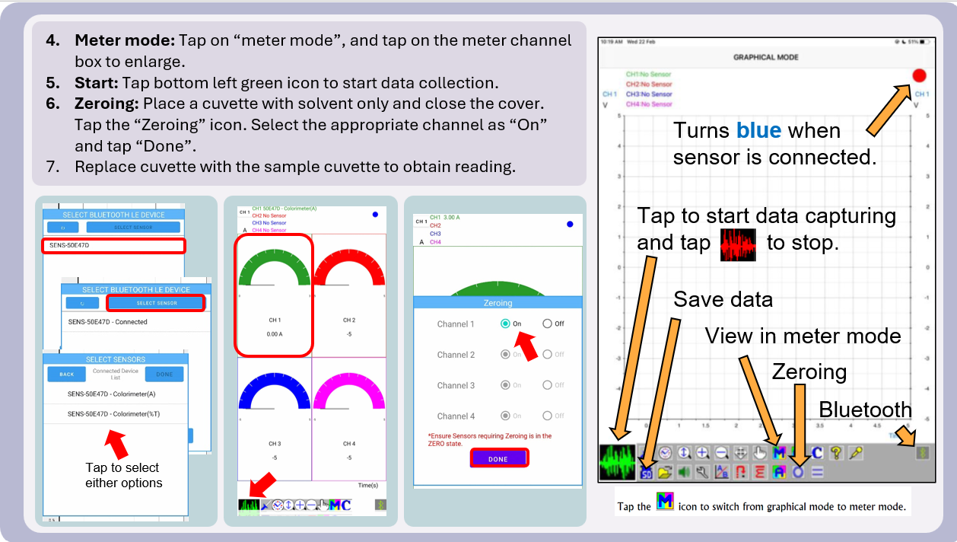

Student Version
------------------------------------------------------------------------------------------------------------------------
Scenario: The Contamination Mystery

The Anonymous Tip
It started with a viral TikTok video. A student cycling along the river filmed thick green algae blooms covering the water surface near an industrial discharge point. "Why is our river dying?" the caption read. Within hours, the video had 50,000 views and dozens of concerned comments about dead fish floating amongst the algae.

By Monday morning, government officials were at the factory gates.

Inspector Chen collected samples from the discharge pipe. The factory manager, Mr Tan, was defensive. "Our treatment system cost $200,000. That green algae? It's natural - happens every year during the rainy season." But Inspector Chen wasn't convinced. The green colouration is attributed to presence of large amounts of suspended algae particles in the water. The excessive algae growth and reports of fish kills suggested nutrient pollution from the fertiliser production operations inside, specifically nitrates and phosphates that fuel eutrophication.

The Stakes
Now the sample is on your laboratory bench. Your supervisor, Dr Lim, has given you 48 hours to determine the nitrate and phosphate concentrations.

"The legal limits for discharge into public waterways are 15 mg/L for nitrates and 5 mg/L for phosphates," she explains. "If this factory exceeds either limit, they face fines up to $50,000 and potential shutdown orders. But if we're wrong, they could sue us for damages. We need to be absolutely certain."

Mr Tan has already called his lawyer and posted on the company's Facebook claiming "harassment by overzealous regulators." The TikTok video now has 200,000 views. Environmental activists are organising a cleanup drive. Local residents are worried about their children's health and the ecosystem collapse they're witnessing.

Your Mission
You are provided 10 ml of the liquid sample. You need to decide what methods are reliable for determining both nitrate and phosphate concentrations, and confirm whether the factory is contributing to the eutrophication crisis.

Dr Lim provided three different methods for your consideration:
- A fast and simple qualitative analysis of nitrates and phosphate anions.
For example, to test for phosphates, acidify the sample with nitric acid, add ammonium molybdate. A bright yellow precipitate forms if phosphates are present.

- A colorimetric method that measures how much light a coloured solution absorbs. There are reagents that can react with nitrates and phosphates to produce coloured solutions. The amount of light absorbed by the coloured solution is directly proportional to its concentration. Any other coloured compounds in the sample could also absorb light and affect the reading.

- A titration method to determine the exact concentrations of nitrates and phosphates.
For example, it is possible to determine the concentration of nitrates through back titration: Nitrate is reduced by an excess Fe²⁺ in the presence of a catalyst. The remaining unoxidized Fe²⁺ ions are titrated with a known concentration of potassium permanganate.
To determine the concentration of phosphate ions, add ammonium molybdate, (NH₄)₂MoO₄, to the solution containing phosphate ions. Titrate the ammonium molybdophosphate with NaOH using a phenolphthalein indicator. One mole of ammonium molybdophosphate contains one phosphate unit and requires 23 moles of NaOH in the titration before the end point is reached.

Dr Lim shared "In this job, accuracy matters. Get it wrong, and either a polluter walks free or an innocent company gets destroyed."

Inspector Chen added “Everyone wants answers fast. We are under pressure for an interim press release in less than an hour time.”

Your task: You need to decide which of the three methods above are reliable for finding the concentrations of nitrates and phosphates, to be certain whether the factory is breaking the law. You will also need to decide if one method of measurement is enough, or if you need multiple methods that agree with each other.

------------------------------------------------------------------------------------------------------------------------
- Explain what is meant by “qualitative” in method 1.

- Explain which approach would be preferred in this given scenario: To use one method of measurement, or more than one method of measurement?

- Which one of the three methods provided by Dr Lim is the most reliable for finding the required concentrations in the sample? Explain your choice and why the other two methods are not as reliable.

- In this scenario, explain the potential limitation of method 3, the titration method in determining the concentration of phosphates in a water sample. Support your explanation with calculations. Assume you are provided with a 0.1 moldm⁻³ solution of NaOH.

- Plan and carry out:

- Visually examine the sample of water provided and record your observations.
Are the observations consistent with expectations from the provided scenario? What information supports your conclusion?
If the observations are inconsistent with expectations, suggest what might have happened to result in the observation.

- Outline how you would accurately determine the concentrations of nitrate and phosphate ions in a given water sample. You are provided with materials and test reagents as shown below, including a colorimeter that is connected via Bluetooth to a mobile device.
In your groups, carry out your plan to determine the nitrate and phosphate concentrations.

Materials Provided:  - Wellplate with spatula  - 6 x 10 ml capped vials  - 1 x 1-10ml micropipette with tip  - 6 x teat pipettes  - colorimeter with 10 cuvettes  - white paper  - kitchen towel  - gloves |     Chemicals:  - nitrate API test kit (MSDS)            - phosphate API test kit (MSDS)    - 1M nitric acid, HNO₃  - 0.5M sodium phosphate, Na₃PO₄  - water  - water sample  - copper (II) sulfate solution (Note: From workshop activity 1)

- The API test kits include colour charts for different concentrations of nitrates or phosphate ions. Have you used this resource in your plan? Why or why not?

- A hypothesis is a testable, falsifiable statement that predicts a relationship between variables based on established knowledge or principles, serving as the basis for experimental investigation.

Consider this alternative scenario:
If the water sample also contained some copper (II) ions, predict how this might affect the experimental results? (i.e. state your hypothesis)

Using the same setup, perform an experiment to test your hypothesis and explain the results obtained. Use the copper (II) sulfate solution provided to you.
Note: Making an incorrect prediction is perfectly acceptable in science. Focus on thoroughly explaining your experimental results and reflecting on your initial hypothesis.

Reflection:
- How did you feel about the activity? In particular, what did you notice about instances when you needed to think of alternatives/different procedures as planned, or change what you are doing?

- What are some features of the task design in Activity 2 that you appreciate? Why?

- What are some features of the task design in Activity 2 that you feel could be improved?

- What are other new features could be included in the task design in Activity 2?

- How might your students find the demand of the task? Provide a rating from 1 to 3:
1 – easy
2- moderate
3 - challenging

Question part | Low progress learners | High progress learners
1
2
3
4
5a
5b
5c
5d

https://edu.rsc.org/uk-chemistry-olympiad/titration-and-phosphates-in-the-environment-chemistry-olympiad-worked-answers/1058.article

