Bukit Merah Secondary School
Secondary 2 Express/Normal Academic Mathematics
Chapter 13 Probability

Name: _________________________________ Class:_________ Date: _______

Introduction
What causes a disease to spread? Infectious diseases are often transmitted through the air. If an infected person breathes or sneezes on you, it is possible that you will become infected. How likely is it that you will become infected? Will you definitely become infected and ill or could you possibly remain uninfected? This activity simulates the spread of disease in a population.
Activity 1 SORBET Making Sense of the Data
Table 1
Stage | No. of newly infected | Total number of infected
0
1
2
3
4
5
Total number of infected
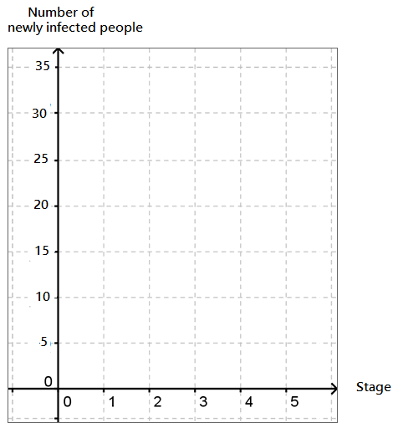
3 possible outcomes in each interaction
- come into contact with an infected person but not infected
- come into contact with an infected person and was infected
- did not come into contact with an infected person

Plot the graph of total number of infected against stages.
Activity 2 Probability of Infection

Table 2: Possibility Diagram
 | 1 | 2 | 3 | 4 | 5 | 6
1

2

3

4

5

6

Which sum is the most contagious?

Table 3: Probability of Getting a Certain Sum
Sum | Probability
2
3
4
5
6
7
8
9
10
11
12
What do you think your graph will look like if there are more students over a longer period of time?

