SORBET in SLS
Learning Objectives:
1) To investigate the spread of a disease
2) To model the spread of a disease
Success Criteria
- I can appreciate the use of a model to simulate the spread of a virus.
- I can understand the concept of likelihood of being infected using the concept of probability.
- I can describe how the susceptible-infected model portrays the spread of a virus.
- I can explain some conditions for getting infected with a virus.

Introduction

What causes a disease to spread? Infectious diseases are often transmitted through the air. If an infected person breathes or sneezes on you, it is possible that you will become infected. How likely is it that you will become infected? Will you definitely become infected and ill or could you possibly remain uninfected? This activity simulates the spread of disease in a population. Watch Video in SLS lesson unit

Virus Pandemic

Imagine that there is an outbreak of a virus at your school. How likely is it that you will catch the virus?
What are some possible outcomes in each interaction between students, teachers and others in the closed environment? Answer these questions in SLS.

Suggested Answers
- come into contact with an infected person but not infected
- come into contact with an infected person and was infected
- did not come into contact with an infected person

Explore the Simulation for Transmission of Diease

The simulation application allows you to set the number of students in a closed environment. As the students move and interact in the closed environment, the disease will spread slowly but surely. The spread of the virus followed a susceptible-infected model with no recovery of patients. The interaction of persons is simulated using the casting of two die. When two persons meet, the application will cast the dice for each person and recorded the sum of the two die. The likelihood of being infected can be determined beforehand as whether the virus is highly contagious or not so contagious.
The simulation has been designed to determine the spread over a five-day period. At the beginning, we assume that one person in the closed environment is infected with the virus. Uncheck all the contagious sums and start the simulation. What do you observe?
Explore with the simulation application and write down some of your observations (TTT)
- Is there a trend in the spread of the virus?
- What is the shape of the graph?
- How does the shape of the graph change for different contagiousness of the virus?
- Does the graph change with different number of persons in the closed environment?
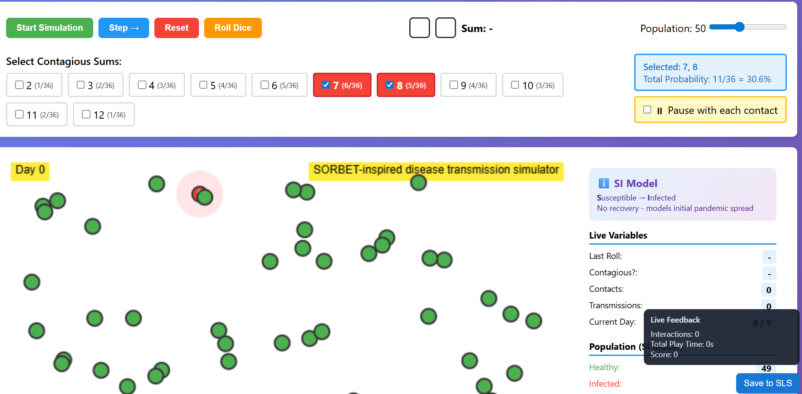
Activity: Simulation
Set a population for the closed environment.
Step 1. Uncheck all the contagious sum and pause with each contact.
Start Simulation. Observe the interaction and see that the number of infections remains one as the simulation has been set to have zero probability of infection.
Step 2. Select one contagious sum such as 7 and start simulation. Observe the interaction and see the number of infections.
Step 3. You may check pause with each contact to see how the disease is being transmitted.
Step 4. You may check more than one contagious sum (such as 7 and 8) to stimulate the transmission.

Making Sense of Our Data

Activity 1
- Discuss Thinking Questions
- Possibility Diagram
- Probability of Getting a Certain Sum
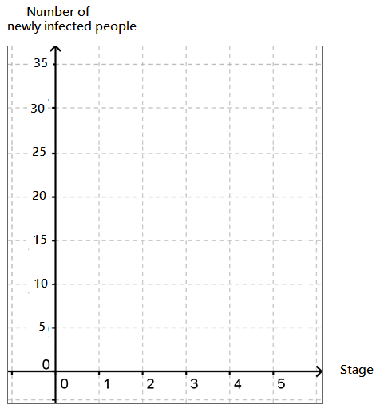
Total Number of Infected People

In your opinion, is the disease a highly contagious one? Explain your answer.

When you came into contact with a contagious person, did you always become infected?

Activity 2
A possibility diagram also known as sample space diagram shows all possible outcome of an event. Complete Table 1 below for throwing of two dice.
Table 1: Possibility Diagram
 | 1 | 2 | 3 | 4 | 5 | 6
1

2

3

4

5

6

Which sum is the most contagious?
Activity 3
The probability of an outcome is the likelihood of outcome in the event.
$Probability=\frac{Number of Favorable Outcomes}{Total Number of Outcomes}$
Complete Table 2 for the probability of getting a certain sum when throwing 2 dice.
Table 2: Probability of Getting a Certain Sum
Sum | Probability
2
3
4
5
6
7
8
9
10
11
12

Activity 4
Plotting the Total Number of Infected People over Time
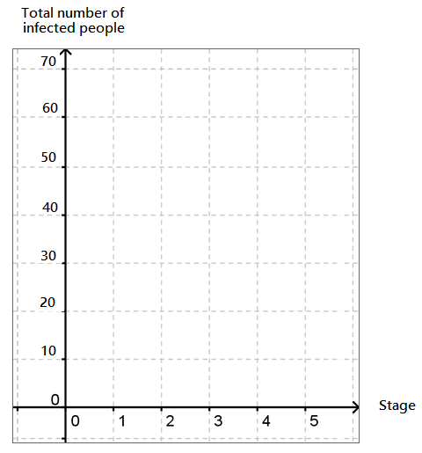
Select the contagious sum in the simulation application. Write down your selection

Contagious Sum = ________________

Make a copy of the graph in the simulation in the grid above.

Answer the following questions.

What do you think your graph will look like if there are more students over a longer period of time?

How should we represent the graphs?

Which graph will show the trend of the spread of disease better?

Activity 5
Reflection
Answer one or more of the following questions.
- Is the model good enough to explain the spread of a virus?
- What factors could contribute to the spread of a virus?
- What are some effective ways to reduce the spread of a virus?

