Name: _____________________________ ( ) Class: 22 / ______


ANDERSON SERANGOON JUNIOR COLLEGE

2022 JC2 Preliminary Examination

PHYSICS Higher 1 8867/02

Paper 2 Structured Questions Thursday 15 September 2022

2 hours
Candidates answer on the Question Paper.
No Additional Materials are required.

READ THESE INSTRUCTIONS FIRST

Write your name, class index number and class in the spaces provided above.
Write in dark blue or black pen on both sides of the paper.
You may use an HB pencil for any diagrams, graphs or rough working.
Do not use staples, paper clips, glue or correction fluid.

The use of an approved scientific calculator is expected, where appropriate.
For Examiner’s Use
Paper 1 (30 marks)
Paper 2 (80 marks)
1 | / 8
2 | / 8
3 | / 10
4 | / 6
5 | / 14
6 | / 14
7 | / 20
8 | / 20
Deductions
Total for Paper 2 (80 marks)

Section A
Answer all questions.

Section B
Answer any one question.

At the end of the examination, fasten all your work securely together.
The number of marks is given in brackets [ ] at the end of each question or part question.
This document consists of 24 printed pages and 0 blank page.
Data

speed of light in free space, c = 3.00 × 10⁸ m s⁻¹

elementary charge, e = 1.60 × 10⁻¹⁹ C

unified atomic mass constant, u = 1.66 × 10⁻²⁷ kg

rest mass of electron, m_{e} = 9.11 × 10⁻³¹ kg

rest mass of proton, m_{p} = 1.67 × 10⁻²⁷ kg

the Avogadro constant N_{A} = 6.02 × 10²³ mol⁻¹

gravitational constant G = 6.67 × 10⁻¹¹ N m² kg⁻²

acceleration of free fall, g = 9.81 m s⁻²

Formulae
uniformly accelerated motion, s = ut + $\frac{1}{2}$ at²
v² = u² + 2as

resistors in series, R = R₁ + R₂ + …

resistors in parallel, 1/R = 1/R₁ + 1/R₂ + …

Section A

Answer all the questions in this section.

1 | (a) | Define acceleration.  ………………………………………………………………………………………………..…………………………………………………………………………………………………....….. [1]

 | (b) | A ball is kicked from horizontal ground towards the top of a vertical wall, as shown in Fig. 1.1.  path of ball  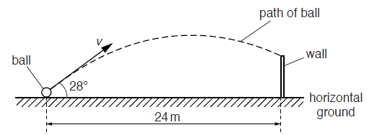  24 m  horizontal ground  28°  wall  ball  Fig. 1.1 (not to scale)  The horizontal distance between the initial position of the ball and the base of the wall is 24 m. The ball is kicked with an initial velocity v at an angle of 28° to the horizontal. The ball hits the top of the wall after a time of 1.5 s. Air resistance may be assumed to be negligible.

 |  | (i) | Calculate the initial horizontal and vertical components v_{x} and v_{y} of the velocity of the ball.  v_{x} = ……….……………………. m s^{–1}  v_{y} = …………………………. m s^{–1} [3]

 |  | (ii) | Calculate the time taken for the ball to reach its maximum height above the ground.  time = …………………………………………. s [2]
 |  | (iii) | The ball is kicked at time t = 0. On Fig. 1.2, sketch the variation with time t of the vertical component v_{y} of the velocity of the ball until it hits the wall. It may be assumed that velocity is positive when in the upwards direction. [2]  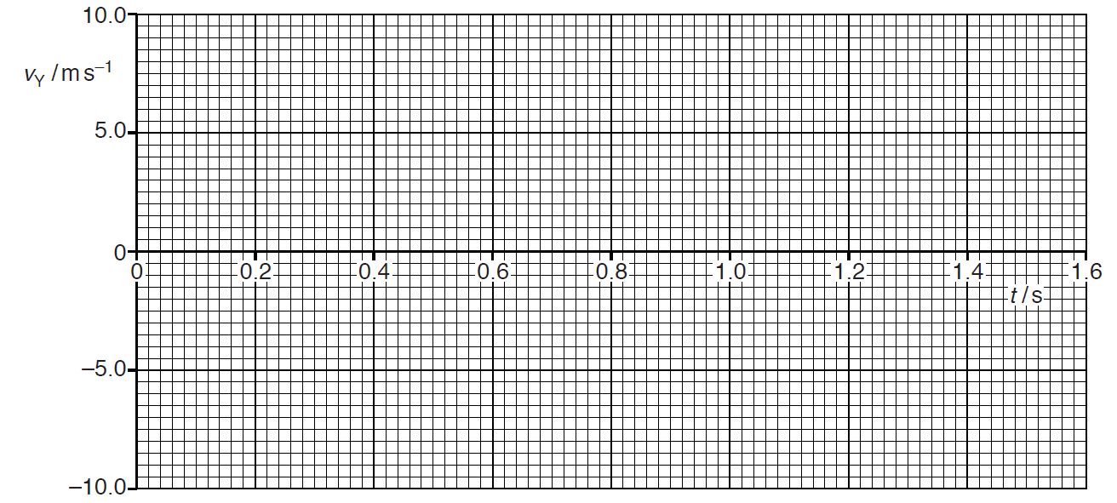  Fig. 1.2
[Total: 8]

2 | (a) | Explain what is meant by equilibrium when used in the context of forces.  …………………………………………………………………………………………….………..  ………………………………………………………………………………………….…………..  …………………………………………………………………………………………….......... [2]

 | (b) |  | Fig. 2.1 is a diagram of a human arm lifting an object.  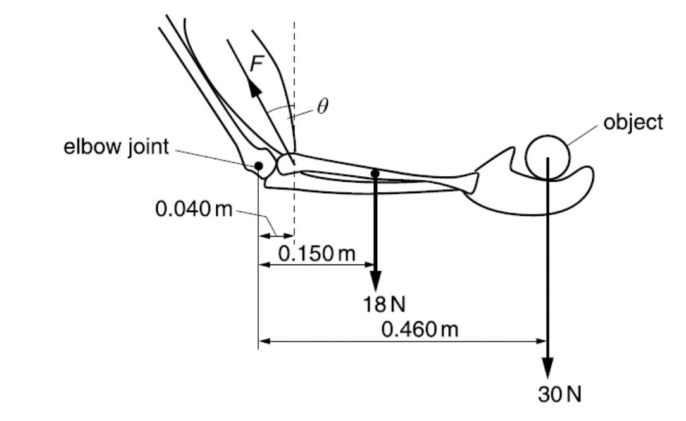  Fig. 2.1 (not to scale)  The lower arm is horizontal and its centre of gravity is 0.150 m from the elbow joint. The weight of the lower arm is 18 N. The bicep muscle exerts a force F at an angle of θ to the vertical.  The horizontal distance between the elbow joint and the point of attachment of the muscle to the lower arm bone is 0.040 m. The weight of the object held in the hand is 30 N and its centre of gravity is 0.460 m from the elbow joint. The arm is in equilibrium.
 |  | (i) |  | Determine the value of F when θ = 15º.  F = …………………………….N [2]

 |  | (ii) | For the lower arm to be in equilibrium, the elbow joint also needs to exert a force R on the lower arm bone.

 |  |  | 1. | Draw a labelled arrow on Fig. 2.1 to represent the force R that the elbow exerts on the lower arm. [1]

 |  |  | 2. | Explain the direction of this force R.
…………………………………………………………………………………....................

…………………………………………………………………………………....................

……………………………………………………………………………….………….... [2]

 |  | (iii) | State how F varies as θ increases.  ……………………………………………………………………………….………….... [1]

[Total: 8]

3 | A stone of weight 3.0 N is fixed, using glue, to one end P of a rigid rod CP, as shown in Fig. 3.1.  C  stone,  weight 3.0 N  glue  75 cm  P  0.13 m s⁻¹  Fig. 3.1  The rod is made to rotate about end C so that the stone moves in a vertical circle of radius 75 cm at constant speed of 0.13 m s⁻¹.
 |  |  | (a) | Calculate the centripetal acceleration of the stone.  centripetal acceleration = …………………………….m s⁻² [2]
 |  | (b) |  | Explain why work has to be done for the stone to move from the position where it is vertically above point C to the position where it is vertically below point C.  …………………………………………………………………………………………….………..  …………………………………………………………………………………………….………..  ………………………………………………………………………………………….…………..  …………………………………………………………………………………………….......... [2]
 |  | (c) |  | Determine the work done on the stone for the motion described in (b).  work done on stone = ……………………………. J [2]
 |  |  | (d) | The angular speed ω of the rod and stone is then gradually increased until the glue snaps. The glue fixing the stone snaps when the tension in it is 18 N.  For the position of the stone at which the glue snaps,
 |  |  |  | (i) | on the dotted circle of Fig. 3.1, mark with the letter X the position of the stone, [1]
 |  |  |  | (ii) | determine the angular speed ω of the stone.  ω = ……………………………. rad s⁻¹ [3]
 |  |  |  | [Total: 10]

4 | The Earth may be considered to be a sphere of radius 6.4 × 10⁶ m with its mass concentrated at its centre.  A satellite is to be launched from the Equator and put into geostationary orbit.
 |  | (a) | The gravitational field strength g at a distance r from a point mass M is given by  Given that g at the Earth’s surface is 9.8 N kg⁻¹, show that the mass of the Earth is 6.0 × 10²⁴ kg.  [2]
 |  | (b) | Calculate the height of the satellite above the Earth’s surface. Explain your working.  height of satellite = …………………………….m [3]
 |  | (c) | Suggest one advantage of launching satellites from the Equator in the direction of rotation of the Earth.  ………………………………………………………………………………………….…………..  …………………………………………………………………………………………….......... [1]
 |  |  | [Total: 6]
5 |  | (a) | A battery of electromotive force (e.m.f.) 12 V and negligible internal resistance is connected to a network of two lamps and two resistors, as shown in Fig. 5.1.  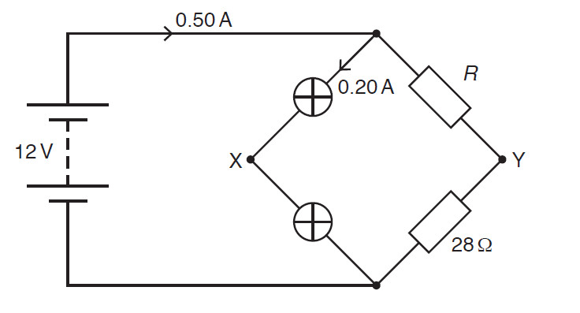  0.50 A  14 Ω  12 V  16 Ω  Fig. 5.1  The two lamps in the circuit have equal resistances. The two resistors have resistance 14 Ω and 16 Ω. The lamps are connected at junction X and the resistors are connected at junction Y. The current in the battery is 0.50 A.

 |  | (i) | Calculate the potential difference across the 16 Ω resistor.  potential difference = …………………………….V [2]

 |  | (ii) | 1. | Determine the potential difference between points X and Y.  potential difference = …………………………….V [1]

 |  |  | 2. | State whether point X or Y is at a higher potential.
 |  |  | ……………………………………………………………………………….………….... [1]

 |  | (iii) | Show that the current in the lamps is 0.10 A.  [1]
 |  | (iv) | Calculate the ratio  total power dissipated by the lamps  .  total power produced by the battery  ratio = ………………………………[2]

 |  | (v) | The 14 Ω is replaced by another resistor of higher resistance.  State and explain the effect, if any, of this change on the ratio in (a)(iv).  ……………………………………………………………………………………………….  ………………………………………………………………………………………………  ………………………………………………………………………………………………  …………………………………………………………………………………………… [2]

 | (b) | A variable resistor of resistance R is connected to a cell with an internal resistance r.  For each value of R, the potential difference V across the variable resistor is measured, the current through the variable resistor is measured two times and the average current I_{ave} is determined. Table 5.1 shows the data recorded.  Table 5.1
  R / kΩ | V / V | I₁ / mA | I₂ / mA | I_{ave} / mA
  1 | 3.00 | 3.00 | 3.02 | 3.01
  2 | 4.82 | 2.40 | 2.42 | 2.41
  3 | 6.00 | 2.00 | 2.00 | 2.00
  4 | 6.87 | 1.70 | 1.74
  6 | 8.01 | 1.34 | 1.34 | 1.34
  8 | 8.72 | 1.08 | 1.10 | 1.09
  10 | 9.22 | 0.93 | 0.91 | 0.92
  12 | 9.61 | 0.80 | 0.80 | 0.80
  14 | 9.89 | 0.73 | 0.69 | 0.71

 |  | (i) | Complete Table 5.1. [1]
 |  | (ii) | Show that the power P dissipated in the variable resistor when its resistance is 3 kΩ is 12 mW.  [1]

 |  | (iii) | The power dissipated in the variable resistor is P. Information from Table 5.1 is used to plot data points on a P against R grid.    Use your answer from (b)(ii) to complete Fig 5.2 and add a line of best fit. [2]  0  2  4  5.0  7.0  11.0  13.0  9.0  6  P / mW  8  10  12  14  R / kΩ  Fig. 5.2

 |  | (iv) | In theory, the power delivered to the variable resistor is maximum when the resistance of the variable resistor is equal to the internal resistance of the cell.  Use Fig. 5.2 to determine the value of r.  r = …………..…………..kΩ [1]

[Total: 14]

6 | (a) | State what is meant by a magnetic field.  ……………………………………………………………………………………..………….…….  ……………………………………………………………………………………………..….…….  ………………………………………………………………………………………….………..….  ………………………………………………………………………………………….……….. [2]
 | (b) | Fig. 6.1 shows the top view of two current carrying wires. The current flowing in both the wires are the same.  Fig. 6.1  On Fig. 6.1, sketch the pattern of the magnetic field. [3]

 | (c) | A charged particle of mass m and charge +q is travelling with velocity v in a vacuum. It enters a region of uniform magnetic field of flux density B, as shown in Fig. 6.2.  region of magnetic field  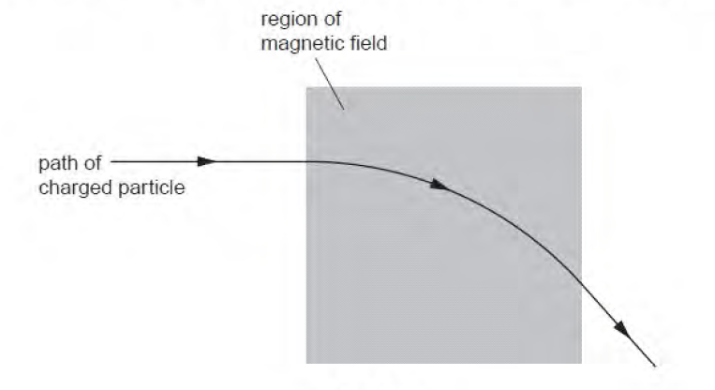  path of charged particle  Fig. 6.2  The magnetic field is normal to the direction of motion of the particle. The path of the particle in the field is the arc of a circle of radius r.

 |  | (i) | Explain why the path of the particle in the field is the arc of a circle.  ……………………………………………………………………………………………..…  ………………………………………………………………………………………….……  ………………………………………………………………………………………….……  ……………………………………………………………………………….…………….[2]

 |  | (ii) | State the direction of the magnetic field.  ………………………………………………………………………………………….….[1]

 |  | (iii) | Show that the radius r is given by the expression  r = $\frac{\text{mv}}{\text{Bq}}$.  [2]

 |  | (iv) |  | A charged particle of mass m, charge −q and velocity ½ v enters the uniform magnetic field in Fig. 6.2 at the same entry point. Sketch on Fig. 6.2 the path of this charged particle after it enters the uniform magnetic field. [1]
 | (d) |  | A thin metal foil is placed in a magnetic field.  A negatively charged particle enters the region of the magnetic field. It loses kinetic energy as it passes through the foil. The particle follows the path shown in Fig. 6.3.  foil  region of uniform magnetic field  Fig. 6.3
 |  |  | (i) |  | On Fig. 6.3, mark with an arrow the direction of travel of the particle. [1]
 |  | (ii) |  | The path of the particle has different radii on each side of the foil. The radii are 7.4 cm and 5.7 cm.  Determine the ratio $\frac{\text{final momentum of particle}}{\text{initial momentum of particle}}$ for the particle as it passes through the foil.  ratio = …………………………….[2]

[Total: 14]

Section B

Answer one question in this section.

7 | (a) | State Newton’s second law of motion.  …………………………………………………………………………………………….………..  ………………………………………………………………………………………….…………..  …………………………………………………………………………………………….......... [2]

 | (b) | Two objects X and Y are attached together by a rope of negligible mass over a frictionless pulley in Fig. 7.1.  5.0 m  X  Y  ground  frictionless pulley  Fig. 7.1  The mass of object X is greater than the mass of object Y. Object Y is held on the ground and object X is at a vertical height of 5.0 m above the ground. Object Y is released. Air resistance is negligible.

 |  | (i) | Explain why the acceleration of object X is less than the acceleration of free fall g.  …………………………………………………………………………………....................  …………………………………………………………………………………....................  ……………………………………………………………………………….………….... [1]

 |  | (ii) | Show that the acceleration of object Y is given by the relation  where m_{X} is the mass of object X, m_{Y} is the mass of object Y, and g is the acceleration of free fall.  [3]

 |  | (iii) | The mass of object X is 6.0 kg and the mass of object Y is 3.0 kg. Calculate the time taken by object X to reach the ground.  time taken = ……………………………. s [2]

 | (c) | Use Newton’s Laws to deduce the principle of conservation of momentum.  [3]

 | (d) | Fig. 7.2 shows the variation with time of momentum for two colliding bodies P and Q.    time / ms  0  100  200  300  400  500  0  momentum / kg m s⁻¹  10  20  30  P  Q  Fig. 7.2  The mass of bodies P and Q are 2.0 kg and 4.0 kg respectively.

 |  | (i) | Explain why the gradients of the graphs during collision have opposite sign.  …………………………………………………………………………………....................  …………………………………………………………………………………....................  ……………………………………………………………………………….………….... [1]

 |  | (ii) | State the condition under which the momentum is conserved.  …………………………………………………………………………………....................  ……………………………………………………………………………….………….... [1]

 |  | (iii) | Show that the momentum is conserved when the two bodies collide.  [1]

 |  | (iv) | Calculate the magnitude of the force acting on body P during the collision.  force = …………………………….N [2]

 |  | (v) | Calculate the magnitude of the impulse on body Q during the collision.  impulse = …………………………….N s [1]

 |  | (vi) | By considering quantitively the relative speeds of approach and of separation of the two bodies, deduce whether the collision is elastic, inelastic or perfectly inelastic.  type of collision……………………………………[3]  [Total: 20]

8 | (a) | State and explain the results of the α−particle scattering experiment that suggest the small size of the nucleus compared to that of an atom.  1. ...………………………………………………………………………………………………….  …………………………………………………………………………………………………........  2. ...………………………………………………………………………………………………….  ………………………………………………………………………………………………......[2]
 | (b) | State what is meant by nuclear fission.  ..…………………………………………………………………………………………………….  ……………………………………………………………………………………………………[1]

 | (c) | When an α−particle bombards a stationary nitrogen−14 nucleus, the following nuclear reaction may occur.  The rest masses of the nuclei and other particles are
  Nucleus or particle | mass / u
   | 14.007525
   | 4.003860
   | 17.004507
   | 1.008142
   | 1.008664
   | 1.007276

 |  | (i) | Determine the binding energy per nucleon of .  binding energy per nucleon = ……………………… J [3]
 |  | (ii) | Oxygen−17 has a binding energy per nucleon of 1.24 x 10⁻¹² J. Explain why oxygen−17 is more stable than nitrogen−14.  ..……………………………………………………………………………………………..  ……………………………………………………………………………………………..[1]

 |  | (iii) | Show that the energy associated with the change in mass in this reaction is approximately 1.9 x 10⁻¹³ J.  [3]

 |  | (iv) | By reference to energy, suggest how it is possible for this reaction to occur.  ..……………………………………………………………………………………………..  ..……………………………………………………………………………………………..  ……………………………………………………………………………………………..[2]

 |  | (v) | The oxygen−17 nucleus and the hydrogen nucleus move apart after the reaction.

 |  |  | 1. | Explain why the oxygen−17 nucleus and the hydrogen nucleus move after the reaction.
…………………………………………………………………………………....................

…………………………………………………………………………………....................

……………………………………………………………………………….………….... [1]

 |  |  | 2. | Describe the effect of this movement on your answer in (c)(iv).
…………………………………………………………………………………....................

…………………………………………………………………………………....................

……………………………………………………………………………….………….... [1]

 | (d) | Radioactive decay is a random and a spontaneous process.  Explain what is meant by  - random decay,  ..……………………………………………………………………………………………………..  …………………………………………………………………………………………………....[1]  - a spontaneous process.  ..……………………………………………………………………………………………………..  …………………………………………………………………………………………………....[1]

 | (e) | Lathanum−140 is a radioactive nuclei that decays to form a stable product of cerium−140.  The decay is represented by the following equation.  where D is a particle emitted during the decay.

 |  | (i) | State the nuclear notation for D.  [1]

 | (ii) | A fresh sample of radioactive material contains N₀ nuclei of lathanum−140 and no cerium−140.  Lathanum−140 has a half-life of 40 hours.  Sketch on Fig. 8.1, the graphs which show the variation with time t of the number N of nuclei in the sample which are lathanum−140 and cerium−140 for t = 0 to t = 120 hours. Label the graph of lathanum as L and the graph of cerium as C.  N  t / hours  0  N₀  120  80  40  Fig. 8.1  [3]

[Total: 20]

