Name: _____________________________ ( ) Class: 22 / ______


ANDERSON SERANGOON JUNIOR COLLEGE

2022 JC2 Preliminary Examination

PHYSICS Higher 1 8867/01

Paper 1 Multiple Choice Tuesday 20 September 2022

1 hour
Additional Materials: Multiple Choice Answer Sheet

READ THESE INSTRUCTIONS FIRST

Write in soft pencil.
Do not use staples, paper clips, glue or correction fluid.
Write your name and class on the Multiple Choice Answer Sheet.
Shade and write your NRIC/FIN.

There are thirty questions on this paper. Answer all questions. For each question there are four possible answers A, B, C and D.
Choose the one you consider correct and record your choice in soft pencil on the separate Multiple Choice Answer Sheet.

Read the instructions on the Multiple Choice Answer Sheet very carefully.

Each correct answer will score one mark. A mark will not be deducted for a wrong answer.
Any rough working should be done in this question paper.
The use of an approved scientific calculator is expected, where appropriate.

This document consists of 18 printed pages and 2 blank pages.
Data

speed of light in free space, c = 3.00 × 10⁸ m s⁻¹

elementary charge, e = 1.60 × 10⁻¹⁹ C

unified atomic mass constant, u = 1.66 × 10⁻²⁷ kg

rest mass of electron, m_{e} = 9.11 × 10⁻³¹ kg

rest mass of proton, m_{p} = 1.67 × 10⁻²⁷ kg

the Avogadro constant N_{A} = 6.02 × 10²³ mol⁻¹

gravitational constant G = 6.67 × 10⁻¹¹ N m² kg⁻²

acceleration of free fall, g = 9.81 m s⁻²

Formulae
uniformly accelerated motion, s = ut + $\frac{1}{2}$ at²
v² = u² + 2as

resistors in series, R = R₁ + R₂ + …

resistors in parallel, 1/R = 1/R₁ + 1/R₂ + …

1 | The prefixes nano (n), micro (µ) and pico (p) are often used with units.  Which row shows their correct values?
   | n | µ | p
  A | 10^{–6} | 10^{–9} | 10^{–12}
  B | 10^{–6} | 10^{–12} | 10^{–9}
  C | 10^{–9} | 10^{–6} | 10^{–12}
  D | 10^{–12} | 10^{–9} | 10^{–6}

2 | The SI unit of specific heat capacity is J kg^{–1} K^{–1}.  What is the unit of specific heat capacity expressed in SI base units?
 | A m s^{–2} K^{–1} | B m² s^{–2} K^{–1} | C kg m s^{–1} K^{–1} | D kg m² s^{–1} K^{–1}

3 | Quantity X has a fractional uncertainty of x. Quantity Y has a fractional uncertainty of y.  What is the fractional uncertainty in ?
 | A x + 2y | B x – 2y | C 3x + 2y | D 3x – 2y

4 | An object has an initial velocity u and an acceleration a. The object moves in a straight line through a displacement s and has final velocity v.  The above quantities are related by the equation shown.  v² = u² + 2as  Which condition must be satisfied in order for this equation to apply to the motion of the object?  A The direction of a is constant and the direction of a is the same as the direction of s.  B The direction of a is constant and the direction of a is the same as the direction of u.  C The magnitude of a is constant and the direction of a is the same as the direction of v.  D The magnitude of a is constant and the direction of a is constant.

5 | A car is travelling at constant velocity. Its brakes are then applied, causing uniform deceleration.  Which graph shows the variation with distance s of the velocity v of the car?
 | A  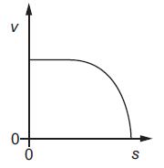 | B  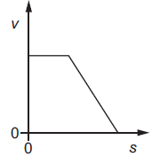 | C  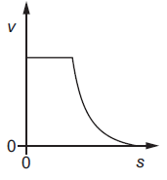 | 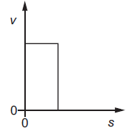  D

6 | An object falls freely from rest in a vacuum. The graph shows the variation with time t of the velocity v of the object.  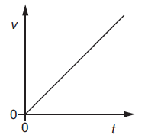  Which graph, using the same scales, represents the object falling in air?  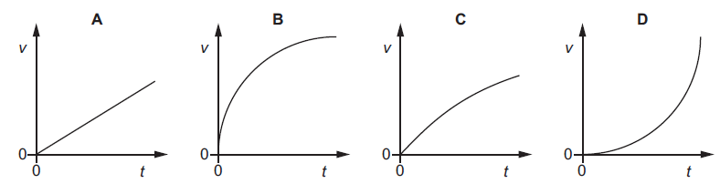

7 | In the train, there are hanging grips for passengers to hold on to when they are standing as shown below.  direction of travel  grips  train  Which of the following shows the position of the hanging grip when the train is travelling with constant velocity and when it is decelerating?
   | moving at constant velocity | decelerating
  A
  B
  C
  D

8 | A ball strikes a horizontal surface with momentum p at an angle θ to the surface, as shown.  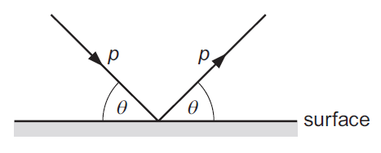  The ball rebounds with the same magnitude of momentum at an angle θ to the surface.  The ball is in contact with the surface for time t.  What is the magnitude of the average resultant force acting on the ball during the collision?

9 | Two spheres A and B approach each other along the same straight line with speeds u_{A} and u_{B}. The spheres collide and move off with speeds v_{A} and v_{B}, both in the same direction as the initial direction of sphere A, as shown below.  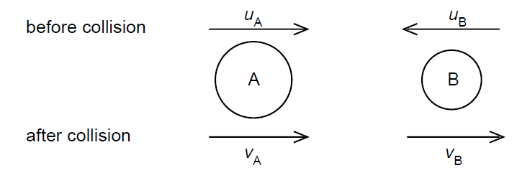  before collision  after collision  Which equation applies to an elastic collision?  A u_{A} + u_{B} = v_{B} – v_{A}  B u_{A} – u_{B} = v_{B} – v_{A}  C u_{A} – u_{B} = v_{B} + v_{A}  D u_{A} + u_{B} = v_{B} + v_{A}

10 | The graph shows the effect of applying a force of up to 5.0 N to a spring.  14  11  0  5.0  force / N  10  spring length / cm  The spring obeys Hooke’s Law for forces up to 7.0 N  What is the total extension of the spring produced by a 7.0 N force?
 | A 4.2 cm | B 5.6 cm | C 15 cm | D 20 cm

11 | A student pulls a book from a shelf by its top corner, holding it between his forefinger and thumb. The book is uniform and has weight W and dimensions x and y as shown.  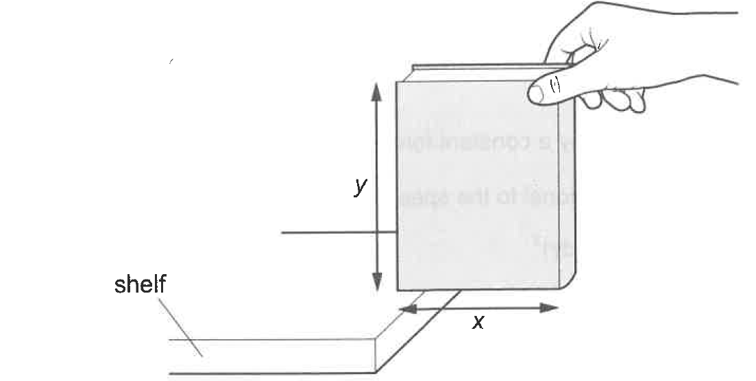  x  y  What moment must the student provide at the corner of the book to stop it from rotating just before it leaves the shelf?  A anticlockwise  B anticlockwise  C clockwise  D clockwise

12 | A heavy ball hanging from a cable is held in equilibrium by a chain, as shown.  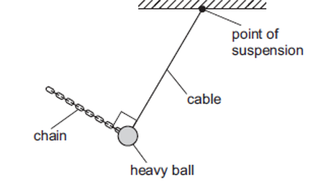  point of suspension  cable  chain  heavy ball  Which vector diagram shows the three forces acting on the ball?
 | 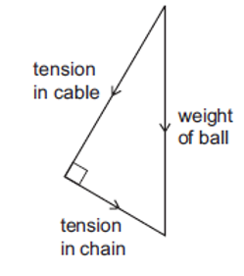  A  tension in cable  weight of ball  tension in chain | 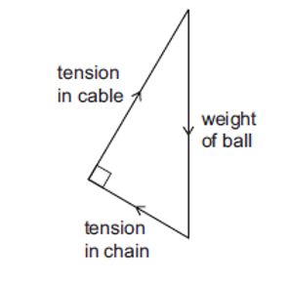  B  tension in chain  tension in cable  weight of ball
 | 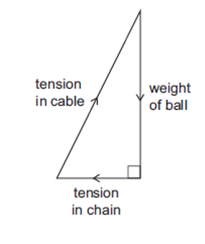  C  tension in cable  weight of ball  tension in chain | D  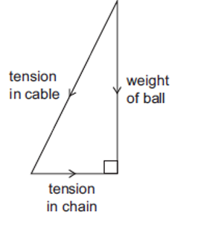  weight of ball  tension in cable  tension in chain

13 | Two masses of 2.0 kg and 5.0 kg are connected by a light string that passes over a smooth pulley and initially held in place as shown.  5.0 kg  2.0 kg  30°  When released, the 2.0 kg mass experiences a constant frictional force of 12 N as it moves up the slope.  What is the total kinetic energy of the masses when the 2.0 kg mass has travelled 1.5 m along the slope?
 | A 26 J | B 30 J | C 41 J | D 55 J

14 | A car of mass 1400 kg is travelling on a straight, horizontal road at a constant speed of 25 m s⁻¹. The useful output power from the car’s engine is 30 kW.  The car then travels up a slope of 3.0° to the horizontal, maintaining the same constant speed.  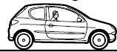  1400 kg  25 m s⁻¹  25 m s⁻¹  3.0°  What is the useful output power of the car’s engine when travelling up the slope?
 | A 18 kW | B 30 kW | C 32 kW | D 48 kW

15 | A speed boat with two engines, each of power output 36 kW, can travel at a maximum speed of 12 m s⁻¹. The total drag D on the boat is related to the speed v of the boat by the equation  D ∝ v².  What is the maximum speed of the boat when only one engine is working?
 | A 3.0 m s⁻¹ | B 6.0 m s⁻¹ | C 8.5 m s⁻¹ | D 9.5 m s⁻¹

16 | A bead is released along a slope and enters a vertical circle of diameter 40 cm with a speed v, as shown.  40 cm  v  bead  Air resistance and friction on the slope are negligible.  What is minimum speed v that the bead must have for it to complete the vertical circle?
 | A 1.4 m s⁻¹ | B 2.4 m s⁻¹ | C 3.1 m s⁻¹ | D 3.4 m s⁻¹

17 | Titan, the largest moon of Saturn, has a circular orbit with radius 1.22 × 10⁶ km. Its centripetal acceleration is 2.55 × 10⁻² m s⁻².  What is the orbital period of Titan?
 | A 1.13 × 10⁻³ s | B 4.35 × 10⁴ s | C 1.37 × 10⁶ s | D 3.01 × 10¹¹ s

18 | On a normal day, the frictional force between the road and the tyres of a car is F. The maximum speed that the car can travel around a bend on a horizontal road without skidding is v.  The frictional force between the road and tyres is reduced by 40 % on a rainy day.  What is the maximum speed that the car can travel around the same bend without skidding on a rainy day?
 | A 0.77 v | B 0.63 v | C 0.36 v | D 0.16 v

19 | A circuit contains two resistors, P and Q, and a power supply of negligible internal resistance, as shown.  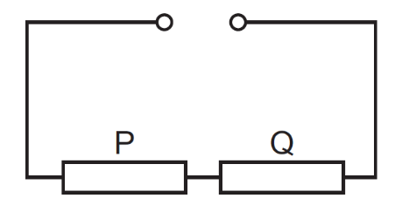  The current in resistor P is 2.0 A and the power dissipated by resistor P is 18 W. Resistor Q dissipates 240 J of energy when a charge of 40 C passes through it.  What is the electromotive force (e.m.f.) of the power supply?
 | A 3.0 V | B 6.0 V | C 9.0 V | D 15 V

20 | The electromotive force (e.m.f.) of a cell is 6.0 V. It has negligible internal resistance and is connected across a resistor. The potential difference (p.d.) across the resistor is also 6.0 V.  The e.m.f. and the p.d. have the same numerical value but represent different processes.  Which statement about the different processes is correct?
  A | The e.m.f. is the energy transferred from chemical energy to electrical energy in the cell and the p.d. is the energy transferred from electrical energy to thermal energy in the resistor.
  B | The e.m.f. is the energy transferred per unit charge from chemical energy to electrical energy in the cell and the p.d. is the energy transferred per unit charge from electrical energy to thermal energy in the resistor.
  C | The p.d. is the energy transferred from chemical energy to electrical energy in the cell and the e.m.f. is the energy transferred from electrical energy to thermal energy in the resistor.
  D | The p.d. is the energy transferred per unit charge from chemical energy to electrical energy in the cell and the e.m.f. is the energy transferred per unit charge from electrical energy to thermal energy in the resistor.

21 | The graphs show the variation with potential difference V of the current I for three circuit components.  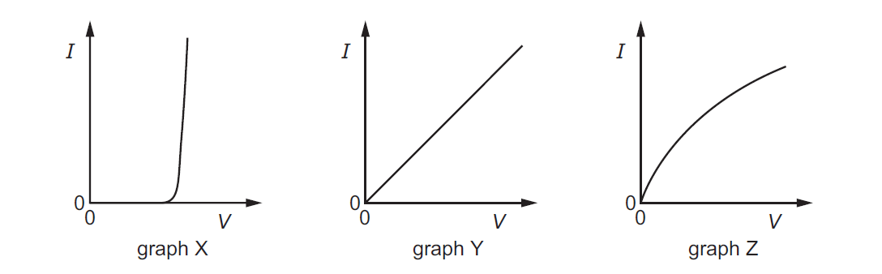  graph Z  graph Y  graph X  The components are a metal wire at constant temperature, a semiconductor diode and a filament lamp.  Which row correctly identifies these graphs?
   | metal wire at constant temperature | semiconductor diode | filament lamp
  A | X | Z | Y
  B | Y | X | Z
  C | Y | Z | X
  D | Z | X | Y

22 | A metal cube has a resistance of 4.0 Ω between opposite faces.  Ten of these cubes are put together to make a cuboid of 1 × 2 × 5 cubes.  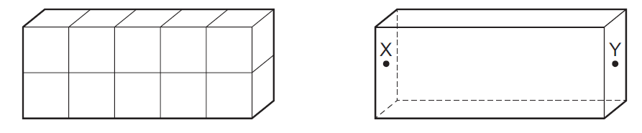  There is no extra resistance where the faces of the cubes touch each other.  What is the resistance of the cuboid when connected between faces X and Y?
 | A 1.6 Ω | B 2.0 Ω | C 10 Ω | D 40 Ω

23 | A thermistor and another component are connected to a constant voltage supply. A voltmeter is connected across one of the components. The temperature of the thermistor is then reduced but no other changes are made.  In which circuit will the voltmeter reading increase?
 | 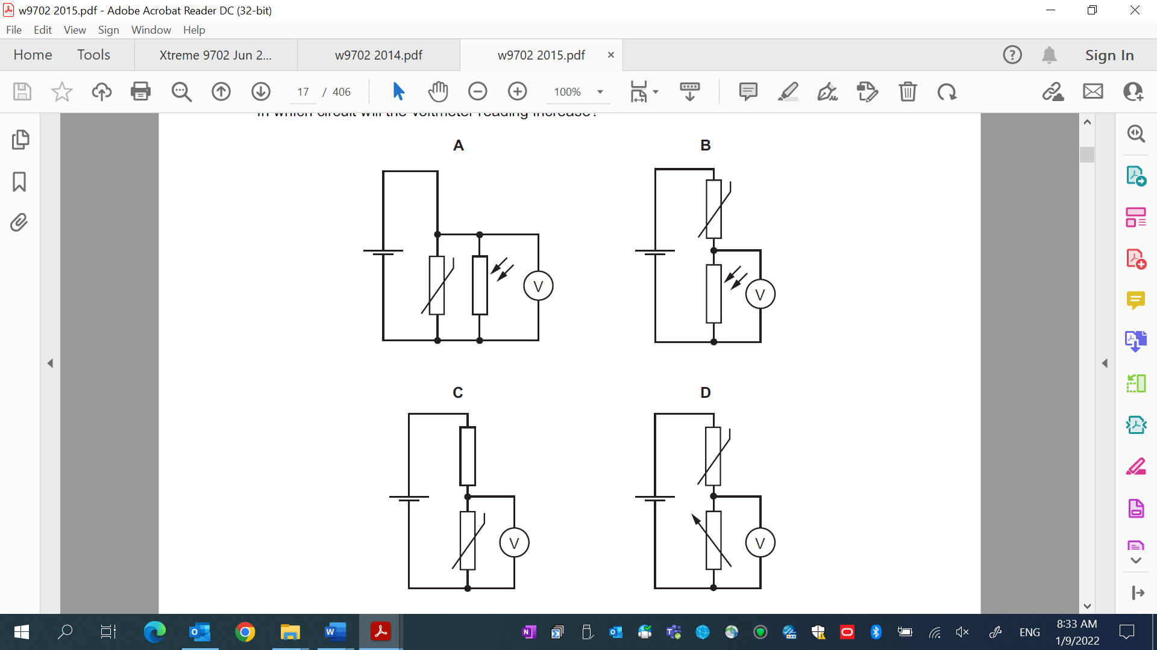  A | B
 | C | D

24 | The figure below shows a circuit that comprises a battery, 3 resistors, an ideal voltmeter and an ammeter. The e.m.f. of the battery is E.  E  R₂  R₃  I ₂  I₃  I₄  R₁  V  A  I ₁  Which of the following shows the correct expression for the voltmeter reading and ammeter reading?
   | ammeter reading / A | voltmeter reading / V
  A | I₁ | I ₄R₃ + I ₃ R₂
  B | I₃ + I₄ | E
  C | I₂ | E − I₄R₃
  D | I₁ + I₃ | I₂R₁
25 | A 15.0 V battery, having an internal resistance of 25 Ω, is connected to a voltmeter, 2 identical fixed resistors and a variable resistor in the following arrangement. The variable resistor has the range indicated and the voltmeter has an infinite resistance.  25 Ω  15.0 V  0 – 50 Ω  50 Ω  50 Ω  V  What are the maximum and minimum values of the voltmeter reading as the variable resistor is altered?
   | maximum voltmeter reading / V | minimum voltmeter reading / V
  A | 6.0 | 4.3
  B | 6.0 | 5.0
  C | 10.0 | 6.0
  D | 10.0 | 7.5

26 | The diagram below shows a current balance used to determine the strength of a magnet. When the light frame is pivoted and the rider placed as seen in the diagram, the frame remains horizontal.  pivot  rider  current  X  Y  Which of the following shows the correct placement of the magnet relative to XY?
 | A  Y  N  X | B  Y  X  N
 | C  Y  N | D  Y  X  N

27 | A beam of electrons is directed into an electric field and is deflected by it.  Diagram 1 represents an electric field in the plane of the paper.  Diagram 2 represents an electric field directed perpendicular to the plane of the paper.  The lines A, B, C and D represent possible paths of the electron beam. All paths are in the plane of the paper.  Which line best represents the path of the electrons inside the field?  diagram 2  diagram 1  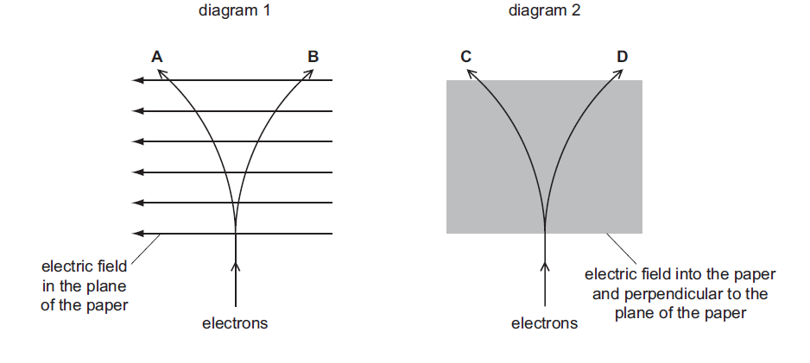  D  C  B  A  electric field into the paper and perpendicular to the plane of the paper  electrons  electrons  electric field in the plane of the paper

28 |  | 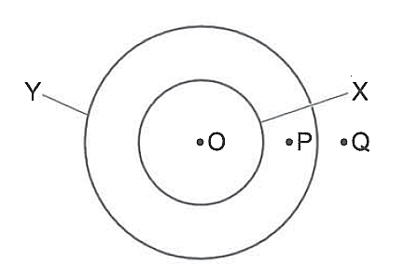  X and Y are two flat circular coils of wire lying on a table. O, P and Q are three points on the table. The diagram is a view from above the coils.  Initially there is a constant current in coil X and no current in coil Y.  A small current is now passed through coil Y, which decreases the magnitude of the magnetic flux density at point O.  How does the magnitude of the magnetic flux density change at points P and Q?
   | P | Q
  A | increases | decreases
  B | increases | increases
  C | decreases | decreases
  D | decreases | increases
29 |  | Two deuterium nuclei fuse together to form a Helium−3 nucleus, with the release of a neutron. The reaction is represented by  The binding energies per nucleon are:  How much energy is released in this reaction?
  for | 1.09 MeV,
  for | 2.54 MeV.
 | A 0.36 MeV |  | B 1.45 MeV | C 3.26 MeV | D 5.44 MeV

30 | Which quantity remains constant during β−emission from a nucleus?  A mass of nucleus  B neutron number of nucleus  C nucleon number of nucleus  D proton number of nucleus

BLANK PAGE

BLANK PAGE

