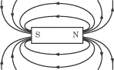

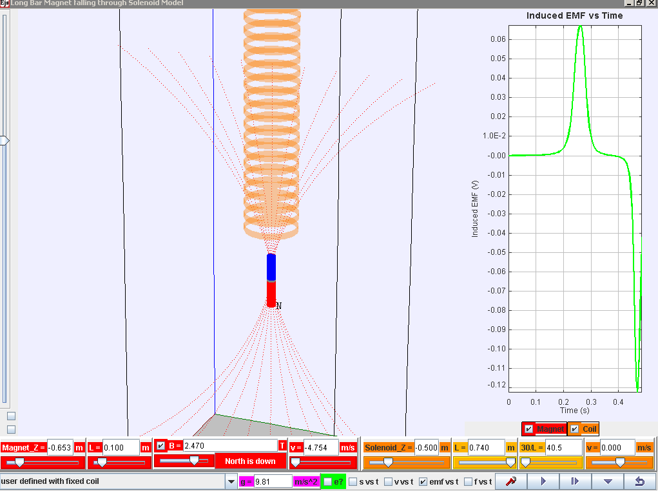
Menu for exploring other scenarios!
show motion of electrons in solenoid
various graphs!
Data analysis!! Really cool tool to help analyse voltage
N
N
reverse magnetic polarity
show magnetic field lines from magnet
Zoom!
view from bottom
vertical/horizontal
Play/pause, step, initialize (compare different runs) and reset
Control buttons
show graphs for magnet and/or coil (solenoid)

Download the simulation ejs_FallingMagnet10memory4.3.0.jar from the following link:
Latest version
https://dl.dropbox.com/u/44365627/lookangEJSworkspace/export/ejs_FallingMagnet10memory4.3.0.jar
Parameters (refer to bottom of the simulation) for exploration
Parameter / unit | Definition/Meaning
Magnet_Z / m | Initial vertical position (z-axis) of the magnet
L / m (in red for magnet) | Length of magnet
B / T | Maximum Magnetic Field Strength (in the core of the magnet)
v / m/s (in red for magnet) | Initial speed of magnet
Solenoid_Z / m | Initial vertical position (z-axis) of the solenoid
L / m (in orange for solenoid) | Length of the solenoid
30/L | This is meant to be number of turns per unit length. With fixed 30 turns set in the computer model.
v / m/s (in orange for solenoid) | Velocity of solenoid (for exploration of relative velocity. )
Engage:
Do you know that useful applications of electromagnetic induction (emi) includes the ability of traffic lights junctions to detect cars stopping at the road cross junction to change the traffic lights? More efficient car detection can be accomplished because of this physics phenomena.
Write down one example of application of emi that you like to share with your classmates.

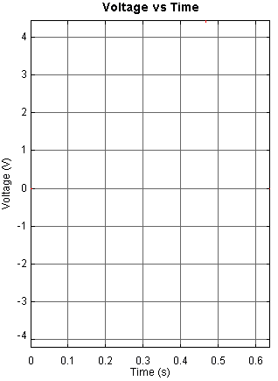
Electromagnetic Induction Inquiry Learning using ICT
When a magnet is moved in and out of a coil, an induced voltage emf is detected in the solenoid coil. Let us find out more about the factors that affect this induced voltage emf.
Let the magnet length be 0.10 m throughout the activities.
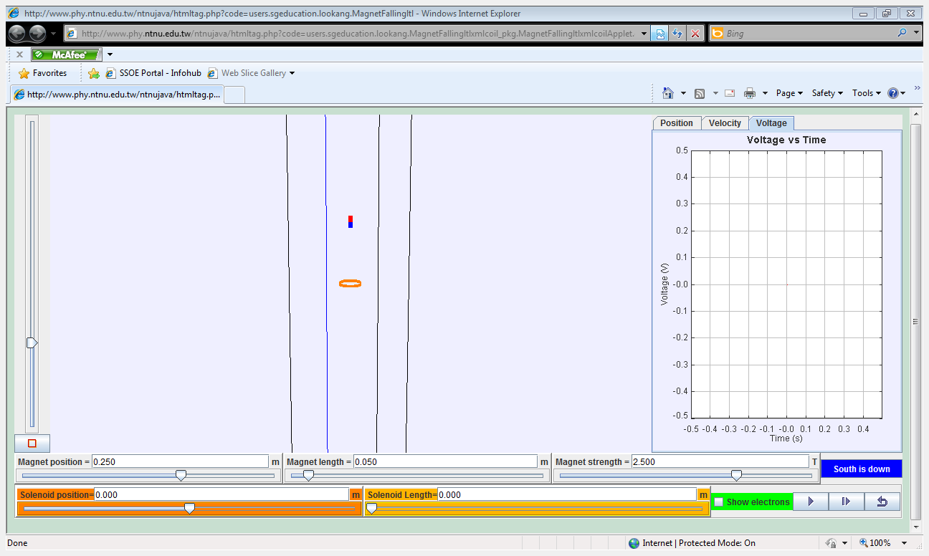
Activity 1 (effects of presence of magnetic field)
- Click (at the bottom right of the screen) to drop the magnet of strength 2.5 T.

- Sketch the voltage vs time graph as shown on the screen.
Label this graph 1.
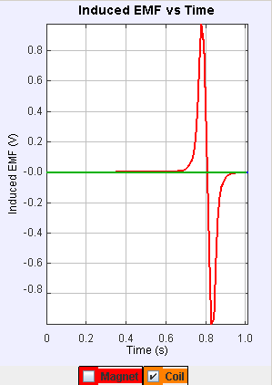
- Click to initialize the experiment so that different ‘runs’ of experiments can be compared on the graphs.

- Replace the magnet with a non-magnetic object by changing the magnet strength to zero.
Press the Enter key.
- Click to drop the non-magnetic object.

- Sketch the voltage vs time graph as shown on the screen.
Label this graph 2.

- The graph on the right should be close to what you have recorded. Suggest what this data-evidence means?

- Click reset to start brand new experiments.
Activity 2 (effects of different magnetic field strength)
    - Change the “magnet strength” to
5.0 T.
Press Enter.

    - Drop the magnet from the same height.
Click

    - Sketch the voltage vs time graph as shown on the screen.
Label this graph 3.

    - (i) using the data tool,  Compare the peak voltages of graph 1 (magnet strength = 2.5 T) and graph 3 (magnet strength = 5.0 T).

(ii) What can you conclude about the relationship between the “magnet strength” and the peak voltage?

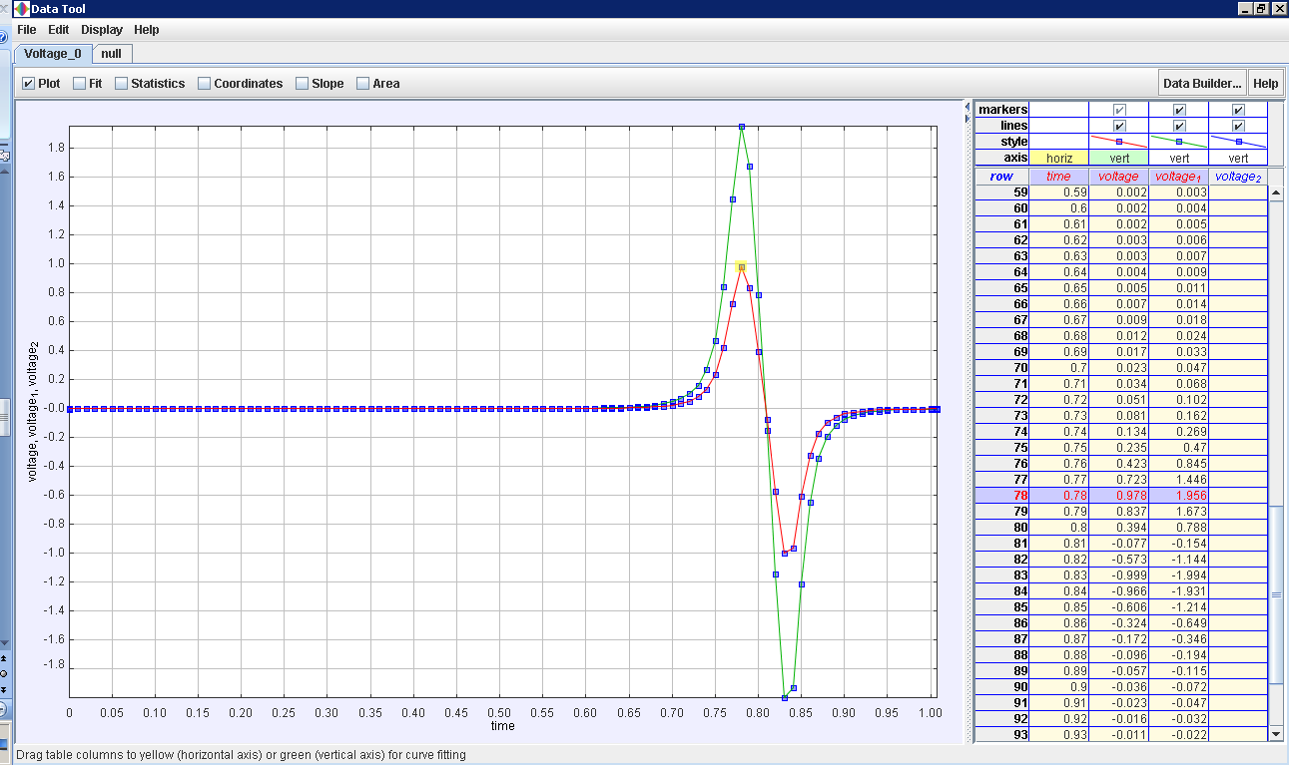
(e) Conduct a few more runs (example B = 7.5, 10, 12.5. 15 , 17,5 T etc) to verify and evaluate your conclusion in (d). Remember to reset  if you want to start the simulation as a brand new simulation or to proceed to next activity.

(f) Sketch your prediction of B = -2.5 T referencing the graph 1 ( B = 2.5T) and explain briefly the shape of this graph

(g) Conduct your own experiment to evaluate the correctness of your prediction. Explain what you got correct and what you came to understand after the data from your own experiment.

Activity 3 (effects of speed due to release height)
- Double the release height of the magnet to 0.500 m.
(Magnet position = 0.500 m)
Press Enter.

- Drop the magnet.
Click

- Sketch the voltage vs time graph as shown on the screen.
Label this graph 4.

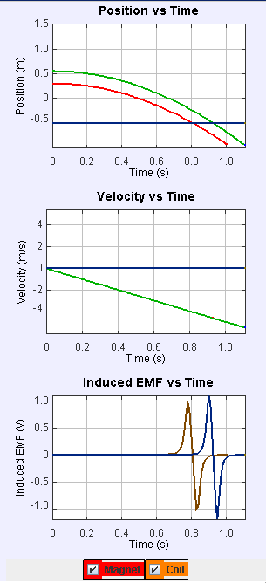
- Using the graphs or otherwise, explain how the release height affects the speed of entry of the magnet into the coil.

- (i) Using the data analysis tool, determine the 1st peak voltages of graph 3 (release height = 0.250 m) and graph 4 (release height = 0.500 m). hint: emf1= ( t = 0.78s ,0.978V) and emf2 = ( t = 0.90s ,1.104V)

(ii) What can you conclude about the relationship between the speed of entry and the peak voltage?

(e) Suggest with reason(s), why the peak emf entering and exiting the coil is unequal in magnitude. Hint: do try out different scenario to test your reason(s).

(g) Remember to reset if you want to start the simulation as a brand new simulation or to proceed to next activity

Activity 4 (effects of long solenoid)
- Increase the length of the solenoid to 1.0 m.
(Solenoid Length = 1.0 m)

- Position the solenoid at -0.500 m.
(Solenoid position = -0.500 m)

- Raise the magnet to a height of 1.00 m. zoom out to see new magnet Z.
(Magnet position = 1.00 m)

- Drop the magnet.
Click

- Sketch the voltage vs time graph as shown on the screen.

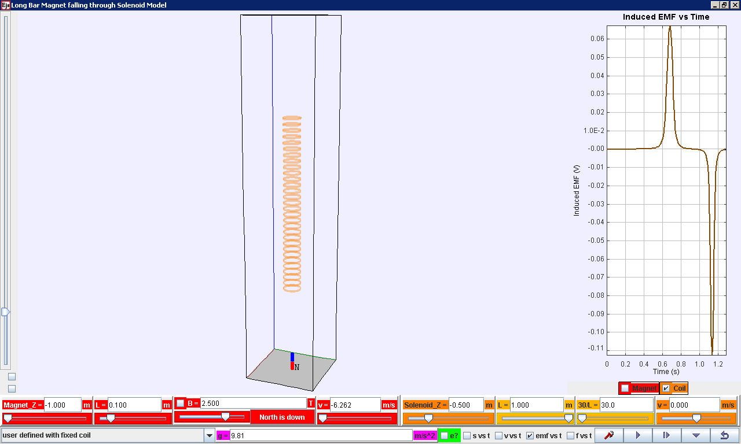
- Describe what you observe about the voltage when the magnet is falling inside the solenoid.

(g) Explain with reason why there is no voltage when the magnet is inside the solenoid.

Activity 5 (effects of relative speed)
- Click on the horizontal view checkbox left of screen and select form menu on bottom left “coil move towards stationary magnet constant speed”

- Run the simulation and you should able to collect data similar to the screenshot below.
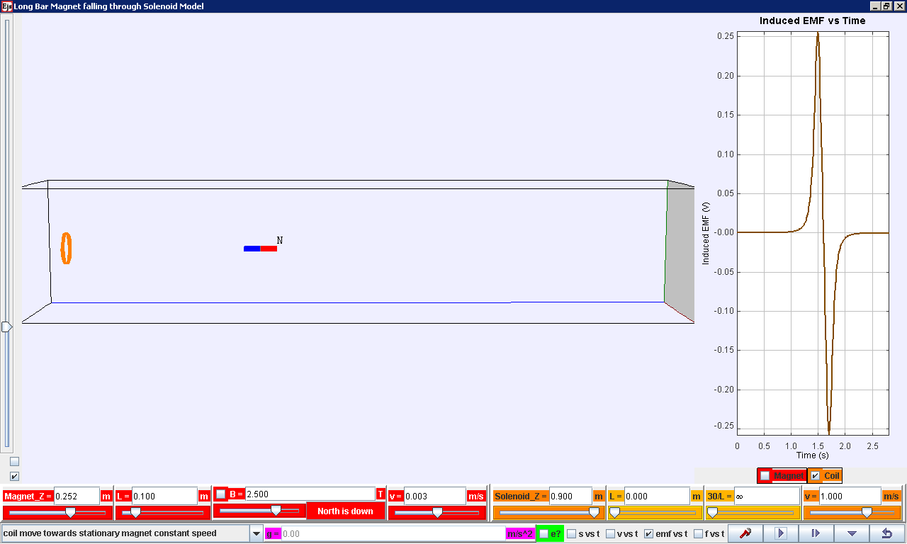

- Notice that induced emf graph has 1 positive peak and 1 negative peak. Record down the 2 values. (for precise values, use the data analysis tool)

- Suggest with reason why the peaks are equal in magnitude.

- Reset the simulation, and select form menu on bottom left “coil move towards stationary magnet constant speed”

- Run the simulation, click on the horizontal view checkbox left of screen and select form menu on bottom left “magnet move towards stationary coil constant speed” you should able to collect data similar to the screenshot below.
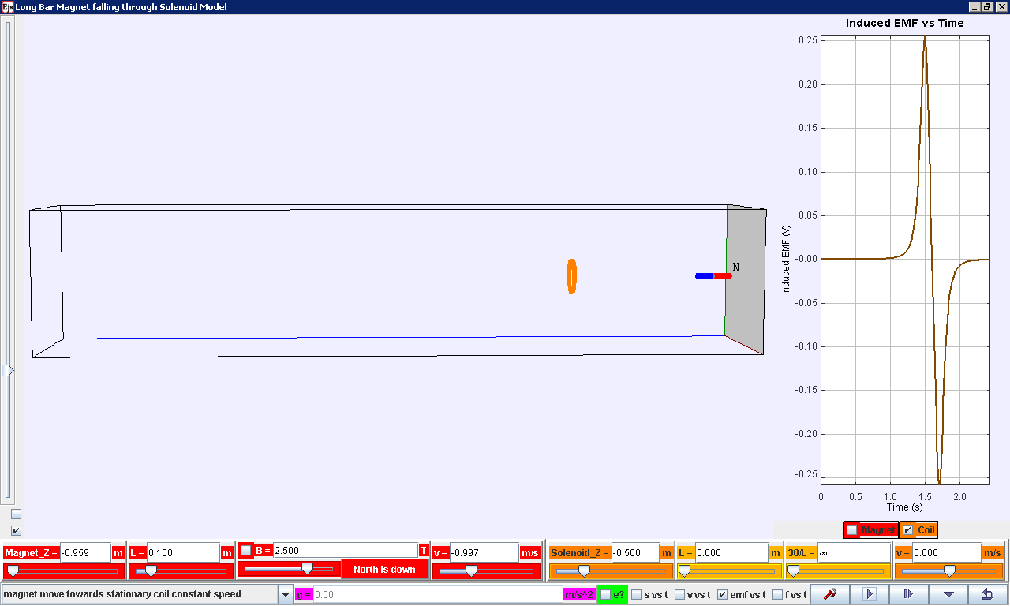
- Notice that induced emf graph has (left to right) 1 positive peak and 1 negative peak. Record down the 2 values. (for precise values, use the data analysis tool)

- Suggest with reason why the emf versus time graphs in this activity are identical.

Activity 5 (effects of moving in and out of coil without rotating magnet)
- Continue the simulation by allowing the magnet bar to move to the edge of the right side and notice the magnet moves to the left now at the same constant speed.

- you should able to collect data similar to the screenshot below.
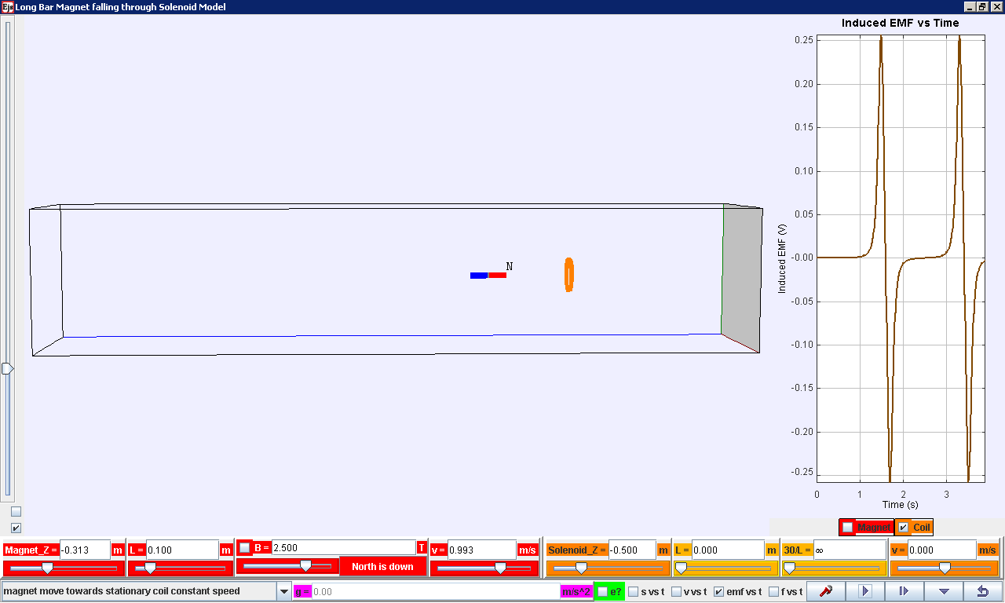

- Notice that induced emf graph has now the earlier 1 positive peak, 1 negative peak followed by positive peak, 1 negative peak.

- Write down your explanation of the emf graph and we discuss this in class.

Activity 6 (effects of decreasing speed)
- Select form menu on bottom left “coil move towards stationary magnet with deceasing speed”

- Run the simulation and you should able to collect data similar to the screenshot below.

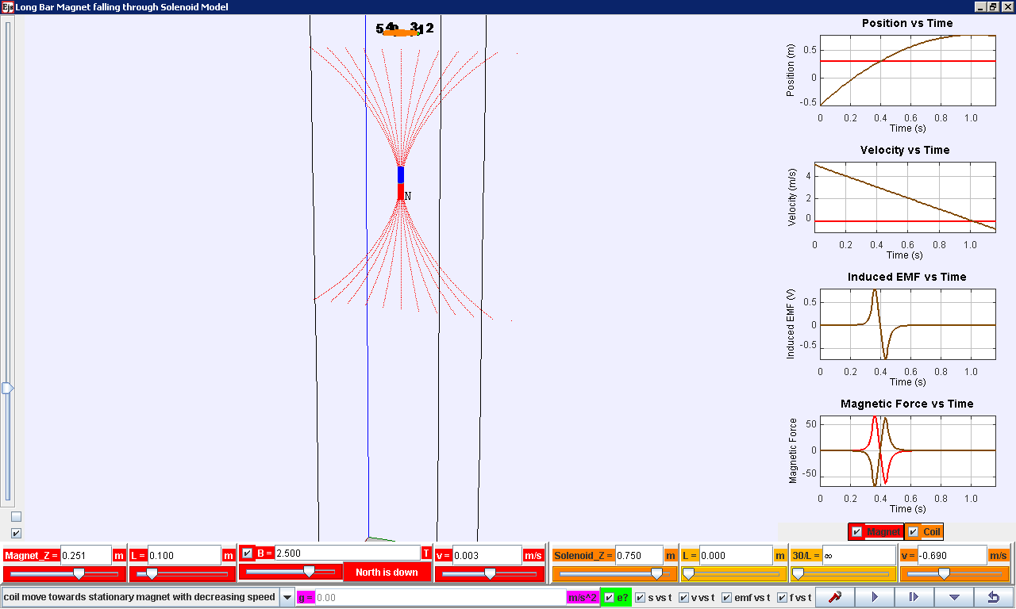

- Notice that induced emf graph has 1 positive peak and 1 negative peak. Record down the 2 values. (for precise values, use the data analysis tool)

- Suggest with reason why the 1st peak is larger in magnitude than the 1st negative peak.

Reflection/Summary:
- Thrusting a magnet into a coil of wire (which forms a closed circuit) and the coil both an electromagnet (checkbox f vs t shows the magnetic forces) and has a current (checkbox shows the electrons in the coil) in it.
(True/False)
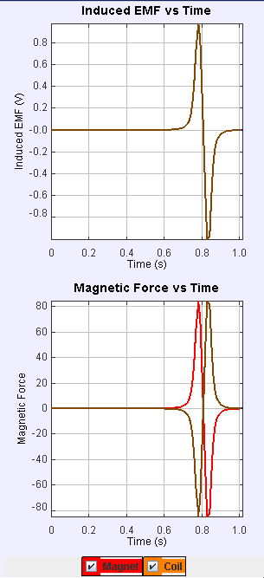
- When a magnet is thrust into a coil of wire (which forms a closed circuit), the coil tends to attract (select checkbox f vs t shows the magnetic forces as shown on the graph) the magnet as it enters and repel the magnet as it enters.
Graph 1: falling magnet in short solenoid coil
(True/False)

- The factors that affect the induced emf are 1) B, magnetic field strength of magnet (activity 1), 2) relative speed of movement entry and exit between magnet and coil.
(True/False)

- In the case when a long solenoid is used, the part where magnet is falling inside the solenoid coil induces nett zero emf because of the summation of individual emf in each coil just aaove and just below the magnet roughly cancel out as they are almost equal in magnitude but opposite current flow thus negative sign in emf.
(True/False)

