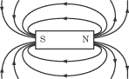

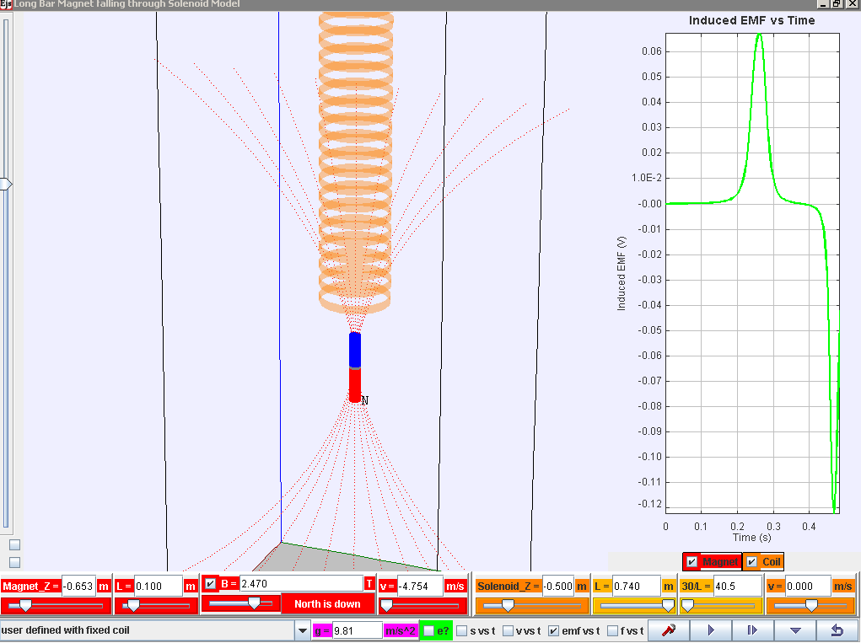
Play/pause, step, initialize (compare different runs) and reset
Control buttons
Bonus! For exploring other scenarios!
Data analysis!! Really cool tool to help analyse voltage
show graphs for magnet and/or coil (solenoid)
various graphs!
show motion of electrons in solenoid
Zoom!
N
N
reverse magnetic polarity
show magnetic field lines from magnet
view from bottom
vertical/horizontal

Download the simulation ejs_FallingMagnet10memory4.3.0.jar from the following link:
Latest version
https://dl.dropbox.com/u/44365627/lookangEJSworkspace/export/ejs_FallingMagnet10memory4.3.0.jar
Parameters (refer to bottom of the simulation) for exploration
Parameter / unit | Definition/Meaning
Magnet_Z / m | Initial vertical position (z-axis) of the magnet
L / m (in red for magnet) | Length of magnet
B / T | Maximum Magnetic Field Strength (in the core of the magnet)
v / m/s (in red for magnet) | Initial speed of magnet
Solenoid_Z / m | Initial vertical position (z-axis) of the solenoid
L / m (in orange for solenoid) | Length of the solenoid
30/L | This is meant to be number of turns per unit length.  Due to programming constraints, it is 30 turns/Length set in the computer model.
v / m/s (in orange for solenoid) | Velocity of solenoid (for exploration of relative velocity. )

