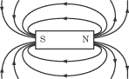

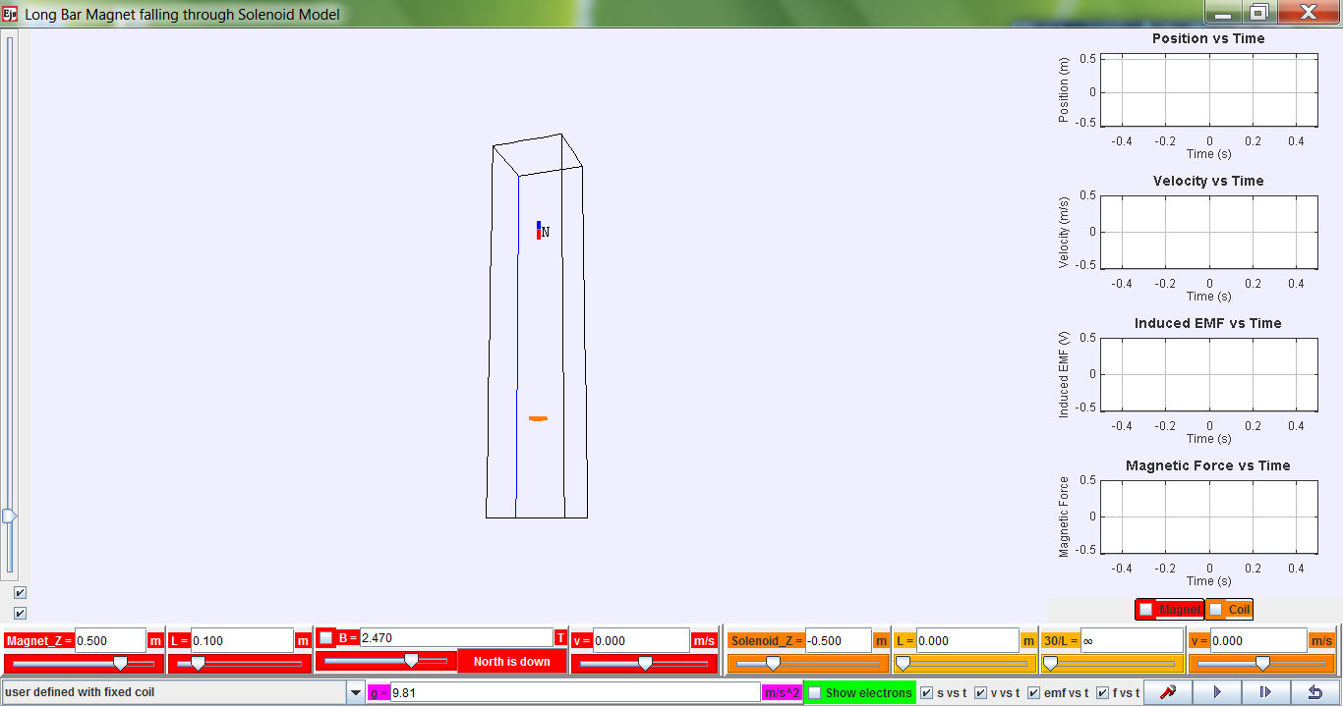
reverse magnetic polarity
show magnetic field lines from magnet
show graphs for magnet and/or coil (solenoid)
N
N
Bonus! For exploring other scenarios!
view from bottom
vertical/horizontal
Zoom!
show motion of electrons in solenoid
various graphs!
Data analysis!! Really cool tool to help analyse voltage


Download the simulation ejs_FallingMagnet08.jar from the following link:
https://dl.dropbox.com/u/44365627/lookangEJSworkspace/export/ejs_FallingMagnet08.jar
OR http://tinyurl.com/magfall QR code on the right. (Needs Java to run.)
Universal symbols
Play / Start
Play in slow-mo i.e. step-by-step or frame-by-frame simulation
Reset to default values or factory settings. Click this after playing every simulation and before changing any settings.
Parameters (refer to bottom of the simulation) for exploration
Parameter / unit | Definition/Meaning
Magnet_Z / m | Initial vertical position (z-axis) of the magnet
L / m (in red for magnet) | Length of magnet
B / T | Magnetic Field Strength of magnet
v / m/s (in red for magnet) | Initial speed of magnet
Solenoid_Z / m | Initial vertical position (z-axis) of the solenoid
L / m (in orange for solenoid) | Length of the solenoid
30/L | This is meant to be number of turns per unit length.  Due to programming constraints, it is 30 turns/Length set by user.
v / m/s (in orange for solenoid) | Velocity of solenoid (for exploration of relative velocity. )

Scenario A – Falling Magnet through a Solenoid
Default Settings  - Change solenoid length to 0.500 m.  - Must press Enter key.  Please note that 30/L becomes 60.0 automatically.  - Click on emf vs t (bottom right).  - Click on Coil (bottom right above v).  - Click to run the simulation.  - Copy the simulated graph onto the axes provided.  - Explain the shape of the simulated graph. | t  E
  Parameter / unit | Magnitude
  Magnet_Z / m | 0.500
  L / m (in red for magnet) | 0.100
  B / T | 2.470
  v / m/s (in red for magnet) | 0.000
  Solenoid_Z / m | –0.500
  L / m (in orange for solenoid) | 0.000 0.500
  30/L | ∞
  v / m/s (in orange for solenoid) | 0.000
………………………………………………………………………………………………………………………
………………………………………………………………………………………………………………………
………………………………………………………………………………………………………………………
………………………………………………………………………………………………………………………
………………………………………………………………………………………………………………………
………………………………………………………………………………………………………………………
………………………………………………………………………………………………………………………

