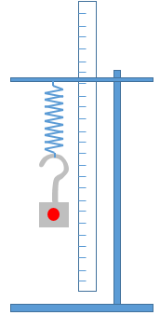
Simple Harmonic Motion (Kinematics and Dynamics Model Development)
- Recording the SHM video
- Setup a basic spring mass system as shown.
  - Clamp a ½ meter ruler in the same plane as the spring mass.
  - Place a coloured sticker on the mass.
- Displace the mass vertically downward and release so that it can oscillate freely.
- Record video of the oscillation for 5 period using phone or any other camera.

- Autotracking the mass to collect displacement and time data of the mass
- Drag the video into tracker software to load the video
- Drag the 2 black triangles of the video time bar to set the start and end time of the video (start the video with the highest positive displacement)
- Click on to create the calibration stick
Drag the end of the calibration stick to the ends of the ruler.
Double click the number and key in the length of 0.5 (all numbers should be in SI unit).
- Click on to create Point Mass
- Click on and select Autotracker from the dropdown menu.
- Hold shift-control and click the middle of the object to be tracked.
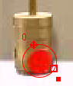
- Drag the circle to select the entire coloured sticker. The template should show the coloured sticker.
- Press to start autotracking
- Click on to toggle the axes.
- Drag the centre of the pink axes to the middle of the oscillation. You can check by ensuring the maximum positive and negative displacement are equal.

- Collecting data from the graphs
- Click on the y-axis of the graph to change the display to y-t graph.
- Using the information from the graph, determine
Amplitude, A = …………………………
Period, T = …………………………
Frequency, f = …………………………
Angular frequency, w = …………………………

- Write an equation in terms of A and T to describe the motion y = ……………………………………

- Creating a kinetic model to test our kinematic description of the motion and make further predictions about the motion
- Click on to create kinetic particle model
- Double click “1” to change the mass to the mass you suspended on the spring (in kg)
- Click to add more parameters.
- Double click on param to change the name to A.
- Double click “0” to key in the value of the amplitude of oscillation.
- the period of the oscillation, T.
- Key in the Position Functions of the equation you proposed in C4.
A wrong answer is shown here for you to start modifying your equations:
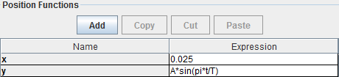
- Right click on your x-t graph to 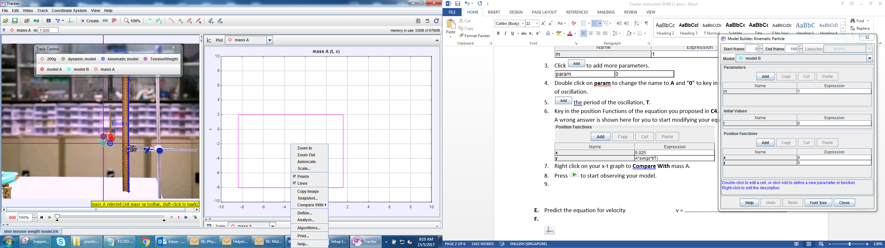 mass A.
- Click on model A to change the Colour to Blue.
- Press to start comparing your model with the actual motion of the mass.
Click on model A > Model builder to edit your Position Functions until your model roughly matches mass A.
- Modify your equation in C4.
- Alert your instructor once you completed this part for class discussion. Record down the equations and parameters of all groups.
m / kg | A / cm | T / s | k / N m⁻¹ | Equation for y
 |  |  |  | y =
 |  |  |  | y =
 |  |  |  | y =
 |  |  |  | y =
 |  |  |  | y =
 |  |  |  | y =

- What can you generalize about the equation for vertical displacement?
……………………………………………………………………………………………………………………………………………….
……………………………………………………………………………………………………………………………………………….

- According to the data from all groups, what are the factors that affect the period?
……………………………………………………………………………………………………………………………………………….

- Using the equation provided by one of the other group, predict the displacement at t = 4s. Check with them if the value you calculated is correct.

- Relating Force in terms of displacement
- Differentiate equation in C4 to obtain the equation for velocity v_{y} = ……………………………………
- Differentiate equation in D11 to obtain the equation for velocity a_{y} = ……………………………………
- Click 3 to display 3 graphs.
- Change the axes to display y-t, v_{y}-t, a_{y}-t graphs. Sketch the graphs of y-t, v_{y}-t and a_{y}-t for 1 period of oscillation in the space provided.
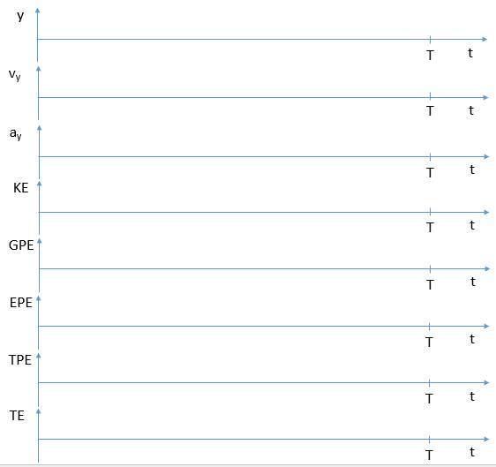
- Compare your equations in E1 and E2 to the graphs. Do they match? ( Y / N )
- Using the equation of y and a_{y}, work out equation a_{y} in terms of y.
a_{y} = ……………………………………

- Hence the force, F_{y} in terms of y is F_{y} = ……………………………………
- Change the axes to display kinetic energy-time, K-t graph. Sketch on axes provided above.
- Compare and comment on the v_{y}-t and K-t.
……………………………………………………………………………………………………………………………………………….
- Click on the y-axis and select define.
  - Double click on “1” to key in the mass used.
  - Add Data Functions.
  - Double click on func and type in PE.
  - Double click “0” and type in m*9.81*y
- Write down the equation for elastic potential energy, EPE in terms of the upstretched length of spring and spring constant
EPE = ……………………………………

- Click on the y-axis and define EPE with the equation you have defined.
- Click on the y-axis and define total potential energy TPE with the equation TPE = GPE + EPE
- Click on the y-axis and define total potential energy TE with the equation TE = TPE + K
- Sketch K-t, GPE-t , EPE-t, TPE-t and TE-t on the space provided above.
- At which point of the oscillation is the KE, GPE, EPE a maximum.
……………………………………………………………………………………………………………………………………………….
……………………………………………………………………………………………………………………………………………….
- Comment on the TE of the osciallation.
……………………………………………………………………………………………………………………………………………….
- Change the axes to display a_{y}-y and v_{y}-y graphs. Sketch the graphs of a_{y}-y and v_{y}-y.
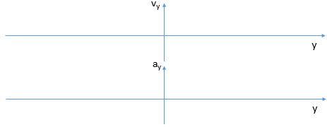

- Creating a dynamic model to test our dynamic description of the motion and make further predictions about the motion
- Click on to create dynamic particle model (Cartesian).
- Key in the parameters of mass, m and period, T.
- Key in the initial value of y.
- Key in the force function according to your equation in E7.
- Right click on your x-t graph to mass A.
- Click on model A to change the Colour to Green.
- Press to start comparing your model with the actual motion of the mass.
- Does your model match the motion of mass A? ( Y / N )

- Relating Force in terms of spring constant and mass
- Draw a free-body diagram of the spring-mass system when it is stretched (maximum negative displacement).

- Write an equation for relating the net force, F_{y} to the tension, F_{T} and weight, W.
F_{y} = ……………………………………

- Express F_{y} in terms of the spring constant k, natural length of spring l, displacement y, mass m and gravitational field strength g.

F_{y} = ……………………………………

- Creating a dynamic model to updated dynamic model with no free parameters* of the motion and make further predictions about the motion
*(A free parameter is a parameter that is not estimated experimentally or theoretically. Free parameter reduce reliability of the model)
- Click on to create dynamic particle model (Cartesian).
- Key in the parameters of mass m, gravitational field strength g, natural length of spring l, and spring constant k.
- Key in the initial value of y.
- Key in the force function according to your equation in G3.
- Right click on your x-t graph to mass A.
- Click on model A to change the Colour to Purple.
- Press to start comparing your model with the actual motion of the mass.
Click on model C > Model builder to edit your Position Functions until your model roughly matches mass A.
- Modify your equation in G3.
- Key in F_{y} = -k*y and observe the motion. Do they match?
Homework: Simply equation G3 to the form F_{y} = -k y
- Using the equation in E7 and the equation Fy = k y, show that T = 2 π $\sqrt{m/k}$

- Check with table in D12. Is the formula T = 2 π $\sqrt{m/k}$ correct for all the data?

Video step by step guide on tracker basic:
https://www.youtube.com/watch?v=H_zrkl16BNs
https://www.youtube.com/watch?v=7_TgOSMqRQs

