
P09 – Gravitational Field Simulation-based Practical
(Pre-lecture Activity)

http://iwant2study.org/ospsg/index.php/interactive-resources/physics/02-newtonian-mechanics/08-gravity

Please use Chrome to run all applets,
Simulation 1 – Geostationary Satellites (What’s that? Can eat or not?)


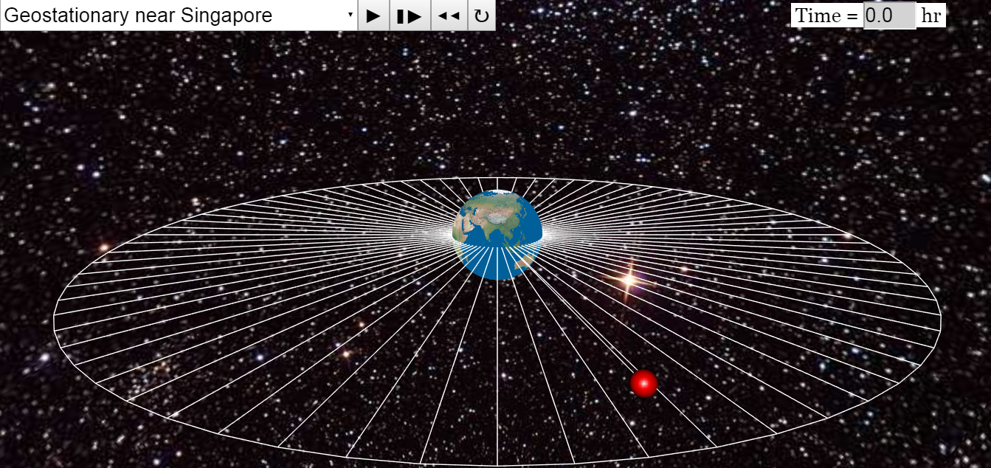
You may zoom in to view better or click on any point, drag up and down to change perspective.
https://tinyurl.com/y7udothb
teacher’s copy

- Click  and observe the motion of a geostationary satellite near Singapore.

Note the period of the orbit.
- Click on  after every run to reset the simulation before selecting another option.
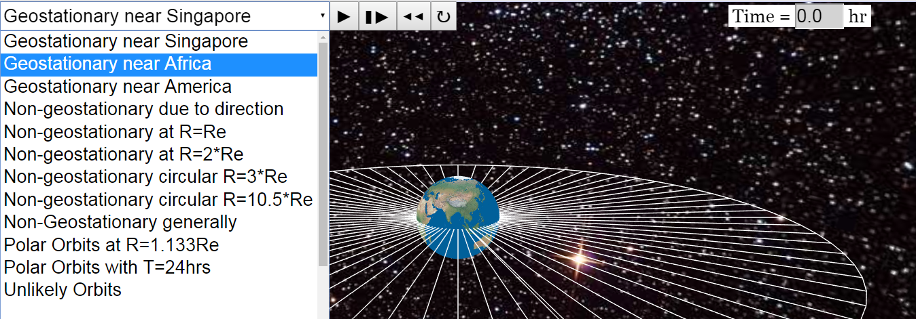
- Use the drop down menu to run two other geostationary orbits.

After observing all three geostationary orbits, I can safely conclude the
24 h

period of geostationary orbits is ……………………

- Click on to reset the simulation. Use the drop down menu to run other non-geostationary orbits. Remember to reset after every run.

After observing different orbits including polar orbits, identify three other characteristic of geostationary satellites.

A geostationary satellite will stay above the same spot throughout its orbit. OWTTE

A geostationary satellite orbits in the equatorial plane or above the equator.

A geostationary satellite follows the same rotation as the Earth (west to east).

1.

2.

3.

- Suggest possible applications for geostationary satellites. (Why are we studying them?)
Telecommunications - including satellite TV (stays above base station), global positioning or GPS - which is used for sat navs (satellite navigation systems)
continuous monitoring necessary for intensive data analysis – able to monitor storm development and track their movements


Simulation 2 – If Superman Throws a Ball Fast Enough…?!
https://tinyurl.com/y735eygl
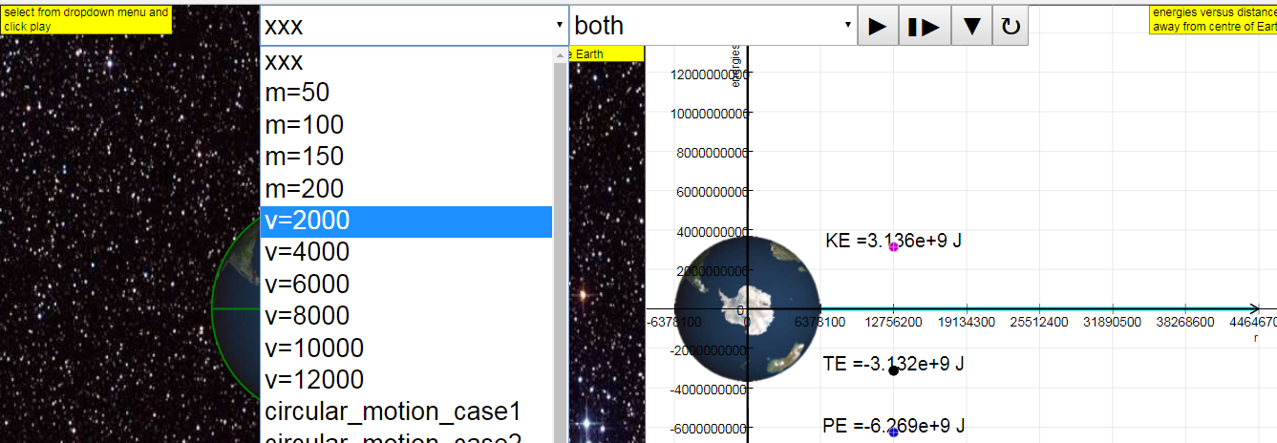
Graphs of KE (kinetic energy), PE (gravitational potential energy) and TE (total energy) are plotted against separation from the surface of the Earth.
- Use the drop down menu to select the initial horizontal speed of a ball projected from the top of a tall mountain.
- Select v=2000 and click to run the simulation.

- Click on to reset the simulation. Use the drop down menu to select v=4000 and click to run the simulation.

State and Explain the main difference between the paths of the two projectile motions.
Double the range for v=4000 path because of doubled initial horizontal velocity. (Same vertical height so same time of flight.)

- Click on to reset the simulation. Use the drop down menu to select v=6000 and click to run the simulation.

How would you explain what is happening here?
As the ball drops towards the surface of the Earth in projectile motion, the surface is “dropping away” or curving away at the same rate.
The ball hence ends up orbiting the Earth, although it is actually falling towards the Earth.

- What is one question you have after running this simulation?

- Click on to reset the simulation. Use the drop down menu to select v=8000 and click to run the simulation.

What do you think is happening?
I think the ball has very high kinetic energy which allows it to escape the Earth’s gravitational field.

欢迎来到引力场！你将被深深吸引！ Welcome to Gravitational Field! You will be deeply attracted!

Simulation 3 – Newton’s Law of Gravitation

Weight is the force acting on a mass due to a gravitational field.
What is a gravitational field? How do two masses interact? Do they need to be in physical contact to do so?
https://tinyurl.com/y9k69twq


- Click to run the simulation with the default setting M₁ = M₂ = 100 kg and
r = 4.00 m.

Note down your observations.
The 2 masses accelerate (“move” not accepted, need to observe an increasing speed) towards one another.

- Click on to reset the simulation.  Use the drop down menu to set  M₁ = 10 kg.  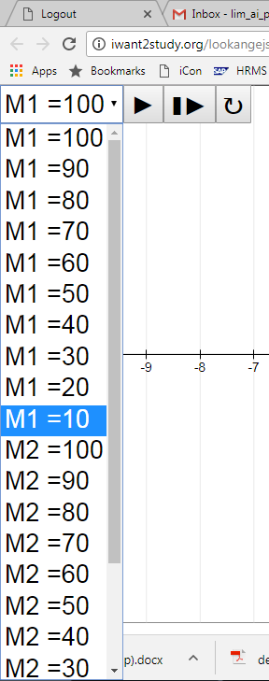  You can drag the masses further apart if you wish.  - Click and record your observations.  The two masses accelerate towards one another (due to gravitational forces). (Student may miss out that the 10 kg mass is accelerating at a small rate towards the other mass. Direct attention to the final position vs initial position.) | - Think about the difference between the two observations in 1 and 3. Thus, explain the motion and final positions of the two masses for the second setting.  Although the forces have equal magnitude (based on observation of the numbers), 100 kg mass has a much smaller (10×) acceleration due to its much larger mass, thus for the same time period the displacement is much smaller and the final positions are very close to the 100 kg mass.  - Draw the gravitational forces on two masses below.  - same length of arrow  M1  M2


Simulation 4.1 – Gravitational Field Strength near and far
https://tinyurl.com/ybfa4aju
https://tinyurl.com/ycdljka4
- Use the drop down menu to look at four different gravitational fields ranging from very_outer_space to very_near_Earth_surface.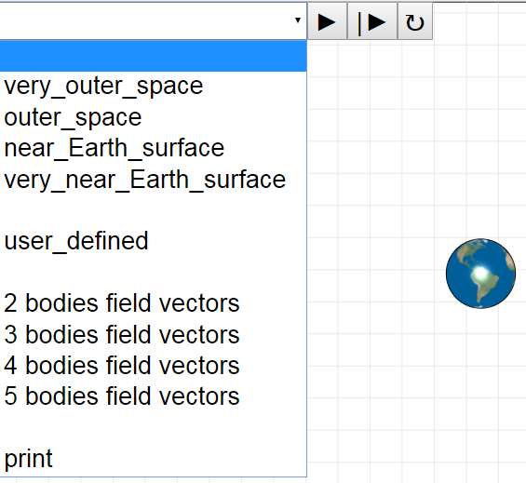 | - Copy and Draw the gravitational field of the Earth when viewed from very outer space.  Earth
- Copy and draw the gravitational field of the Earth when viewed from very near the Earth’s surface.

Earth’s surface

- Distinguish between the two extreme cases:
very far from and very near to the Earth.

radial, uniform (roughly uniform ≈ 9.81 m s^{–2})


Simulation 4.2 – Gravitational Field Strength relationship and graph

- Drag the mass slowly around to see how gravitational field strength varies
with separation from the Earth.

- Draw, on the axes below, the graph of gravitational field strength g against separation from centre of the Earth r.  g  r | - Deduce how g is numerically related to r.  Show your calculations.  By looking at the numbers for g and r, students deduce that g is inversely proportional to square of -r.

Simulation 5 – Binary Stars? Huh?
https://tinyurl.com/yd4ehhp9

Google for some background on binary stars.

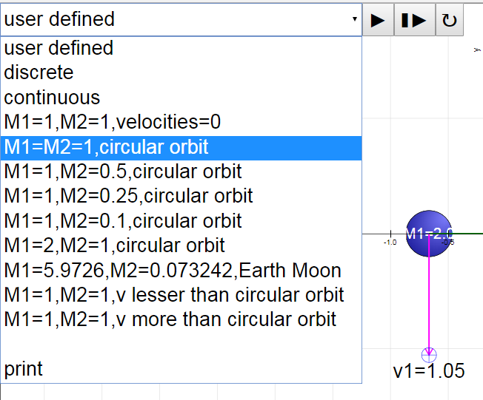 |  | - Use the drop-down menu and select M1=M2=1,circular_orbit.  - Click and observe the motion of both masses, noting the magnitudes of the forces, F1 and F2, on each mass.  Record your observations.  The two stars move in circular orbits about a common centre which is equidistant from M1 and M2.
- Click on to reset the simulation.

Use the drop-down menu and now select from the menu M1=1,M2=0.1,circular_orbit.

- Click and observe the motion, noting the orbits of the binary stars.

Record your observations.
The two stars move in circular orbits of different radii about a common centre which is very close to M1 where M1 is 10× M2.

- Newton’s first law of motion states that an object at rest will remain at rest and an object in motion will remain in motion at constant velocity in a straight line in the absence of an external resultant force.

Hence, for an object to move in circular motion, there must be a
resultant force on the object causing it to go around in a circle.

What would you say cause the stars to move in a such a manner?
The gravitational forces acting mutually on both stars provide the resultant forces for them to move in circular orbits.

 | Complete this lesson with an online summary of  - 3 concepts you feel you have understood,  - 2 questions you still have, and  - 1 feedback on the practical.  https://tinyurl.com/y9d7np8e

URLs for students who prefer to use laptops:
Simulation 1 – Geostationary Satellites
https://tinyurl.com/y7udothb

Simulation 2 – If Superman Throws a Ball Fast Enough…?!
https://tinyurl.com/y735eygl

Simulation 3 – Newton’s Law of Gravitation
https://tinyurl.com/y9k69twq

Simulation 4.1 – Gravitational Field Strength near and far
https://tinyurl.com/ybfa4aju

Simulation 4.2 – Gravitational Field Strength relationship and graph
https://tinyurl.com/ycdljka4

Simulation 5 – Binary Stars?
https://tinyurl.com/yd4ehhp9

Conclusion
https://tinyurl.com/y9d7np8e

