P09 – Gravitational Field Inquiry-based and Simulation-based Lesson

Links to the Gravity ebook – http://tinyurl.com/ebookGF
For iOS users:  customised app  http://snappy.appypie.com/user/download-plist/appId/8a81e93355ba  iTunes  (You need US store account)  https://itunes.apple.com/us/book/gravity-advanced-level-gce/id1001442379?mt=11 | For Android users:   customised app  http://snappy.appypie.com/media/appfile/8a81e93355ba.apk  Google Play Books  https://play.google.com/store/books/details/Loo_Kang_Lawrence_Wee_Gravity_Advanced_Level_Physi?id=LS3_CQAAQBAJ
Points to Note:
- Page numbers are based on iBook, portrait orientation and smallest font size but the page numbers become different when displayed in landscape orientation and with increased font size even on the same iPad. Hence, use the section as a guide.
- After keying in values or models, remember to press the return key.

Links to the simulations in the Gravity ebook – http://tinyurl.com/ebookGFsim

Activity 1 – Newton’s Law of Gravitation    https://dl.dropboxusercontent.com/u/44365627/lookangEJSworkspace/export/ejss_model_gravity01_1/gravity01_1_Simulation.xhtml | Activity 2 – Binary Stars    https://dl.dropboxusercontent.com/u/44365627/lookangEJSworkspace/export/ejss_model_gravity02/gravity02_Simulation.xhtml
Activity 3 – Gravitational Field Strength    https://dl.dropboxusercontent.com/u/44365627/lookangEJSworkspace/export/ejss_model_gravity04_1/gravity04_1_Simulation.xhtml | Activity 4 – Satellite in Circular Orbit    https://dl.dropboxusercontent.com/u/44365627/lookangEJSworkspace/export/ejss_model_gravity08_2/gravity08_2_Simulation.xhtml
Activity 1 (page 24) – Newton’s Law of Gravitation (Section 7.1.3.3)

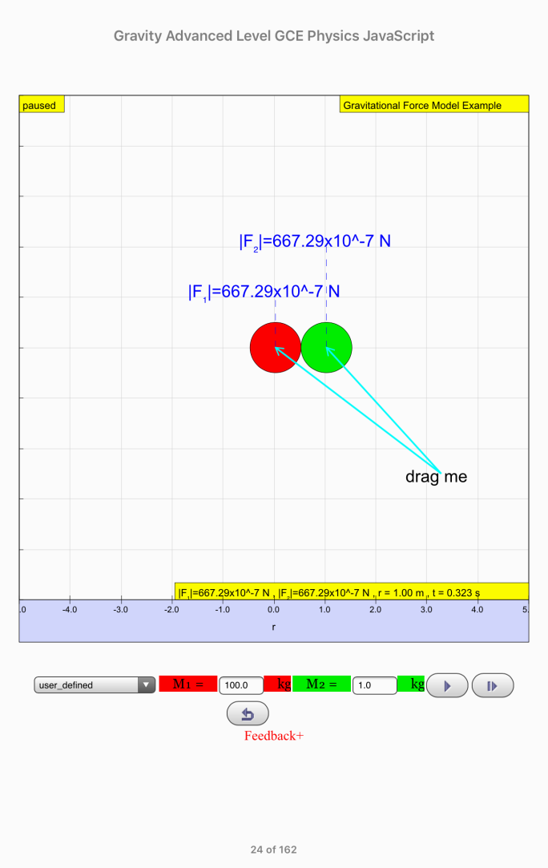 | Thinking Question: When the Earth pulls you down, why do you not pull the Earth up?  - Set M₂ = 1.00 kg (press the return key after keying in 1.00). (M₁ = 100 kg and r = 4.00 m by default)  - Click and record your observations.  - Explain the motion and final positions of the two masses.  The two masses accelerate towards one another due to gravitational forces (note: the motion of the 100 kg mass may be imperceptible.)  Although the forces have equal magnitude, 100 kg mass has a much smaller (100×) acceleration due to its much larger mass (which is why its motion is unnoticeable), thus for the same time period (s = ut + ½ at²) the displacement is much smaller and the final positions are very close to the 100 kg mass.

Activity 2 (page 28) – Binary Stars (Section 7.1.4)

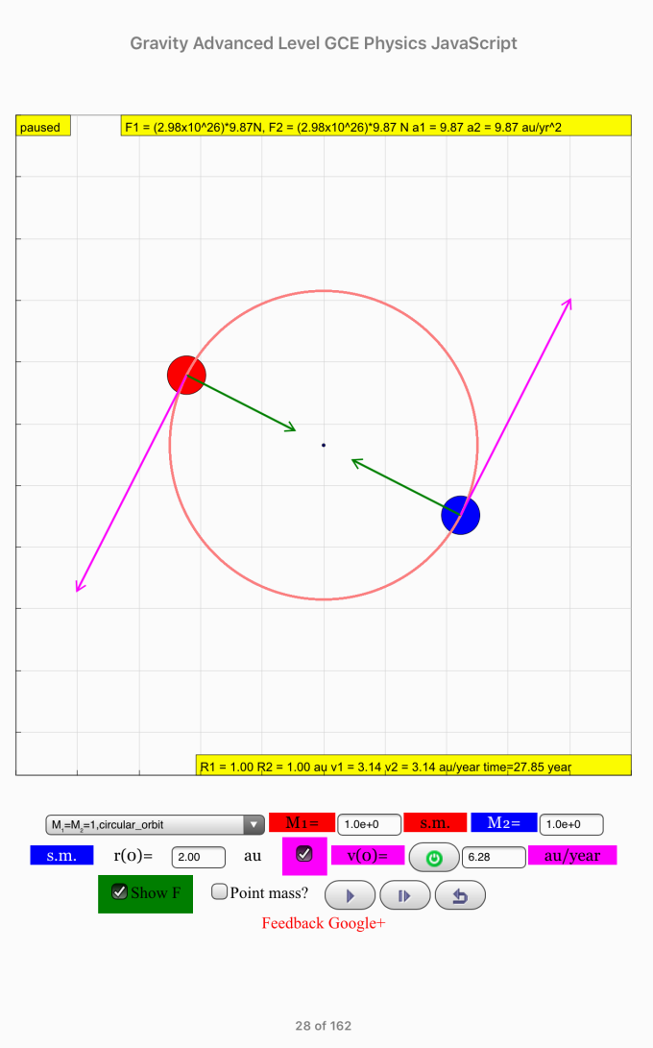  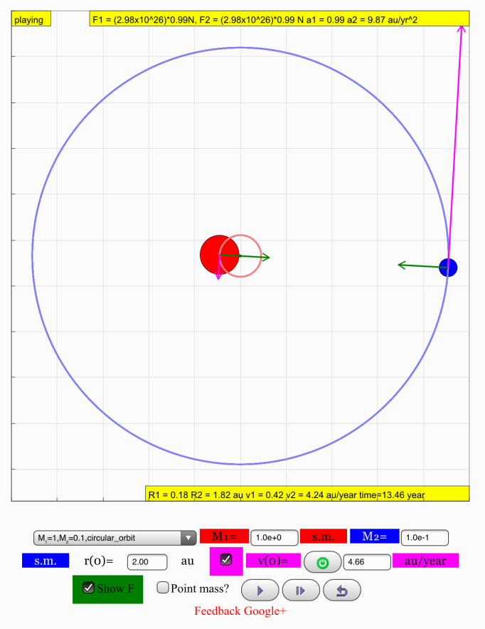 | - Drop-down menu default setting should be “M1=M2=1,circular_orbit”.  - Click and observe the motion, noting the magnitudes of the forces (green arrows) on each mass.  Record your observations.  The two stars move in circular orbits about a common centre which is equidistant from M1 and M2.  - Click and now select from the menu “M1=1,M2=0.1,circular_orbit”.  - Click and observe the motion, noting the orbits of the binary stars.  Record your observations.  The two stars move in circular orbits of different radii about a common centre which is very close to M1 where M1 is 10× M2.  - You can attempt the example (N09/I/16) on page 29 and use the simulation on page 31 to verify your answer.

Self-Directed Learning (page 32) – Gravitational Field Lines
Activity 3 (page 54) – Gravitational Field Strength (Section 7.2.6)

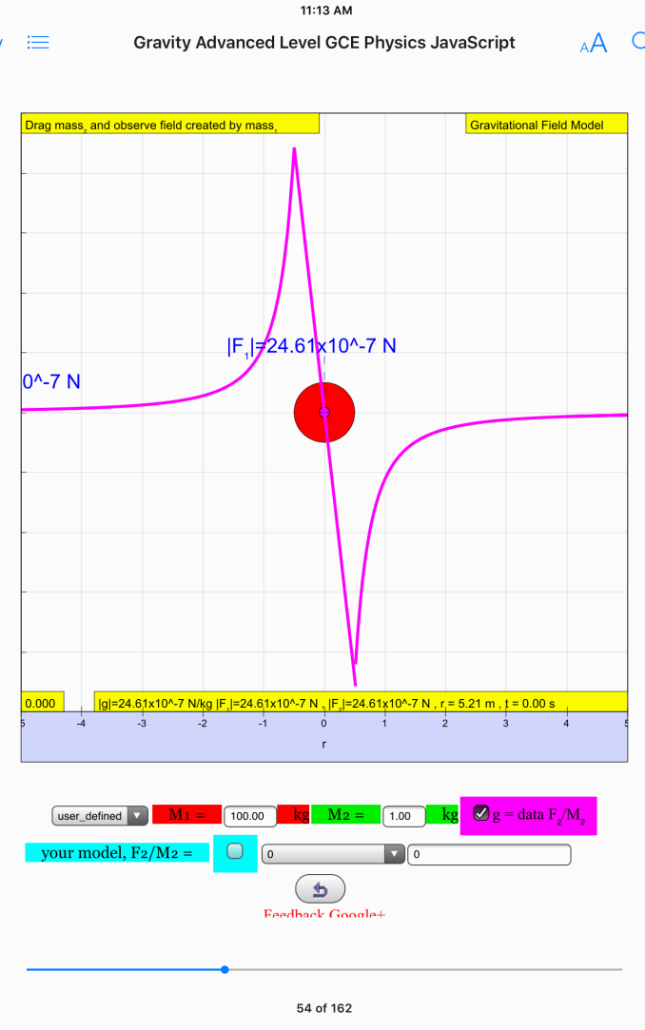 | This activity is to allow students to use mathematical equations or use the drop-down menu for model to propose a mathematically valid equation to represent gravitational field strength.  - Select from the drop-down menu to see how different mathematical models give rise to different graphs.  - Draw the mass to see the correct shape of graph.  - Draw the correct graph below.  g  r  - Flip to page 60 to repeat simulations for different mathematical models to see how g for the Earth varies.

Activity 4 (page 97) – Satellite in Circular Orbit (Section 7.4.2.3)

v=2000  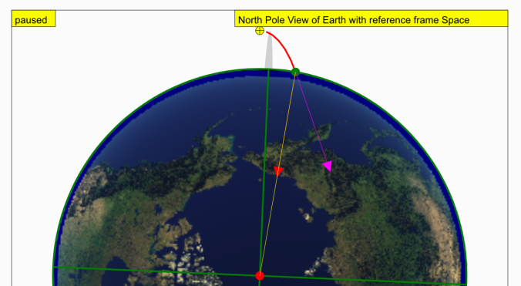  v=4000  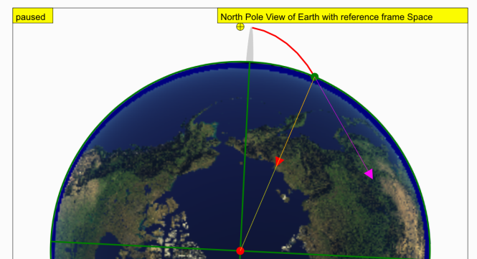  v=8000  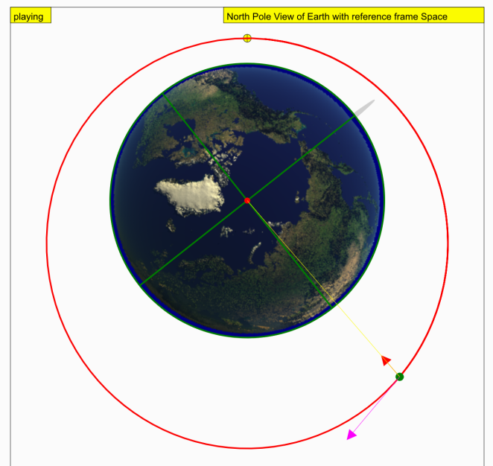  v=10000  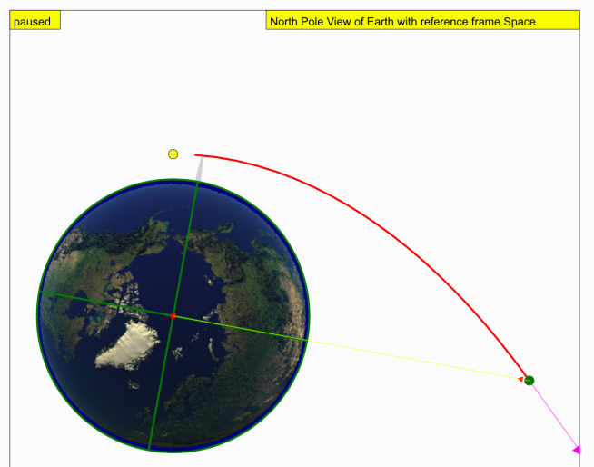 | - Drop-down menu default setting should be v=2000, click and record your observations.  The satellite travels a parabolic path and falls onto the Earth’s surface.  - Click and now select v=4000 from drop-down menu, click and record your observations.  What is different from the previous scenario?  The satellite travels a parabolic path and falls onto the Earth’s surface. The range is 2× further as the initial velocity is 2×.  - Click and now select v=8000 from drop-down menu, click and record your observations. What happens now?  The satellite travels a parabolic path and falls towards the Earth’s surface. However, the Earth’s surface is curving away and the satellite reaches an altitude where its path parallels that of the Earth’s curved surface.  - Explain why satellites can remain in orbits and not fall down to the Earth.  Satellites in orbit are falling towards the Earth. However, the Earth’s surface curves away (“falls”) at the same rate, hence the satellites remain falling and in orbit.  - Click and now select v=10000 from drop-down menu, click and record your observations. What happens now?  The satellite’s speed is so high that it travels further and further away from the Earth, thus escaping the Earth’s gravitational field.

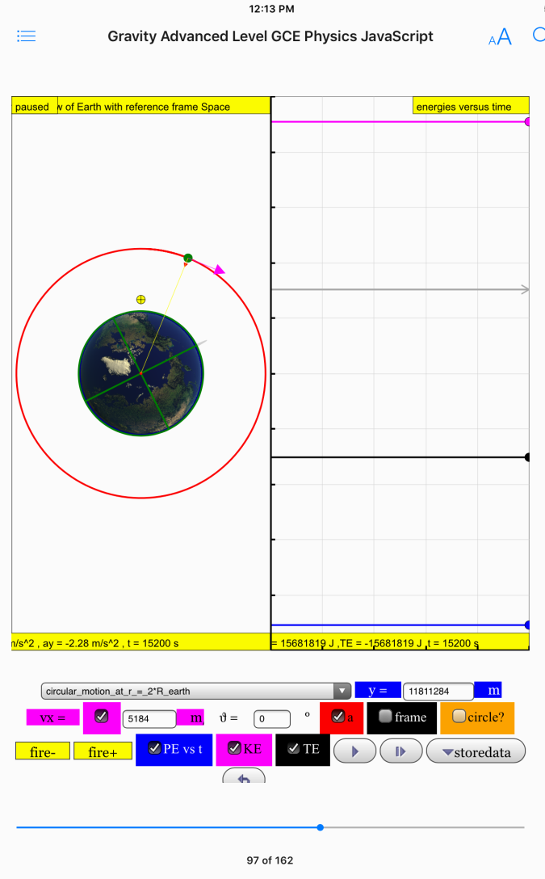  KE  TE  PE | - Tick the checkboxes for PE, KE and TE to view the potential energy (PE), kinetic energy (KE) and total energy (TE) of the satellite.  - Select “circular_motion_at_r_=_2*R_earth” from the drop-down menu.  - Click and observe the graphs.  Sketch the graphs below.  energies  time  - Explain the shape of the graphs.  For same R, GPE is constant and negative (using the formula to deduce).  If there are no resistive forces and no change in GPE, then KE stays constant and positive.  TE is therefore constant and from derivation, –½GPE.

