Evergreen Secondary School
Science Department

Name: _______________________________( ) Class: ___________ Date: _______________

Energy Change in Bungee Jump: Real World Physic using TRACKER video Analysis

Guided Lesson Notes

Web URL: http://tinyurl.com/evg2016may18
Video and instructions how to run TRACKER is available at the above URL.

A | Analysing Energy Change in a Bungee Jump.
The figure below shows a man making a bungee jump.
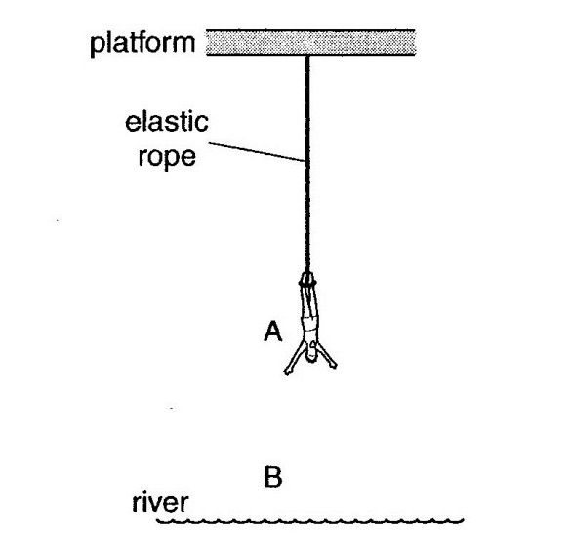
The man starts his jump from a platform above a river. The elastic rope tied to his feet becomes tight when the man reaches point A. The lowest point he reaches is B.

The mass of the man is 80 kg,
The gravitational field strength is 10 N/kg.

(a) Describe the energy changes as the man falls from A to B.
O Level Physics 2008 P2 Q2 part (a)

Assumption made in this analysis: air resistance is negligible.

B | My Prediction
 | i) | Predict and explain the change in GPE from A to B.  …………………………………………………………………………………………………  Reason: ………………………………………………………………………………………  …………………………………………………………………………………………………
 | ii) | Predict and explain the change in KE from A to B.  …………………………………………………………………………………………………  Reason: ………………………………………………………………………………………  …………………………………………………………………………………………………
 | iii) | Predict and explain the change in EPE from A to B.  …………………………………………………………………………………………………  Reason: ………………………………………………………………………………………  …………………………………………………………………………………………………

C |  | My Investigation Using Tracker Video Analysis  displacement-time graph  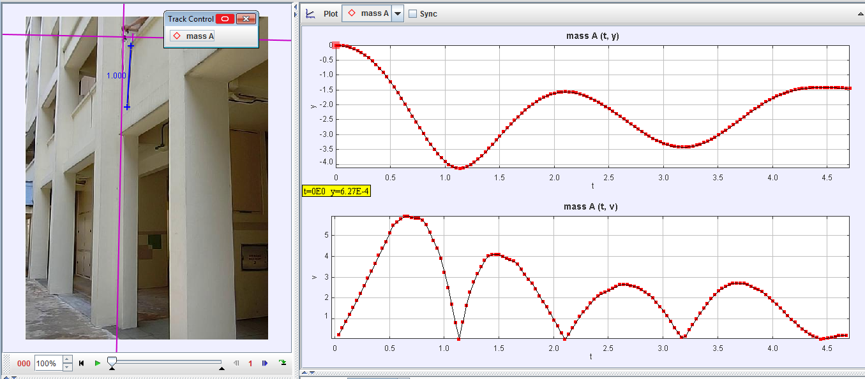  Frame number  speed-time graph
 | i) |  | Use the displacement–time and speed-time graphs to identify point A and B in the video. Label points A and B on the graphs above.  Point A is at frame number ……………., t = ………….s  Evidence from the graph(s): ………………………………………………………………..  …………………………………………………………………………………………………  Point B is at frame number ……………., t = ………….s  Evidence from the graph(s): ………………………………………………………………..  …………………………………………………………………………………………………

 | ii) | Use the graphs feature on the right panel of TRACKER to display appropriate graphs and answer the following questions.
 |  | a) | State and explain the change in GPE.  The GPE is ………………………………………………………………………………  Evidence from the graph(s) or video: ………………………………………………..  …………………………………………………………………………………………….
 |  | b) | State and explain the change in KE.  The KE is ……………………………………………………………………………….  Evidence from the graph(s) or video: ………………………………………………..  ……………………………………………………………………………………………
 |  | c) | State and explain the change in EPE.  The EPE is ………………………………………………………………………………  Evidence from the graph(s) or video: ………………………………………………..  ……………………………………………………………………………………………

D | Principle of Conservation of Energy
 | a) | Applying the Principle of Conservation of Energy, state the relationship between GPE, KE and EPE. Assume that air resistance is negligible.  …………………………………………………………………………………………………  …………………………………………………………………………………………………
 | b) | Display the graphs of GPE, KE and EPE on one screen.  What can you conclude on the relationship between GPE, KE and EPE?  …………………………………………………………………………………………………  …………………………………………………………………………………………………
 | END

TKK/May 2016

