Activity 1

INVESTIGATE
Go to the following simulation: http://tinyurl.com/ast2016-3
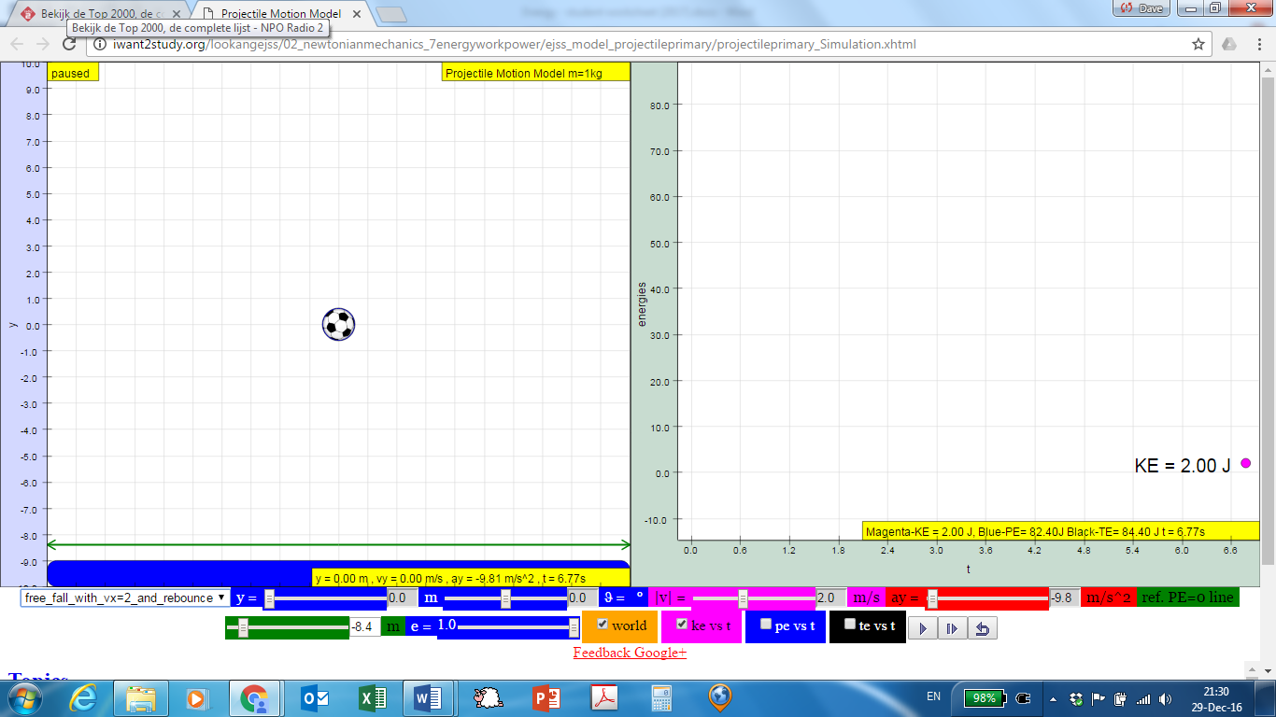
The left panel shows a football being given an initial velocity. This could be zero (the ball is being dropped, free_fall), upwards (tossed up, toss_up) or horizontal (thrown horizontally).
The right panel allows you to plot the energy of the object over time. The default is a plot for kinetic energy (ke), but you can also request potential energy (pe), and total energy (te). Remember that you can play the simulation by clicking the appropriate button (). Click the pause button (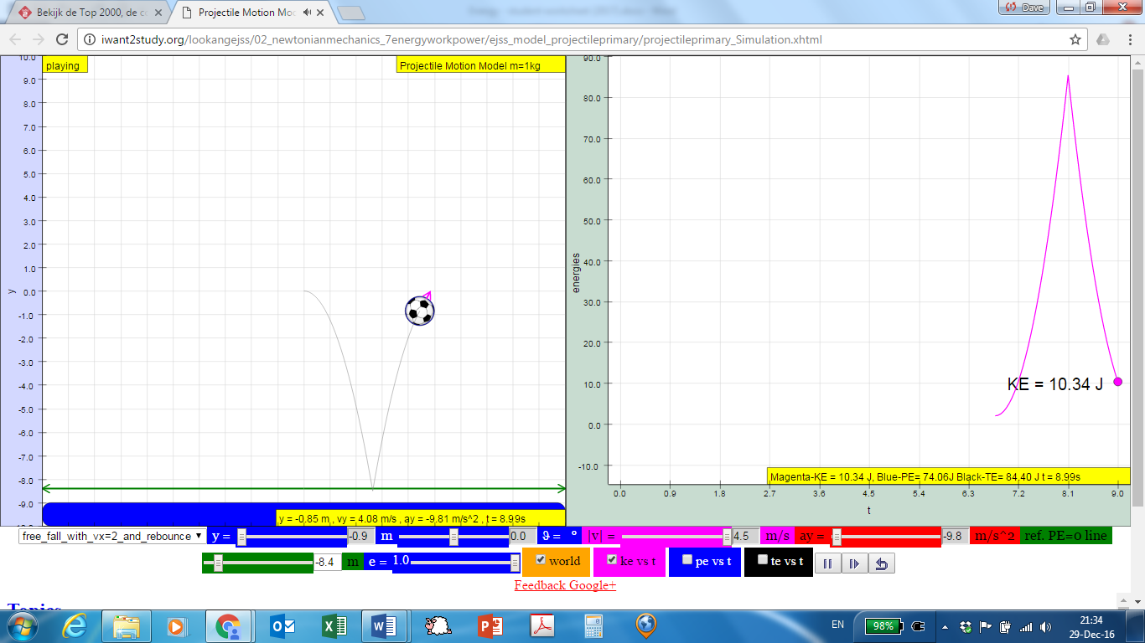) to pause the simulation and to reset it.

- First select the “free_fall” setting, using the drop-down box in the lower left, highlighted in the figure above. Watch the ke and pe graphs as the object moves. What do you notice?

- Now try the “toss_up” setting. How are the ke and pe graphs different, as compared to the “free_fall” setting?

- You can alter the reference line for this simulation. Reset the simulation for “free_fall” or for “toss_up” but, before you press play, change the “ref. PE=0 line” to a different value.
How are the ke and pe graphs different when you choose a different PE reference line?

MODEL
You may have noticed that the kinetic energy ke depends on the speed |v|. Now set the simulation to “user_defined”. You can then choose the speed you want by typing the value in the magenta box in the bottom. You can read the corresponding kinetic energy ke in the yellow box below the graph in the right-hand panel. Try to fill up the table below.

Speed |v| in m/s | Speed x Speed (v²) | Kinetic energy ke in J
1.00
2.00
3.00 | 9.00
4.00
5.00 |  | 12.5

Now that you have investigated some of the different motions of the football, let’s try to model this by creating some rules about pe and ke. Note that the mass of the ball in the simulation is 1.00 kg, as shown in the yellow box above the left image (“Projectile Motion Model m=1kg”).

- Write down some rules for the relationships between pe and ke. Here’s an example:
“Rule 1: The graph for ke does not depend on the PE reference line.”

ConcepTest 1! Go to http://b.socrative.com/login/student and join room number 657814.
APPLY
In the previous activity, you set up a model for the world as simulated by the applet. The best model would hold, even if the circumstances of an experiment were to change. Now test your model to see if the rules hold true for a different pre-set motion: “free_fall_and_rebounce”.

- Which of your rules are still the same after trying the “free_fall_and_rebounce” setting?

- Were any of your rules not retained? If so, which one(s)?

Activity 2

INVESTIGATE

Go to the following website to access a simulation about energy of a pendulum: http://tinyurl.com/ast2017-1
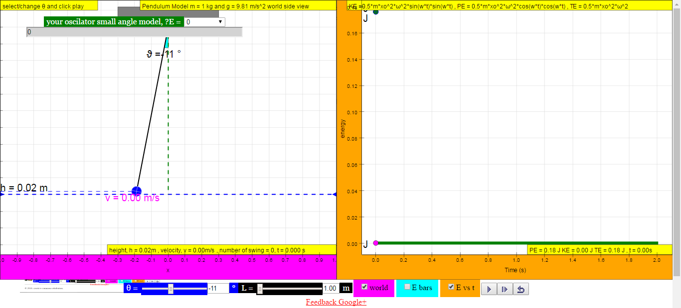
The left panel shows a pendulum—a mass on a string that can oscillate back and forth.
A second panel shows up on the right if you check the appropriate box at the bottom of the screen:
- E bars gives bar graphs that show the amount of potential energy (pe) and kinetic energy (ke) at any specific moment. They change as the pendulum swings.
- E vs t shows the pe and ke of the pendulum as a function of time.
Remember that you can play the simulation by clicking the appropriate button (), the pause button () to pause and to reset.

- Run several trials with the pendulum, watching the E bars and the E vs t graphs. Note that you have to choose either the E bars or the E vs t graphs; you cannot show both at the same time.
- You can drag the pendulum’s bob to change its position. This changes the initial angle, indicated by the Greek letter θ or θ, pronounced theta. Alternatively, you can use the blue sliding bar with the label θ at the bottom).
- You can also change the length L of the pendulum using the black slider labelled L at the bottom of the simulation, or by entering a value using your keyboard.
Press play () and let the pendulum oscillate for a while. Answer the following questions by looking at the E vs t graphs.
- At what point (or points) of the pendulum’s swing is the potential energy the highest?

- At what point (or points) of the swing is the kinetic energy the highest?

- What happens if you change θ (but leave L the same)?

- What happens if you change L (but leave initial θ the same)?

MODEL
The potential energy pe depends on the height above the lowest point h. Set up the applet to show the E bars on the right. Pause the applet at various points. Try to fill up the table below for various values of h. Note that the mass of the bob is 1 kg and that the acceleration of free fall is g = 9.81 m/s².

Height h in m | Weight m g in N | Potential energy pe in J
 | 9.81

Time for some more modelling rules!

- Write down some rules for the pe and ke in the pendulum’s motion. Consider rules in general, and some rules involving θ and L. Here’s an example of a general rule:
“Total energy te is equal to the sum of pe and ke”

ConcepTest 2! Go back to http://b.socrative.com. The room number was 657814.

The first rule, given above, is a consequence of the principle of conservation of energy. It states that
“energy can be converted from one form to another but cannot be created or destroyed.”
In our oscillating pendulum, energy is converted from potential to kinetic and back again all the time. But energy cannot be destroyed, so the total amount remains fixed.
APPLY
This figure shows the E vs t graph for a few swings of a pendulum.
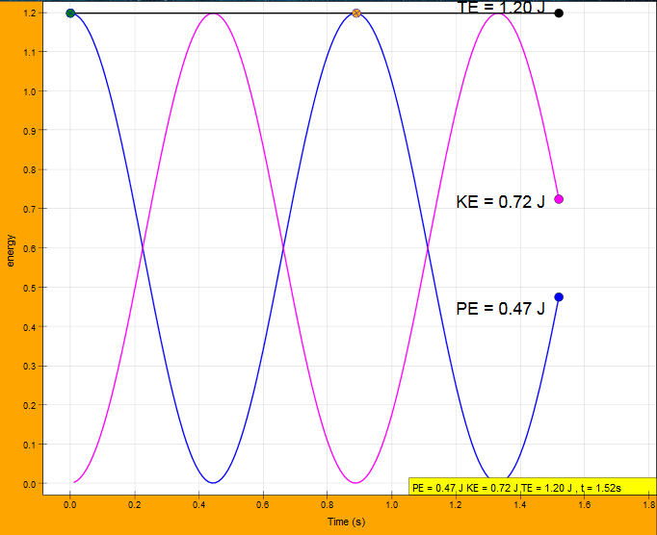
- Can you reproduce this figure? Try adjusting the initial angle and the length of the pendulum to see if you can re-recreate it perfectly.

ConcepTest 3!

APPENDIX: ConcepTests to be used

- Car #1 has twice the mass of car #2, but they both have the same kinetic energy. How do their speeds compare?
- 2 v₁ = v₂
- √2 v₁ = v₂
- 4 v₁ = v₂
- v₁ = v₂
- v₁ = √2 v₂

- You push a box halfway up a ramp, so that it has potential energy equal to Z. If you push the box all the way up the ramp, the potential energy will be
- equal to Z.
- greater than Z, but less than 2 Z.
- equal to 2 Z.
- one-half Z.
- impossible to determine
Possible extension question for classroom teaching: if the energy changed when you pushed the box up the ramp, where does the energy come from?

- Two marbles, one twice as heavy as the other, are dropped to the ground from the roof of a building. For these small marbles, air resistance is negligible. Just before hitting the ground, the heavier marble has
- as much kinetic energy as the lighter one.
- twice as much kinetic energy as the lighter one.
- half as much kinetic energy as the lighter one.
- four times as much kinetic energy as the lighter one.
- impossible to determine

