Objective | To create an interactive that allows students to explore how tilt angles affect output power (to emplace in Tab 2 Activity 1 of SLS lesson)
SLS Lesson | Solar Panels in Singapore [Enrichment] (moe.edu.sg)
Independent Variable | Tilt angle
Dependent Variable | Output power
Display | - Sun and sun’s rays  - Solar panels at various tilt angles  - Toggle for tilt angle  - If possible, graph of output power against tilt angle
Reference Images | Solar panels  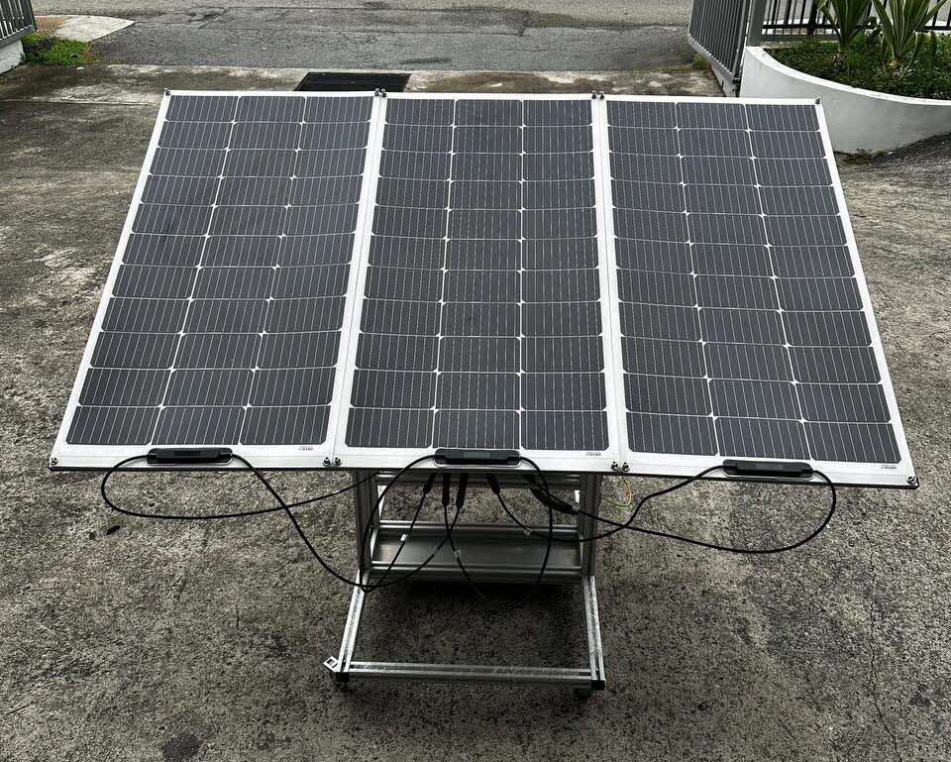
Solar panel and Sun
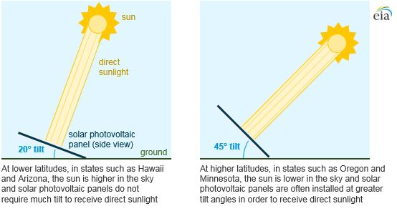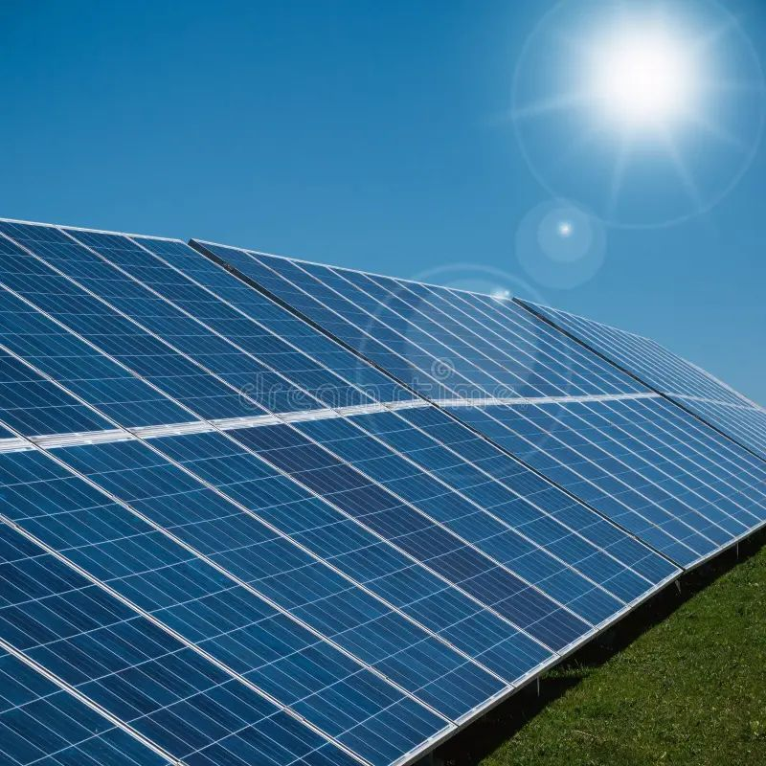
Reference data | Solar Radiation on a Tilted Surface | PVEducation  Singapore data:  Latitude 1.290270  Longitude 103.851959
Solar Array Tilt Angle and Energy Output | Greentech Renewables
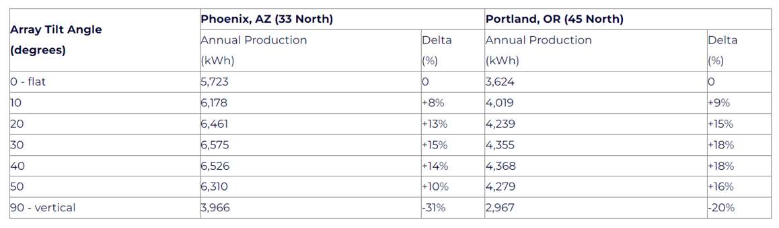
 | Fig. 6(c) and 6(d) of current/voltage against tilt angle (outdoor results)

