Anglican High School
Secondary 2 Science 2016
Physics Chapter 2: Kinematics

Kinematics | Analysing motion using video tracker

Name: |  | ( |  | ) |  | Class: |  |  | Date:

Analysing motion
So far, we have learn how to analyse the motion of a moving object by reading a tickertape diagram. However there are some inherent problems with using a ticker tape timer. For example, the friction of the ticker tape will definetely have an effect on the motion of the object. Can you think of any other problems with using a tickertape timers?
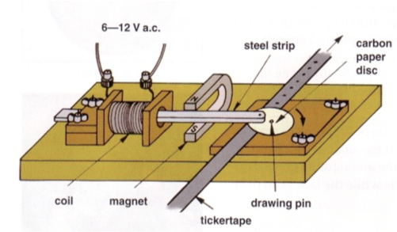

Video trackers
To overcome some of these problems, perhaps we can explore some ways of recording the motion without getting into contact with the object. We can take a video and mark out the position of the various positions of the moving object.

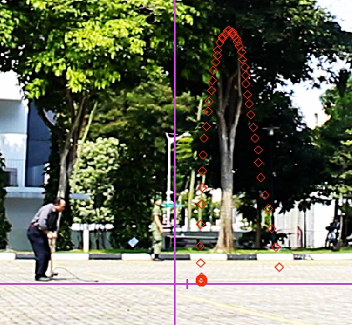 | 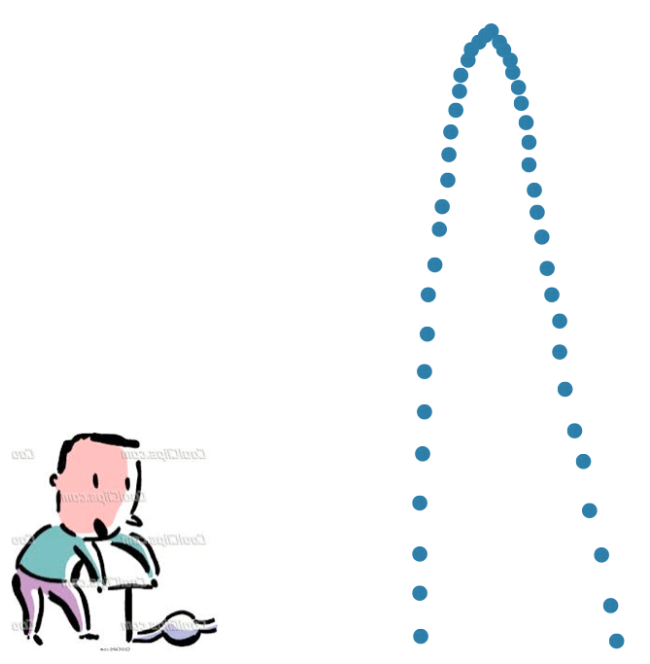

We have seperated the video into frames of 40.0 ms each and marked out the various positions. However, a problem encountered here is that the points were a little too close to each other to visually analyse the motion easily.

Overcoming problems
To overcome this problem, a simple way was to select alternate frames to analyse, providing a larger diference in position. However, this was done at the expense of having greater detail between the individual frames. As you can see in the diagram below, we now have a more obvious view of the motion.

Describing motion in words
One of the simplest ways of describing motion is in words. The diagram shows the path of the rocket at intervals of about 80.0 ms. Describe the motion qualitively.

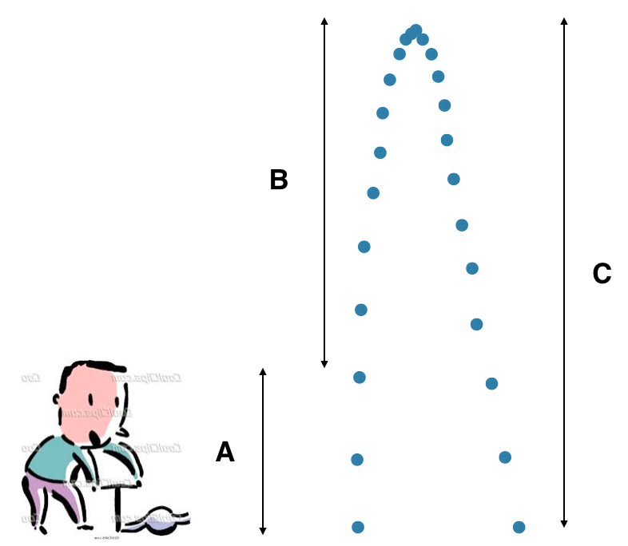

Describe the motion of the water rocket in the three sections. (you may wish to use the following keywords)
Key words: accelerating upwards downwards velocity

Graphical representation of motion
By using the tracker software from opensourcephysics, we are also able to generate various graphs to describe the motion of the moving objects. Can you decide which is the speed-time graph and which is the velocity-time graph? Justify your answer with a short paragraph.

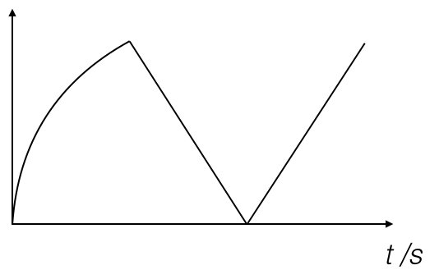 |  | 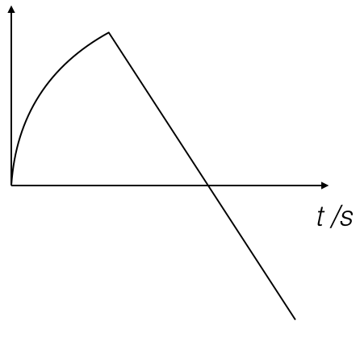

Justification

Taking upwards to be positive, label the following sections on the following graph. (the sections overlap and may have more than one label ) *label the y-axis
- Initial thrust
- Highest point
- Landed
- Acceleration
- Decceleration
Directions
Acceleration due to gravity near the Earth’s surface is given as $10m/s^{2}$ downwards. This means that objects falling under the sole influence of gravity is 10 m/s each second downwards. For the water rocket to achieve lift-off, it has to counteract gravity with the thrust given by expelling water due to the air pressure. This causes the water rocket to accelerate upwards, in the same direction as its velocity (section A)

As both velocity are vectors, we are concerned with their directions. At the different sections, indicate the direction of velocity and acceleration using arrows and labelling them on the figure of the rocket next to the tracked points.
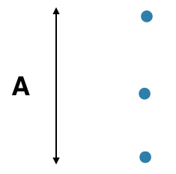 | 
