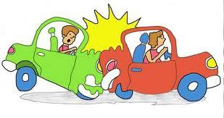
Exploring Impulse & Momentum II
- Car crash simulator
Proceed to download the “Collision carts model” applet:
https://dl.dropbox.com/u/44365627/lookangEJSworkspace/export/ejs_Momentum1DForceModel04.jar and read the following instructions carefully.

- Car crash investigation
An accident has occurred and the police tasked you with the role of investigating the impact of the accident. You are required to work as a team and make use of your skills and knowledge learnt in dynamics to determine the forces acting on both cars and the energy lost during the impact. Let’s begin!
- Launch the above “car crash simulator”.
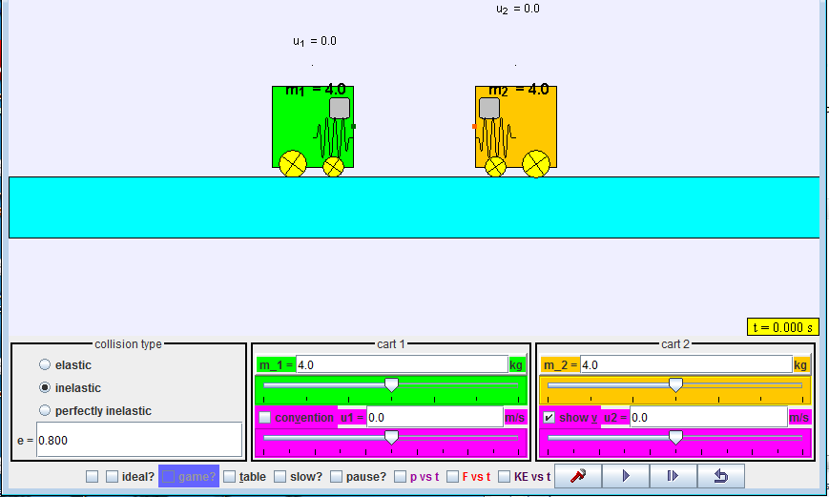
Fig. 1. Screenshot of the “car crash simulator” default settings.

- Using the default parameter (m₁= 4.0 kg, m₂= 4.0 kg, e = 0.8), set the initial velocities of the “cars” as u₁=2.0 m s⁻¹ and u₂= -2.0 m s⁻¹ and check the boxes “p vs t”, “slow”, “cart 1”, cart 2”.
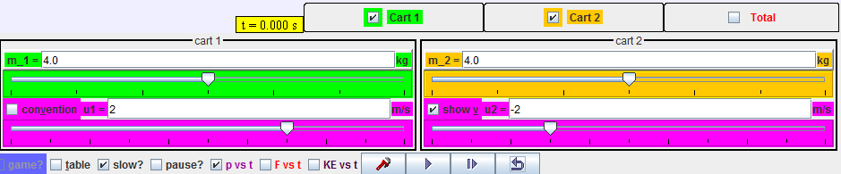

Fig. 2. Screenshot of the “car crash simulator” to investigate collision of identical cars with same momentum in a head-on collision.
- Click the play button and observe the collision between the two carts. Take note of the momentum vs time graph of the collision. Make use of the buttons below to pause, play in step or replay the collision event. Record down your observations below.

Fig. 3. Play/Pause, step and replay buttons.
Time of impact, t:
Duration of impact, Δ t:
Change in momentum of m_{1,} Δ p₁ :
Change in momentum of m_{2,} Δ p₂:
Average force of impact, <F>:
Total initial KEof system:
Total final KE of system:

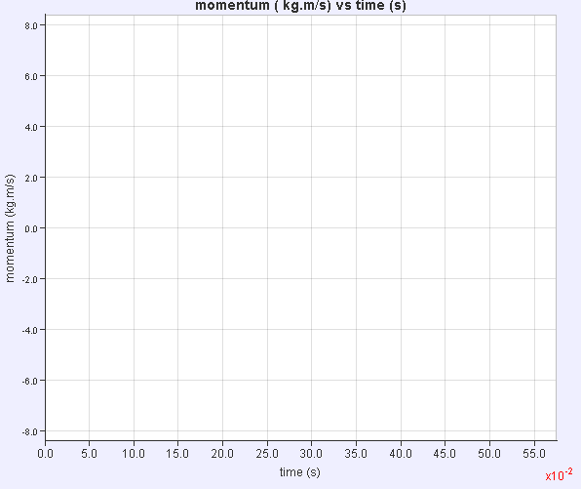
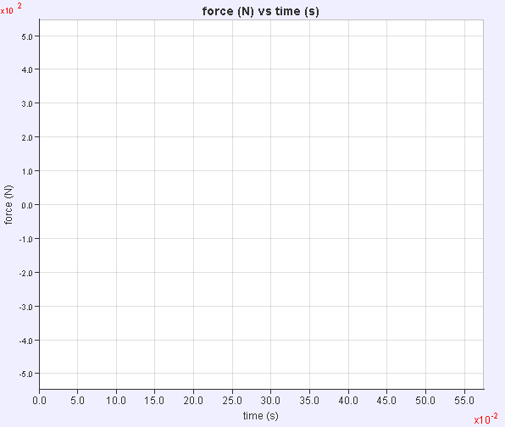

Q1. Is momentum conserved throughout the collision? How do you infer this from the graph?

…………………………………………………………………………………………………………

…………………………………………………………………………………………………………
Q2. What can you say about the change in momentum (impulse) of the two carts?

…………………………………………………………………………………………………………

Q3. What does the gradient of the momentum-time graph represent?

…………………………………………………………………………………………………………

Q4. Why do the gradients of each graph carry opposite sign from each other?

…………………………………………………………………………………………………………

…………………………………………………………………………………………………………

- Vary the masses and the initial velocities of the carts, so that they are different. Repeat for two more sets of data (1. Both initial velocities positive, 2. Both initial velocities negative). Take note of the momentum vs time graph of the collision. Make use of the buttons below to pause, play in step or replay the collision event. Record down your observations below.

m₁
m₂
u₁
u₂
Time of impact, t:
Duration of impact, Δ t:
Change in momentum of m_{1,} Δ p₁ :
Change in momentum of m_{2,} Δ p₂:
Average force of impact, <F>:
Total initial KEof system:
Total final KE of system:

- Apply what you have learnt to solve Q20 of your tutorial!

