Projectile motion (Model Development)
- Record video of projectile using webcam or any other camera
  - Ensure object is moving parallel to camera (not towards/away from camera)
  - Include a reference length (such as ruler) in the same plane as moving object
http://www.wikihow.com/Record-from-a-Webcam

- Collect displacement and time data by manual tracking the ball with the tracker software.
- Drag the video into tracker software to load the video
- Drag the 2 black triangles of the video time bar to set the start and end time of the video (you may not want to analyse the entire video)
- Click on to create the calibration stick
Drag the end of the calibration stick to the ends of an object with known length (such as a ruler)
Double click the number and key in the appropriate length
- Click on to create point mass
- Hold on the shift-key and click the object to be tracked (Do not release the shift-key).
The video will move on to the next frame. Repeat the step until you have tracked sufficient points for your analysis.
(If you click any points inaccurately, you can drag the dots you have clicked earlier to the correct position)
- Click on the y-axis of the graph to change the display to x-t graph.

- Click on the mass A and change the footprints to 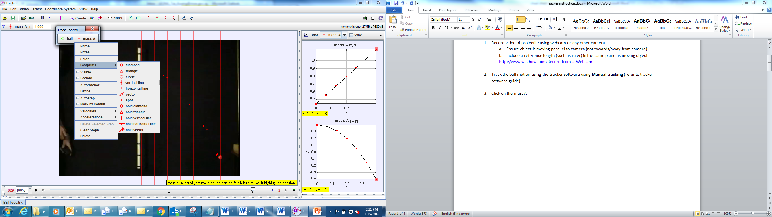

- Observe and discuss about the spacing between the horizontal displacements in each time interval.
………………………………………………………………………………………………………………………………………………………

- Model the x-t graph
- Double click the graph to activate Data Tool.
- In the data tool, select Analyze – curve fit to find the gradient of the graph.
- Check the autofit box.

- Determine the units of the gradient using the unit analysis and suggest the meaning of the gradient.

- File-close all to close the data tool (No need to save changes)
- Click on the mass A and change the footprints to

- Observe and discuss about the spacing between the vertical displacements in each time interval.
………………………………………………………………………………………………………………………………………………………

- Click on the y-axis of the graph to change the display to y-t graph.
- Using the Modelling cheat sheet, suggest changes to the axis to linearize the equation.
Click on the axis and define you own data functions for the axis. Example: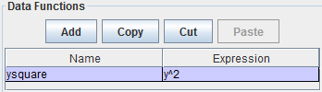
- Repeat step 5 to model the y-t graph.
- Determine the units of the gradient using the unit analysis and suggest the meaning of the gradient.

- Checking your model
  - Click on to create dynamics particle model (Cartesian).
  - Drag the slider to the last frame of the video
  - Click “Plot” and select “2” to display 2 graphs simulteously.
  - Select x-t on the 1st graph and y-t on the 2nd graph.
  - On each of the graph, right click to select “compare with” mass A (or whatever particles you have tracked).
  - Key in the values of x, y, v_{x}, v_{y}, f_{x}, f_{y} such that the model motion and graph matches that of mass A.
  - To fine tune the matching, mouse over the bar, 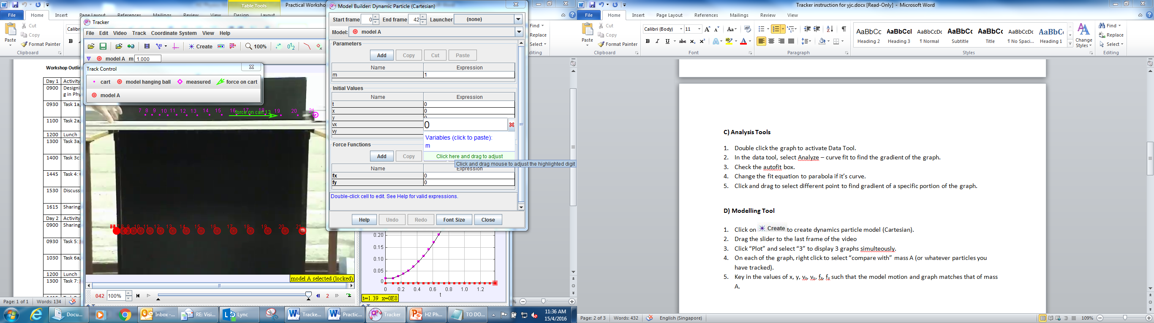 then click and drag to change the values. When your mouse is closer to the left, the 1st dp will be adjusted. When your mouse is closer to the right, the last dp will be adjusted.

Tracker Software guide summary
A) Manual tracking
- Drag the video into tracker software to load the video
- Drag the 2 black triangles of the video time bar to set the start and end time of the video (you may not want to analyse the entire video)
- Click on to create the calibration stick
Drag the end of the calibration stick to the ends of an object with known length (such as a ruler)
Double click the number and key in the appropriate length
- Click on to create point mass
- Hold on the shift-key and click the object to be tracked (Do not release the shift-key).
The video will move on to the next frame. Repeat the step until you have tracked sufficient points for your analysis.
(If you click any points inaccurately, you can drag the dots you have clicked earlier to the correct position)
- Click on the y-axis of the graph to change the display to other types of graph.
B) Autotracking (Sticking a big coloured sticker on the object will help to auto track)
- Step 1 to 5 is identical to manual tracking
- Click on “mass A” and select autotracker
- Hold shift-control and click the middle of the object to be tracked.
- Drag the circle to select a bigger area of the object (Select a bigger area for more precise autotracking. However the object selected should not change in appearance or be obstructed throughout the video)
- (Optional) Reduce the evolution rate to 5% for more precise tracking
- Press Search to start autotracking

Video step by step guide:
https://www.youtube.com/watch?v=H_zrkl16BNs
https://www.youtube.com/watch?v=7_TgOSMqRQs

C) Analysis Tools
- Double click the graph to activate Data Tool.
- In the data tool, select Analyze – curve fit to find the gradient of the graph.
- Check the autofit box.
- Change the fit equation to parabola if it’s curve.
- Click and drag to select different point to find gradient of a specific portion of the graph.

D) Dynamic Modelling Tool
- Click on to create dynamics particle model (Cartesian).
- Drag the slider to the last frame of the video
- Click “Plot” and select “3” to display 3 graphs simulteously.
- On each of the graph, right click to select “compare with” mass A (or whatever particles you have tracked).
- Key in the values of x, y, v_{x}, v_{y}, f_{x}, f_{y} such that the model motion and graph matches that of mass A.
- To fine tune the matching, mouse over the bar, then click and drag to change the values. When your mouse is closer to the left, the 1st dp will be adjusted. When your mouse is closer to the right, the last dp will be adjusted.

Note: The force may change over time. To key in different forces at different time, you can use the “if statement”.
Eg. From 0 to 2 s, the horizontal force is 3 N and subsequently the horizontal force is -4 N.
Key in Fx as “if (t<2, 3, -4)

