Name: _______________________________ ( ) Class: ______________ Date: __________
Subject: | Physics - Secondary | Time: 60mins
Worksheet Title: | Kinematics of a Falling Ball – Tracker Video Analysis

Aim: To use tracker video analysis tool for simple investigation on falling ball

Apparatus: Computer Lab with
Tracker by Prof. Douglas Brown, Workshop by Wee_Loo_Kang@moe.gov.sg
Windows Installer Tool:http://www.cabrillo.edu/~dbrown/tracker/
WebstartTool : http://www.cabrillo.edu/~dbrown/tracker/webstart/tracker.jnlp
Tracker is free software; you can redistribute it and/or modify it under the terms of the GNU General Public License
Internet Help http://www.cabrillo.edu/~dbrown/tracker/tracker_help.pdf or http://www.cabrillo.edu/~dbrown/tracker/help/frameset.html
Tutorial video http://www.youtube.com/watch?v=cuYJsnhWXOw
http://www.youtube.com/watch?v=WSG1x3klkH0
Workshop: http://weelookang.blogspot.sg/2014/02/tracker-workshop-at-national-jc.html

Engage:
Concepts in mechanics which include speed, velocity and acceleration are explored in this lesson. The tracker video analysis tool can be used in most motion based physics that allows learning physics to be fun and meaningful.

Procedure:
Setup
- Launch the Tracker software by using the Windows 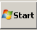 Start|All Programs|Tracker|Tracker and the screen should look like this.
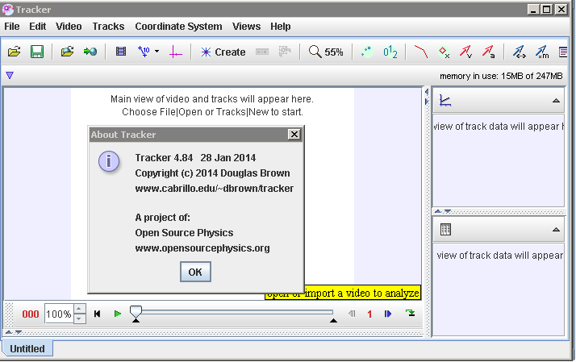
Play
Frame number
Step back
Axes
Tape Measure
File Open
Clip Settings

Acceleration vector
Velocity vector

- 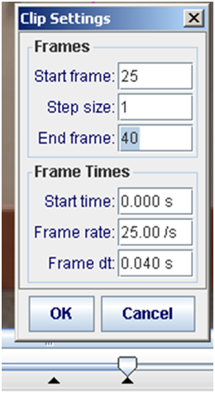Click the Open button or File|Open menu item and select a QuickTime video (.mov) or tracker file (.trk) to open it. Import use ballbouncelookang01_x264.mp4 (refer to website for download video link or tinyurl.com/trackernjc) and save the project as a filename of your choice for example balldropbounce4x_yourname.trk.
Select the display of the clip settings by clicking the clip settings button as shown.
In the clip settings dialog, set the Start and End frames to define the range you wish to analyze. In this video, set start frame to be 25 while the end as 40. Click on OK to proceed. Hint: numbers will defer when using own video.
- To calibrate the scale on the video, click the new calibration stick button to show the calibration stick A measure. For this video, the 1.000 m metre rule is on the video, move it to capture the length as in the video.
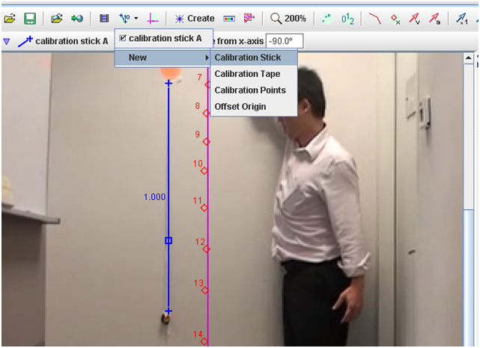
1.000 and press ‘Enter’
- Set the reference frame origin and angle. Click the Axes button to show the coordinate axes. Drag the centre of the axes origin (DO NOT drag the side tick that rotates the axes) and/or x-axis to set the reference frame origin and angle. A common choice for the origin is the initial position of an object of interest.
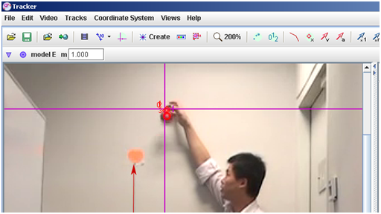

- 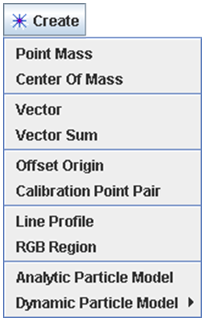Track objects of interest with the mouse or model them with particle models. Click the Create button and choose a track type from the menu of choices. Most moving objects are tracked using a Point Mass.

- (optional) The ball maybe difficult to detect due to the quality of the frames, thus in this case, select the Video|Filters|Deinterlace|Even|Close. This step may increase the visibility of the ball.

- To track an object, mark its position on every frame by holding down the shift key and clicking the mouse (crosshair cursor) as the video automatically steps through the video clip. Note: don't skip frames--if you do, velocities and accelerations cannot be determined. Track the ball until end of frame.Plot and analyze the tracks The Plot View displays graphs of track data. To plot multiple graphs, click the Plots button and select the desired (3) plots number. Click the x- or y-axis label to change the variable plotted on that axis. In this video, choose y versus t, vy versus t & ay versus t.
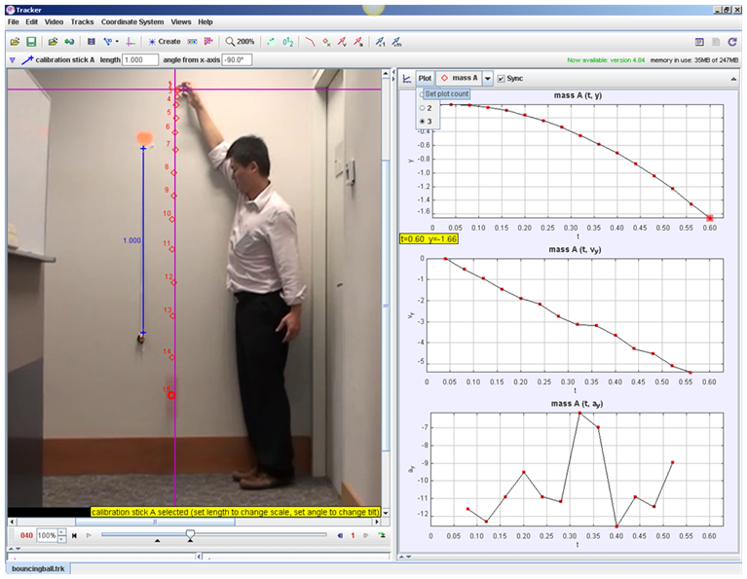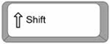
+ mouse click

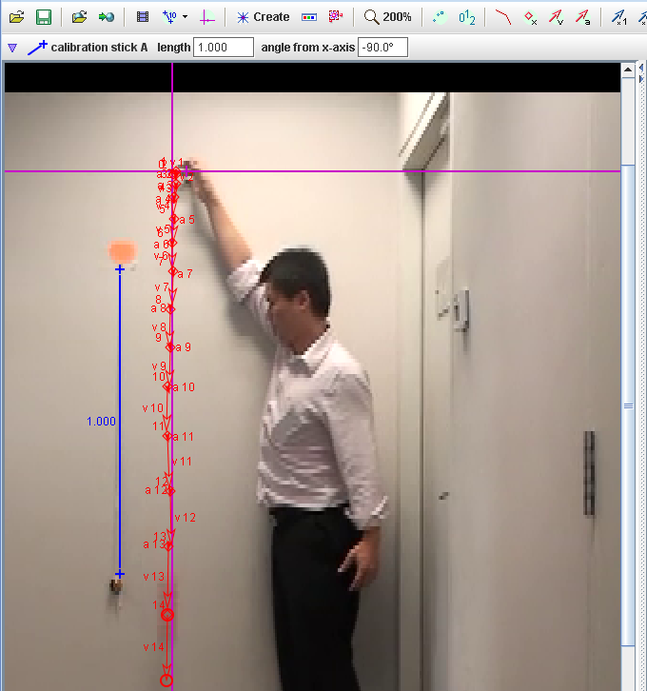

- Select the velocity and acceleration 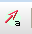 vectors to show. In your groups, discuss and make sense of the shape y versus t graph on the right top plots panel in relation to the motion map (v and a vectors). Hint: play the video to observe the changes

(A) DISPLACEMENT IN Y DIRECTION AGAINST TIME GRAPH
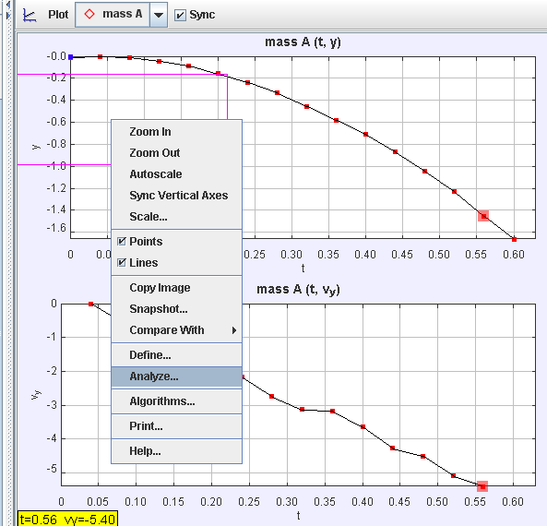
- Right-click on a plot (y versus t) to and select Analyze…. in the popup menu. For this graph, A Parabola Fit is suitable.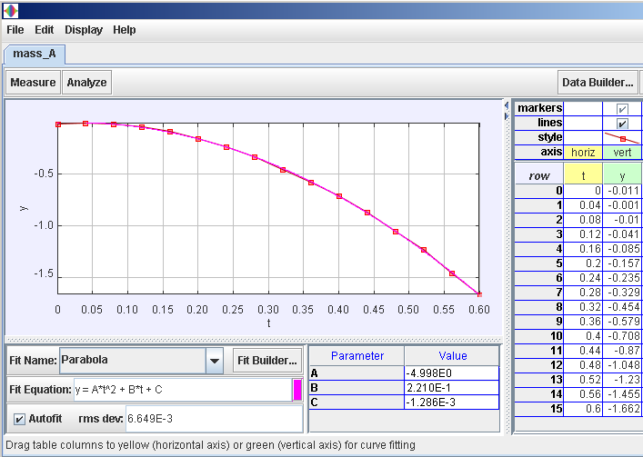

Select Analyze|Curve Fits|Parabola For time t =0 to 0.5 s, write down your values for the “Parabola” Fit Equation of the form y = A*t^2 + B*t + C, your data analysis values

Parameter A = _________________ and units __________

Parameter B = _________________ and units ___________

Parameter C = _________________ and units ____________

- Hence or otherwise, suggest an estimate for the gravitational acceleration on Earth, showing your working clearly. Hint: Equation of Motion under constant acceleration: ${y=\frac{1}{2}t^{2}+u t+y}_{0}$

- Hence or otherwise, suggest an estimate for initial velocity of the ball at frame 25.

(B) VELOCITY AGAINST TIME GRAPH

- Right-click on a plot (vy versus t) to access display and Analyze… options in a popup menu. For this graph, A Linear Fit is suitable. For time t =0 to 0.5 s, write down your values for the “Linear” Fit Equation of the form v_{y} = A*t + B, your data analysis values.

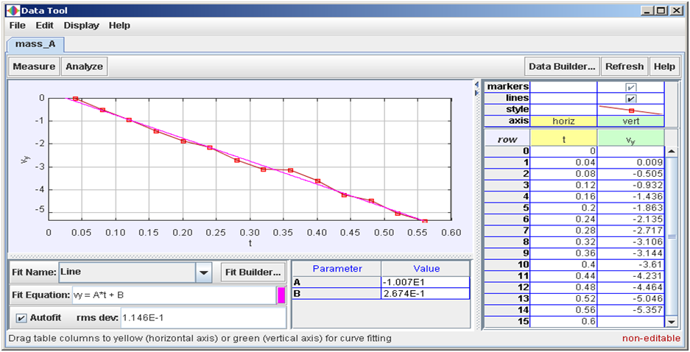
Select Analyze|Curve Fits|Line For time t =0 to 0.5 s

Parameter A = _______________ and units __________

Parameter B = ________________ __________

- Hence or otherwise, again suggest an estimate for the gravitational acceleration on Earth, showing your working clearly. Hint: Equation of Motion under constant acceleration: ${v=a t+u}_{}$

- Hence or otherwise, again suggest an estimate for initial velocity of the ball at frame 25.

(C) EXTEND LEARNING – Model Building.
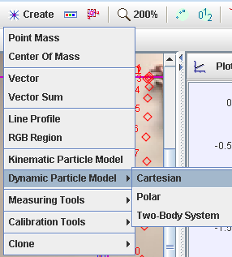
- To check whether you know how to use the numbers determined for v and a, model building process provides formidable learning experience.
- Go to Tracker select Create|Dynamic Particle Model|Cartesian and a new Model A is generated.
- Calculate the average of

vy = ___________________and

ay = ______________________ based on your earlier workings.

- Key in the initial vy and fy, assuming m = 1 kg. hint: F = ma
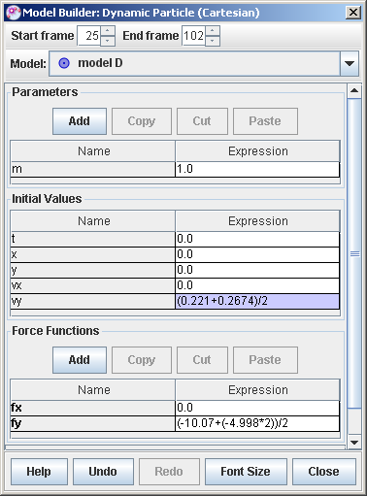
- Activate the motion map and right click to do a compare with the Model created.
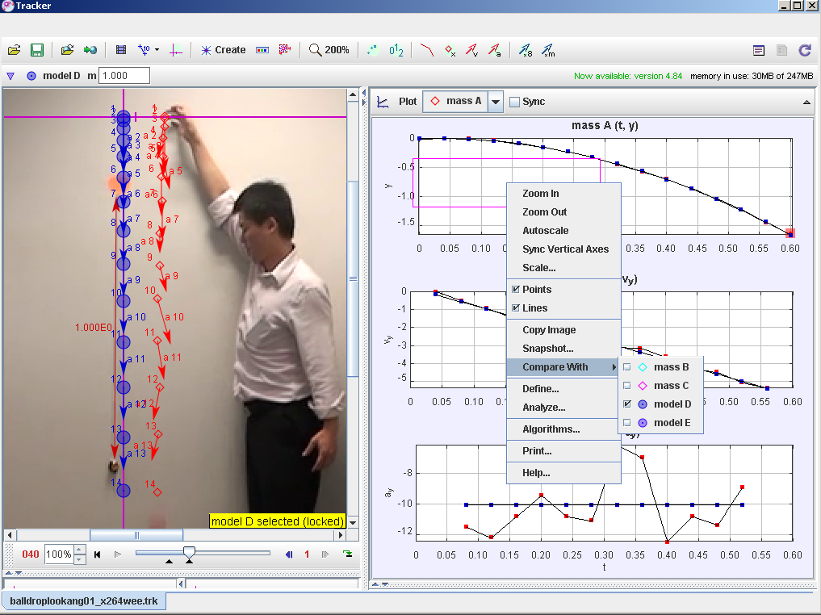

(D) PRACTICE – Video analysis and Model Building on your own video.

- Take your own video of an object of your choice falling under the influence of gravity and import it inside the tracker program using the import function. Best practices in video taking include having the one metre ruler in the video view (calibration purpose), a single colour background (ease of tracking), mounted camera (reduce errors) etc. After that, transfer the video file in mp4 or commonly used formats and tracker should be able to read them. When you are ready to share, export the whole project as a balldropbounce4x_yourname.trz as link it as a comment on my blog http://weelookang.blogspot.sg/2014/02/tracker-workshop-at-national-jc.html.

