Subject: | Physics - Secondary | Time: 90 mins
Worksheet Title: | Kinematics of a Falling Ball – Tracker Video Analysis

Aim: To investigate the kinematics of a falling ball

Apparatus: Computer Lab with
Tracker by Prof. Douglas Brown, Workshop by Wee_Loo_Kang@moe.gov.sg
Windows Installer Tool: http://www.cabrillo.edu/~dbrown/tracker/installers/Tracker-4.61-windows-installer.exe
Webstart Tool : http://www.cabrillo.edu/~dbrown/tracker/webstart/tracker.jnlp
Tracker is free software; you can redistribute it and/or modify it under the terms of the GNU General Public License
Internet Help http://www.cabrillo.edu/~dbrown/tracker/tracker_help.pdf or http://www.cabrillo.edu/~dbrown/tracker/help/frameset.html
Forum: Kinematics of a Falling Ball using Tracker Video Analysis Physics Secondary
Video http://www.youtube.com/watch?v=HfnXBDOhGE0&NR=1
http://jabryan.iweb.bsu.edu/videoanalysis/balldropbounce4x.avi
http://jabryan.iweb.bsu.edu/videoanalysis/ElasticI.avi
http://www.cabrillo.edu/~dbrown/tracker/mechanics_videos.zip
PD video http://www.youtube.com/watch?v=cuYJsnhWXOw
http://www.youtube.com/watch?v=WSG1x3klkH0

Background:
Concepts in mechanics which include speed, velocity, acceleration, force, gravitational field and energy conversion and conservation are explored in this lesson. Analysis of the motion of an object is performed using free-body and vector diagrams, graphical analysis as well as Mathematical formulas.

Procedure:
Setup
- Launch the software tracker by double clicking on the tracker.jar file. The screen should look like this.
File Open
Play
Clip Settings
Frame number
Axes
Tape Measure
Step back
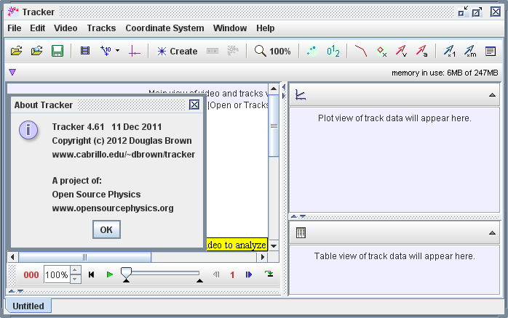

- Click the Open button or File|Open menu item and select a QuickTime video (.mov) or tracker file (.trk) to open it. Import the video ballbouncelookang01_x264.mp4 and save the project as a filename of your choice for example balldropbounce4x_mpeg4_002.mp4.trk.
Select the display of the clip settings by clicking the clip settings button at the right end of the player as shown.
In the clip settings dialog, set the Start and End frames to define the range you wish to analyze. In this video, set start frame to be 2 while the end as default. Click on OK to proceed.
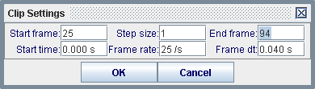
- Set the reference frame origin and angle. Click the Axes button to show the coordinate axes. Drag the origin and/or x-axis to set the reference frame origin and angle. A common choice for the origin is the initial position of an object of interest.
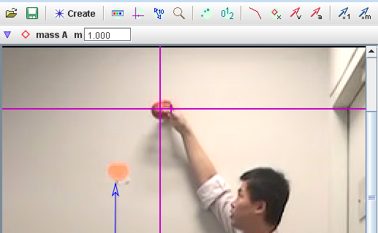
- To calibrate the scale on the video, click the Tape Measure button to show the tape measure. For this video, the 1.000 m metre rule is on the video, move it to capture the length as in the video.
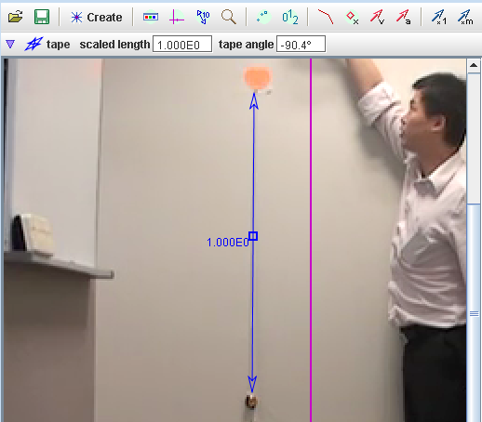

- Track objects of interest with the mouse or model them with particle models. Click the Create button and choose a track type from the menu of choices. Most moving objects are tracked using a Point Mass.
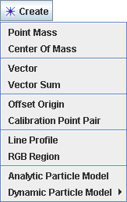

- (optional) The ball maybe difficult to detect due to the quality of the frames, thus in this case, select the Video–Filters-Deinterlace-Even and close it after selection. This step may increase the visibility of the ball.

- 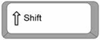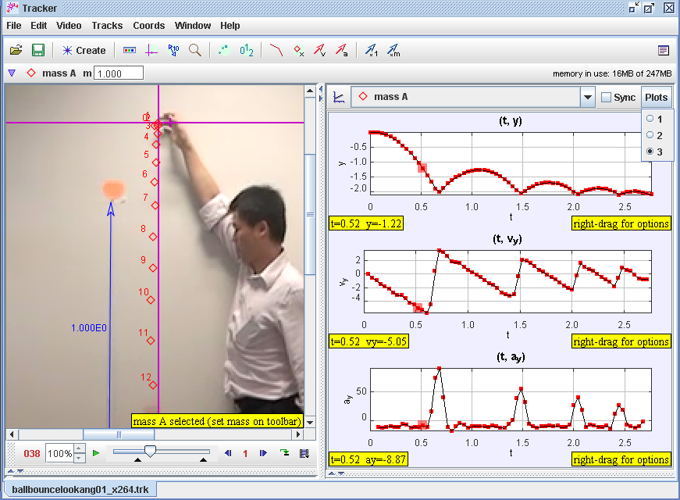If tracking an object, mark its position on every frame by holding down the shift key and clicking the mouse (crosshair cursor) as the video automatically steps through the video clip. Note: don't skip frames--if you do, velocities and accelerations cannot be determined. Track the ball until end of frame. Plot and analyze the tracks The Plot View displays graphs of track data. To plot multiple graphs, click the Plots button and select the desired (3) plots number. Click the x- or y-axis label to change the variable plotted on that axis. In this video, choose y versus t, vy versus t & ay versus t.
+ mouse click

- In your groups, discuss and make sense of the shape y versus t. Describe in as much detail as you can, the key features of the y vs t plot.

Y vs t , graph of displacement versus time of the bouncing ball, up as positive

- 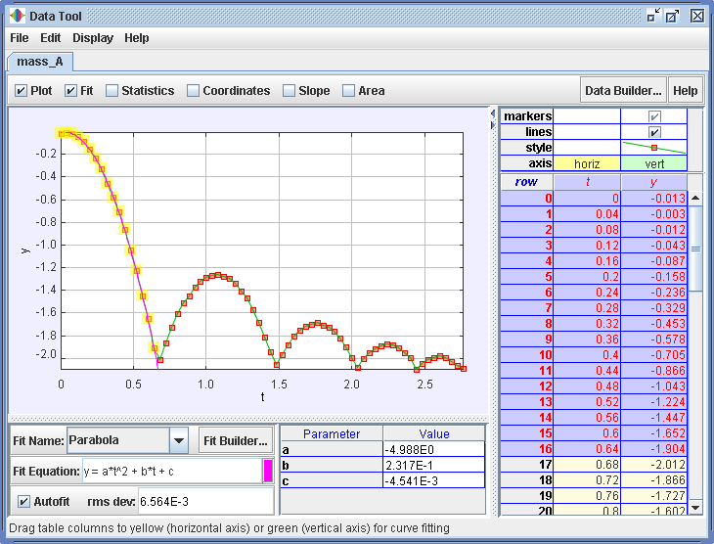Right-click on a plot (y versus t) to access display and analysis options in a popup menu. Select the various options as shown in the figure.

- POE using s vs t graph to get v vs t and a vs t
- Graph v vs t
- Graph a vs t
- Now, activate 3 graph view and select vy vs t and ay vs t
- Compare your initial predictions with the actual graphs-data. Explain why is your initial ideas the same and different, Do you know why your initial idea is slightly incorrect/different?
- Add the v vs t graph

- 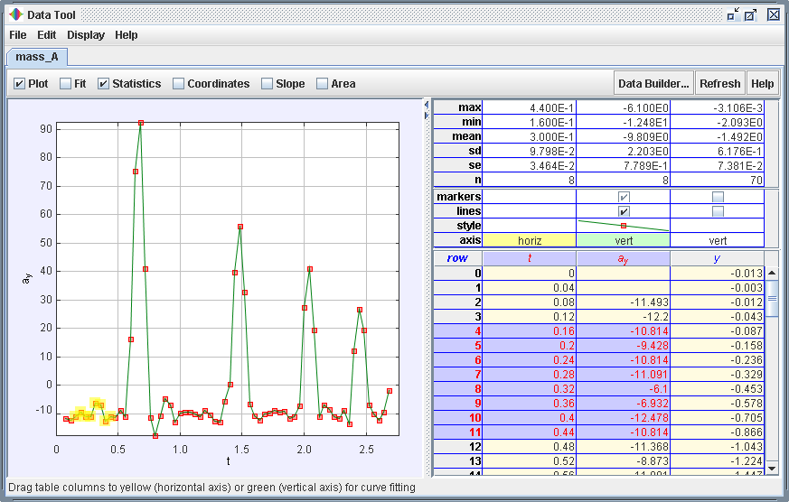Right-click on a plot (a_{y} versus t) to access display and analysis options in a popup menu. Select the various options as shown in the figure.

What is the average values of a_{y}=__-9.809E0___________ units _m/s^2__in your statistics mean?

Suggest with reason(s) what this value should be __gravitational field acceleration of Earth ~ -9.8 m/s^2 with positive y direction as upwards___________________?
Hint: Pedagogical consideration could be student might ask about the negative sign which can be easily explained by the adoption of the Cartesian coordinate system in tracker, but in word problem solving, the student may have a
((-9.976)+( -1.003E1)+( -9.809E0) )/3 = -9.94 m/s^2

* Name one assumption in this example’s determination of a_{y}
The ruler in the video is correctly calibrated and measured in the tracker

* Calculate the percentage error in this value hint: use the average g.

(9.94 – 9.81)/9.81 = 1.3%

* Suggest with reason, what are the sources of error and how to reduce the error?
The human measurement of each position of the ball, consistently take the middle of the blur ball as reference. (Random)

The ruler axes could be not vertically downwards in the direction of the gravitational field due to off axis video taken(Systematic)

The ruler could be off the calibrated length, need to recalibrate against longer length (Systematic)

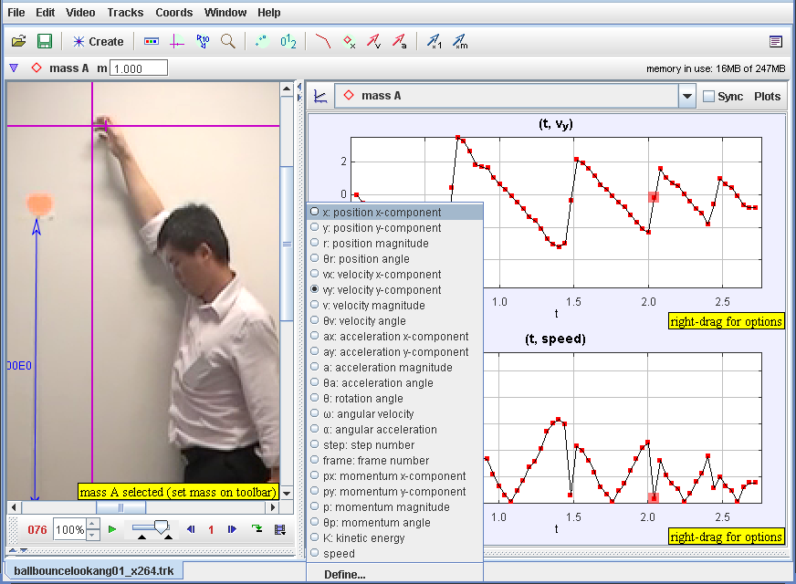

- Right click on the plot of v_{y} versus t and select Analyze-Area and select by click and drag the 2 grey vertical boundaries to select the area to measure for the duration of start of motion to the start of 1st bound of the ball. Calculate the area under a velocity-time graph.
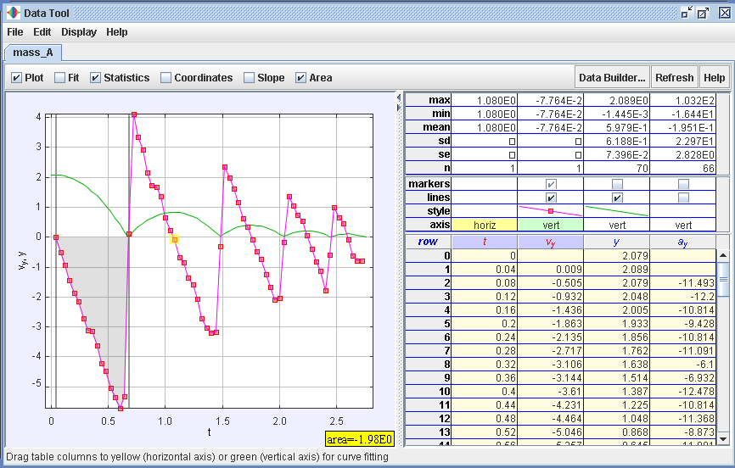
Drag the grey lines
the area under a velocity-time graph from t = 0 to 2.04 s is -1.98 m

- *How is the area under a velocity-time graph related to change in displacement?

Area under a velocity-time graph = change in displacement

- 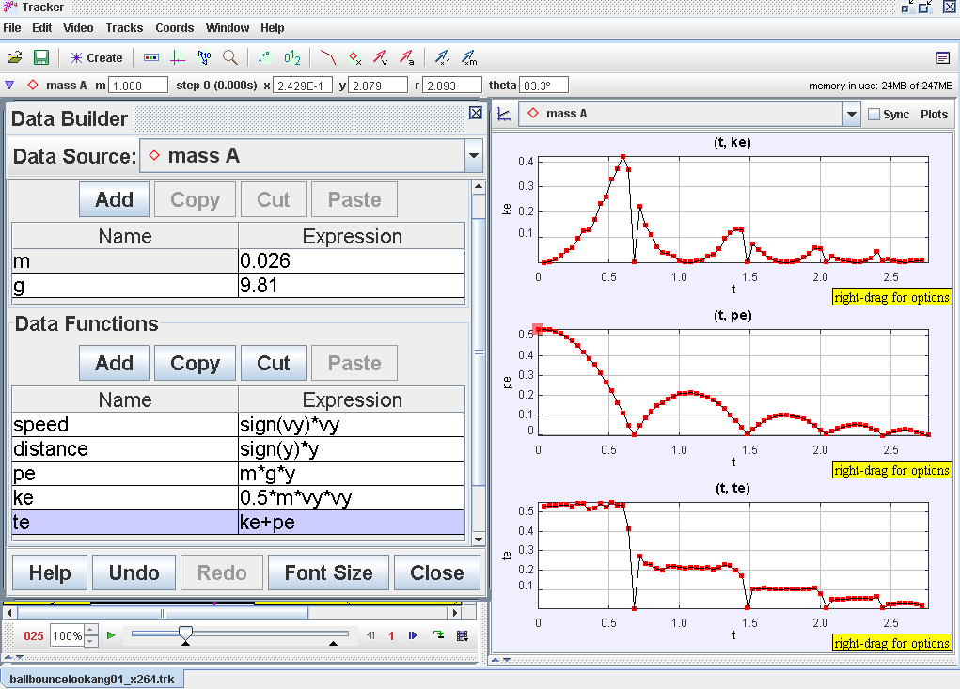By defining potential energy, kinetic energy and total energy, hence show the analysis as shown.

- Suggest what evidence(s) indicate that the total energy is conserved and for which part of the motion?
The total energy is conserved when the ball is moving in the air without bouncing on the ground

- Calculate the percentage total energy loss for the 1st rebound and suggest what happened to the total energy loss? hint: think about energy conversion

TE loss = ((-0.219) – (0.54))/ 0.54 = 0.59

Converted to other energy like heat and sound

- Now click and drag the axes of the World View at any y position. What did you observe? What conclusion(s) can you draw about the determination of potential energy with respect to a reference level?
The PE is arbitrary set depending on the reference level (axes of y )

Please email WEE_Loo_Kang@moe.gov.sg to improve the lesson
Post your *.trk file (may need to zip it first) on the ICT connection discussion forum http://ictconnection.edumall.sg/cos/o.x?ptid=709&c=/ictconnection/forum&func=forumdisplay&id=47 if you need help with this tracker tool.

- For time t =0 to 0.5 s, write down your values for the “Parabola” Fit Equation of the form y = a*t^2 + b*t + c, your data analysis values.
Coefficient parabola fit, a = ___-4.988______________ and units ___m/s^2_______
Coefficient parabola fit, b = ___0.2317______________ ____m/s_______
Coefficient parabola fit, c = ___0______________ ______m______
- * Repeat Steps 9 to 11 for plot (v_{y} versus t) and fill in the “Linear” Fit Equation of the form y = a*t + b. hint: EOM v = u + a*t
Coefficient of linear fit, a = __ -1.003E1 _______________ and units __m/s^2________
Coefficient of linear fit b = ____ 2.585E-1 ____________ ___ m/s________

- * Hence or otherwise, suggest an equation for the graph of
v_{y}(t)= ____ 2.585E-1 + -1.003E1*t______________________ and units ______m/s_______ .

