Name: _______________________________ ( ) Class: ______________ Date: __________

Kinematics of a Falling Ball

Topic: Kinematics |  | Estimated Duration: 2 hours
More information and extended learning material is available only at www.Tinyurl.com/evg3phy
- Aim
To describe the motion of an object falling under gravity in terms of the graphs of its displacement and velocity with respect to time.
- Description
A ball is launched vertically upwards by a person’s hand (Figure 1). It eventually reaches a maximum height before falling back to the ground. Note: upwards motion is taken as positive and downwards motion is taken as negative in this exercise.

Positive direction


Figure 1

- Key Questions
- How do the graphs of motion of the ball tell us when it changes direction?
- How do the graphs of motion of the ball tell us when it is speeding up or slowing down?
- How is the displacement-time graph of the ball related to its velocity-time graph?

- Materials
- Worksheets
- Tracker software from http://www.cabrillo.edu/~dbrown/tracker/
Materials such as sample videos and Beginners’ Guide can also be found on the website.
- Video clip of ball thrown upwards
(From the above website, download “mechanics_video.zip” from “Sample Videos”. Locate and save the video “BallTossUp” onto your computer desktop.)

(A) SETTING UP

- Launch the software tracker by double clicking on the tracker.jar file. The screen should look like this.
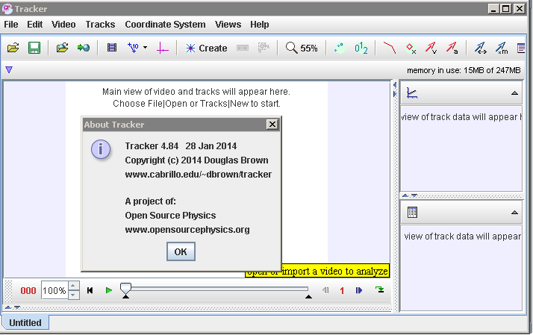
Axes
Tape Measure
File Open
Clip Settings
Play
Frame number
Step back

- Click the Open button or File|Open menu item and select the video “BallTossUp” from the desktop.

- Select the display of the clip settings by clicking the clip settings button . In the clip settings dialog, set the Start and End frames to define the range you wish to analyze. In this video, set the start frame to be “14” and end frame as “39” as shown below. Click on “OK” to proceed.

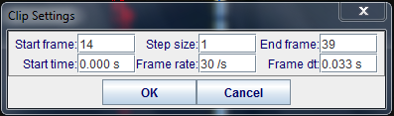

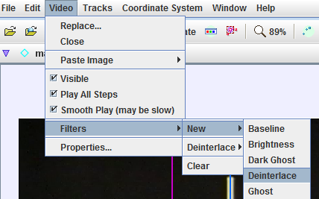
- (optional) The ball maybe difficult to detect due to the quality of the frames, thus in this case, select the “Video|Filters|New|Deinterlace|Even” and close it after selection. This step may increase the visibility of the ball.

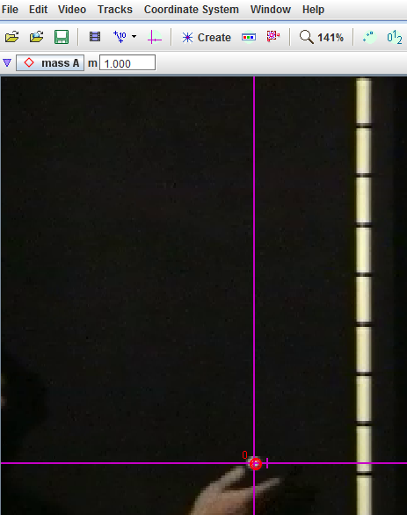
- Set the reference frame origin and angle. Click the Axes button to show the coordinate axes. Drag the origin and/or x-axis to set the reference frame origin and angle. A common choice for the origin is the initial position of an object of interest.

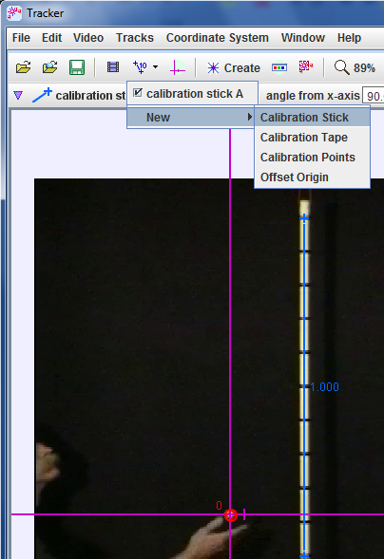
Initial position

- To calibrate the scale on the video, click the Tape Measure button to show the tape measure. For this video, the 1.000 m metre rule is on the video, move it to capture the length as in the video.
1.000

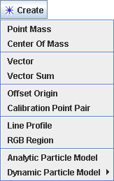
- Track objects of interest with the mouse or model them with particle models. Click the Create button and choose a track type from the menu of choices. Most moving objects are tracked using a Point Mass.
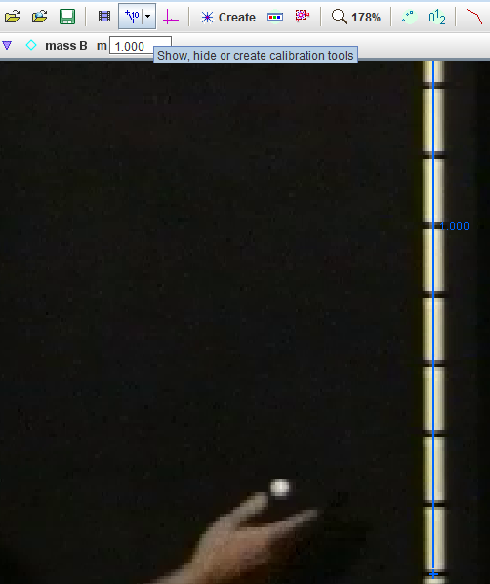

- 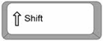When tracking an object, mark its position on every frame by holding down the shift key and clicking the mouse (crosshair cursor) as the software automatically steps through the video clip. Note: don't skip frames--if you do, velocities and accelerations cannot be determined. Track the ball until end of frame.
Mouse over and click on object to be tracked
+ left Mouse click
1.000

- Plot and analyze the tracks. The Plot View displays graphs of track data. To plot multiple graphs, click the Plots button and select the desired (3) plots number.

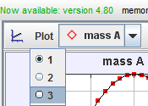

Select 3 Plots

- Click the x- or y-axis label to change the variable plotted on that axis. In this video, choose y versus t and v_{y} versus t. and a_{y} versus t.
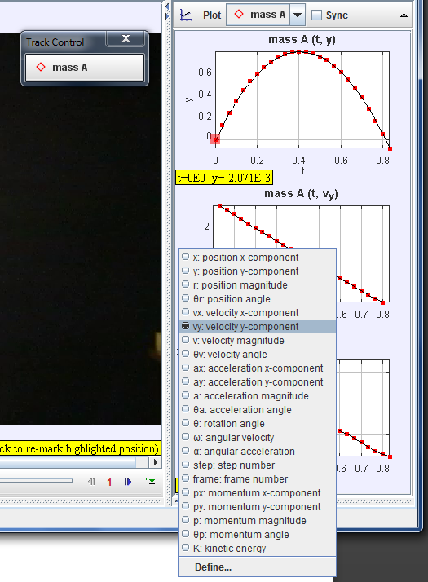

(B) DISPLACEMENT IN Y DIRECTION AGAINST TIME GRAPH

1. In the right panel of y vs t, right click with the mouse and select Analyze. 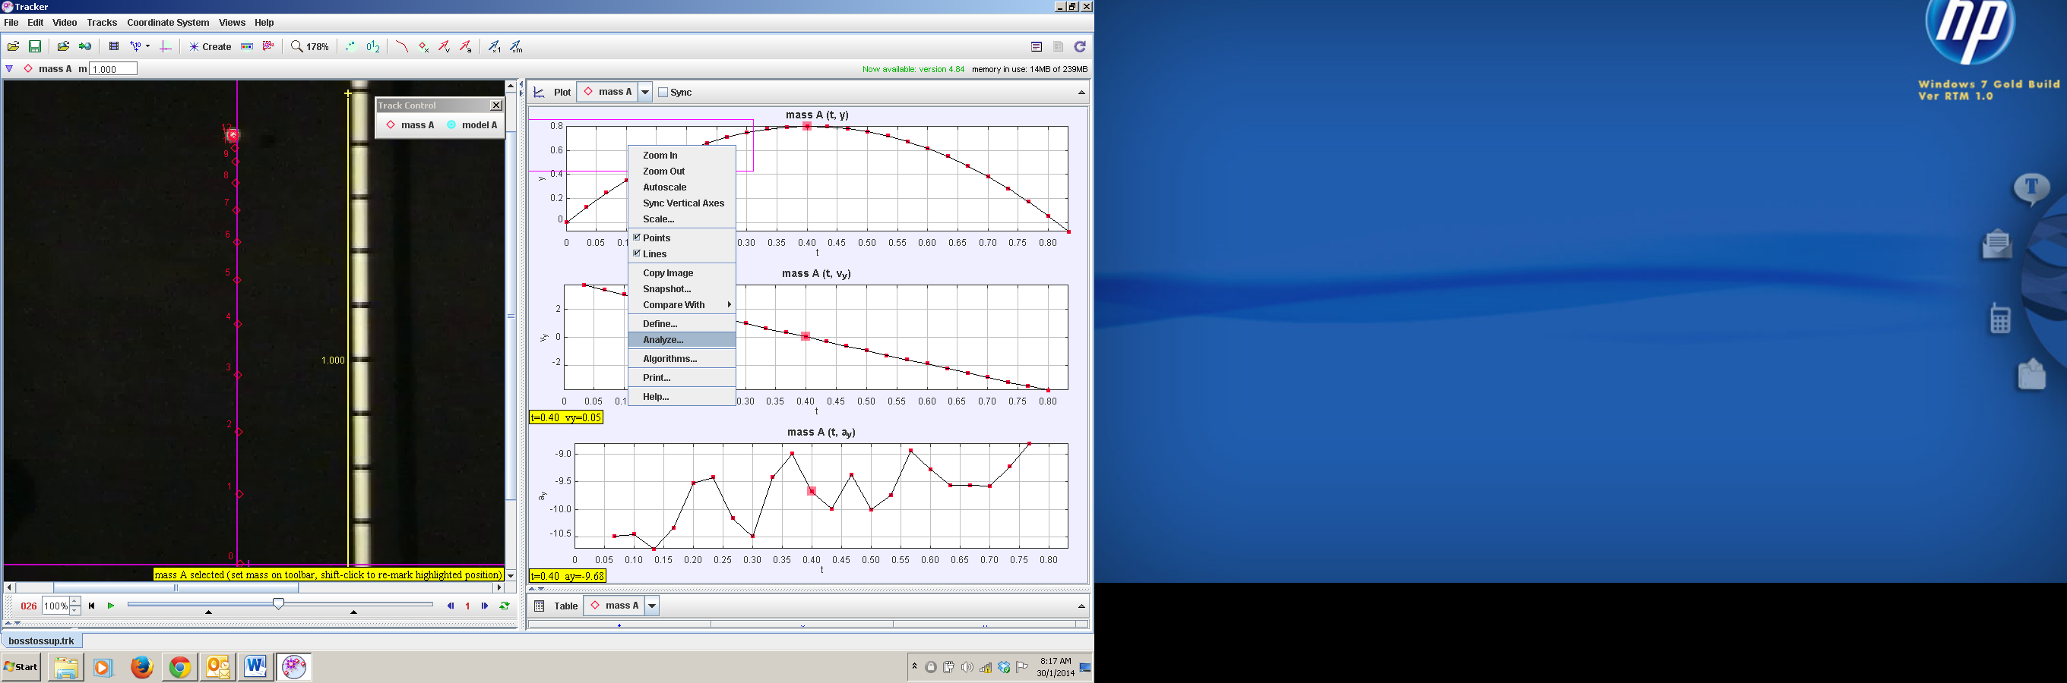
2. Select Measure – Slope and move the mouse to the respective point of interest and look at the slope values. Note: Slope = 1.98E0 is a representation for 1.98 x 10 ⁰
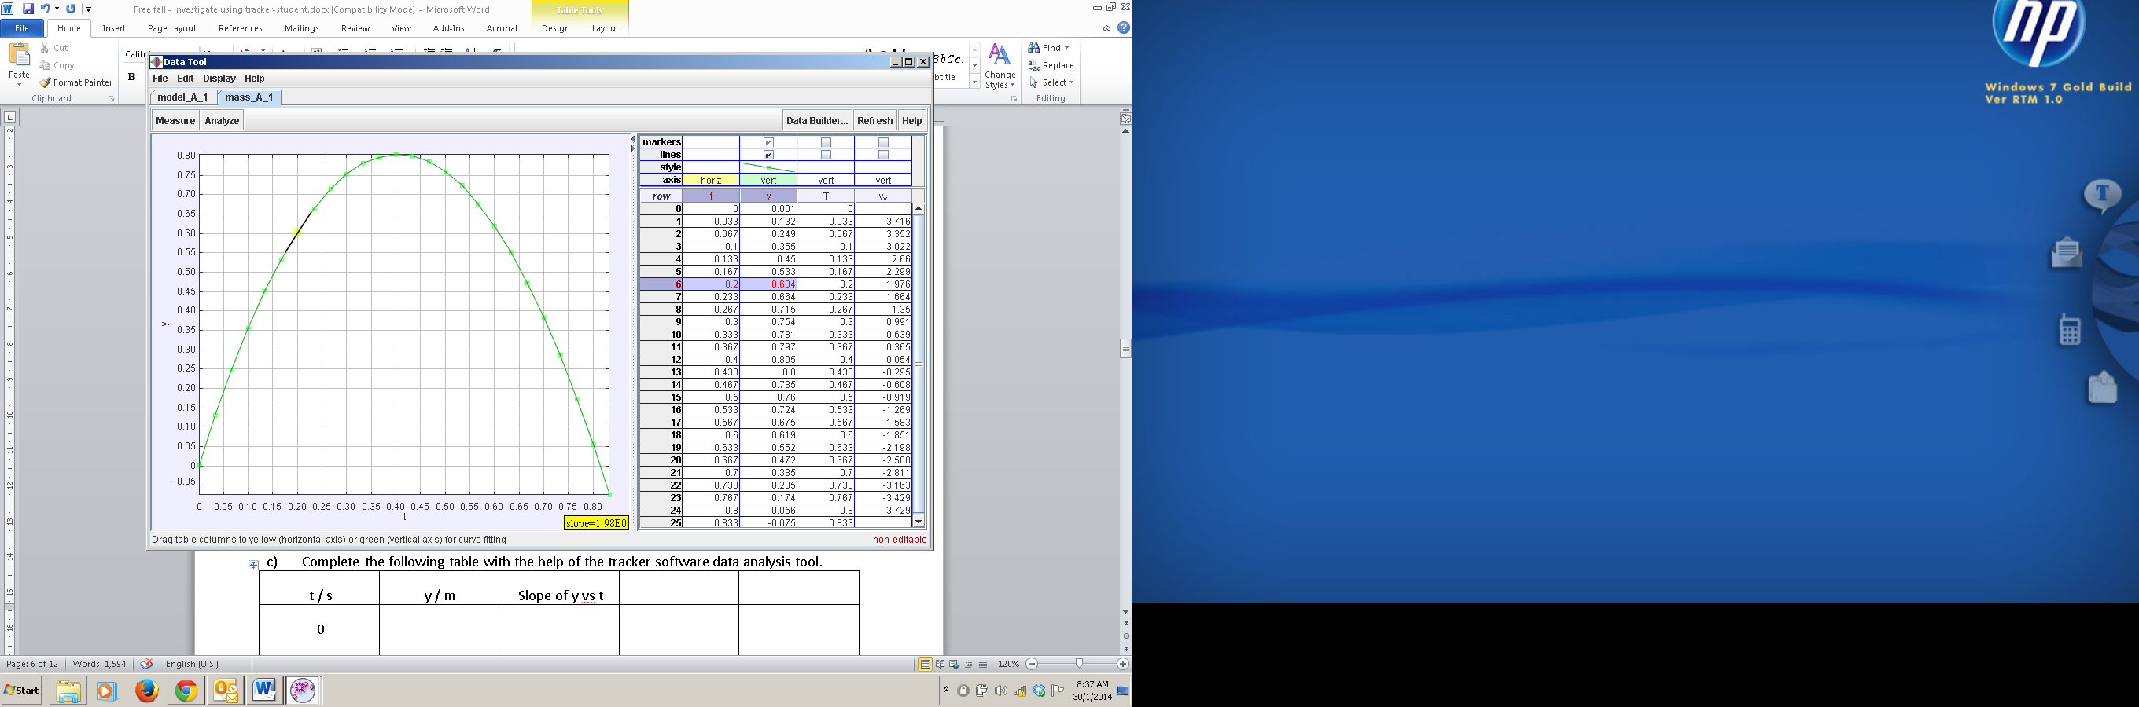
Figure 1

- Figure 1 shows the displacement in y direction against time graph. In Figure 1, highlight the region for which the ball is
a) moving upwards and label this region A,
b) changing direction and label this point B,
c) moving downwards and label this region C.

- Complete the following table with the help of the tracker software data analysis tool.

t / s | Region A, C or point B | y / m | Slope of y vs t / ms⁻¹ | Direction of motion up, down, change direction etc.
0.00
0.20 |  | 0.604 | 1.98 | up
0.40 | B
0.60
0.80

- Discuss with your partner drawing from the evidences on the table collected, and circle the most appropriate answer.
- When y is increasing, the direction of motion is upwards / downwards / change direction, the slope of the y vs t is decreasing / zero / increasing.
- When y is at it’s highest, the direction of motion is upwards / downwards / change direction, the slope is y vs t is momentarily decreasing / zero / increasing.
- When y is decreasing, the direction of motion is upwards / downwards / change direction, the slope of the y vs t is decreasing / zero / increasing.

(C) VELOCITY AGAINST TIME GRAPH

- Similarly, in the right panel of v_{y} vs t, right click with the mouse and select Analyze.
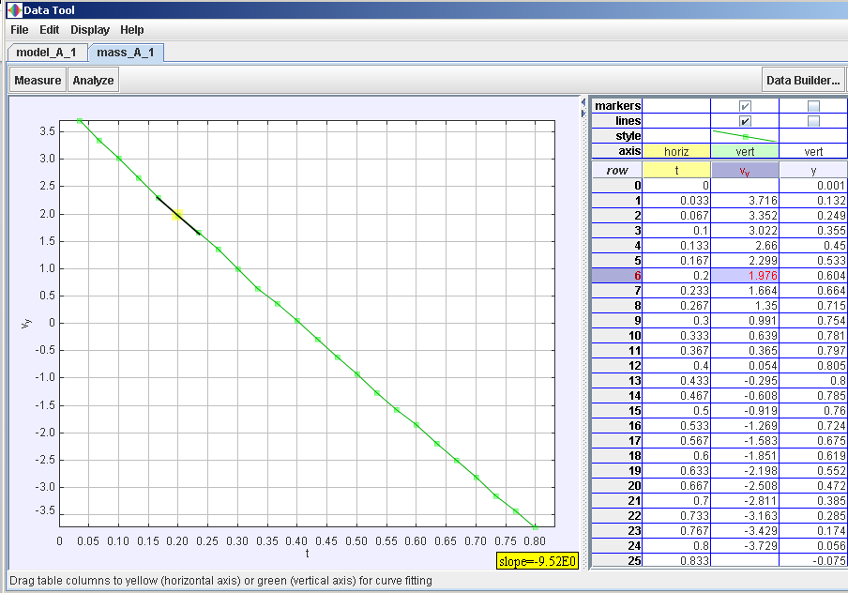
- Uncheck the y column and click and drag the vy column next to the t column as shown.
Figure 2

- Figure 2 shows the velocity against time graph. In Figure 2, highlight the region for which the ball is
a) moving upwards and label this region A,
b) changing direction and label this point B,
c) moving downwards and label this region C.

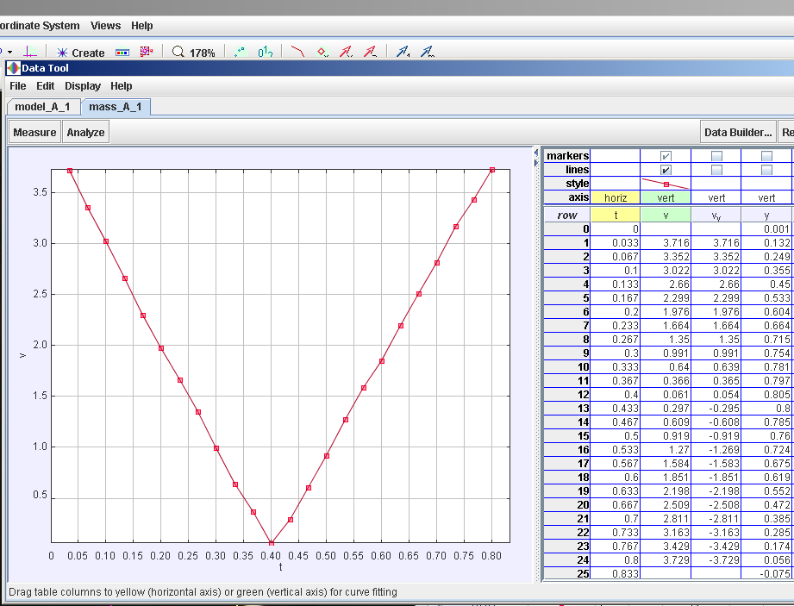
- Complete the following table with the help of the tracker software data analysis tool. Hint: |v_{y} |can be found as a selectable variable on right graph.

t / s | Region A, C or point B | v_{y} / ms⁻¹ | |v_{y} |/ ms⁻¹ | Slope of v_{y} vs t / ms⁻² | Direction of motion up, down, change direction etc. | |v_{y} |speed up or slow down etc.
0.00
0.20 | A | 1.976 | 1.976 | -9.52 | up | Slow down
0.40
0.60
0.80

- Discuss with your partner drawing from the evidences on the table collected, and circle the most appropriate answer.
- When y is increasing, the direction of motion is upwards / downwards / change direction, the velocity v_{y} is decreasing / zero / increasing but the magnitude of the velocity is |v_{y}| is decreasing / zero / increasing .
- When y is at it’s highest, the direction of motion is upwards / downwards / change direction, the velocity v_{y} is decreasing / zero / increasing but the magnitude of the velocity is |v_{y}| is decreasing / zero / increasing .
- When y is decreasing, the direction of motion is upwards / downwards / change direction, the velocity v_{y} is decreasing / zero / increasing but the magnitude of the velocity is |v_{y}| is decreasing / zero / increasing .

- By comparing the columns of v_{y} and $\frac{dy}{dt}$ ,the slope of y vs t or otherwise, suggest a mathematical equation involving $\frac{dy}{dt}$ and $v_{y}$.

_________________________________________________________________________
- Describe the gradient at point B and hence state the instantaneous velocity of the object at B.

_________________________________________________________________________
- Using the completed data in column Slope of v_{y} vs t, calculate the average of Slope of v_{y} vs t, showing your working clearly.

_________________________________________________________________________

(D) ACCELERATION AGAINST TIME GRAPH

- Similarly, in the right panel of a_{y} vs t, right click with the mouse and select Analyze.
- Uncheck the unnecessary columns such as y, vy, |v|and and click and drag the ay column next to the t column as shown. Uncheck the slope and now select the Analyze – Statistics as shown.
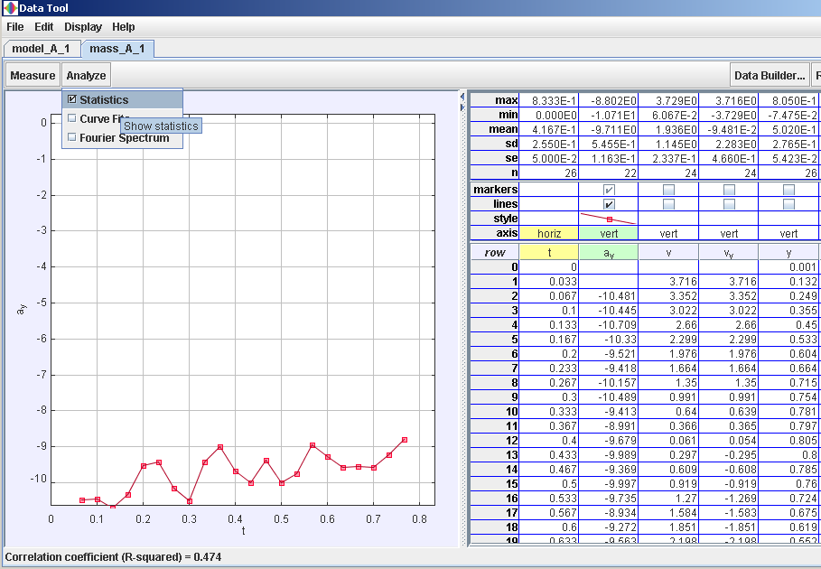

- Record down the value of mean of a_{y} ___________________________and suggest the significance of the acceleration in y direction means in real life on earth.

_________________________________________________________________________

- By comparing the value found in average of Slope of v_{y} vs t (C8 above) with the mean of a_{y} (D3 above), suggest a mathematical equation involving $\frac{dv_{y}}{dt}$ and $a_{y}$.

_________________________________________________________________________

- Suggest the type of error (none / random / systematic / all of the choices) that is associated with measurement/calculation of a_{y} that results in an equal chance to fluctuate between the true value.

_________________________________________________________________________

- Go to the tracker world view and change the calibration value from the correct value of 1.000 m to say 1.5 m (overestimation of the correct measurement of one metre ruler), record down the value of the a_{y} now. Reset back the calibration length to 1.000 m for the extend learning part.
1.500

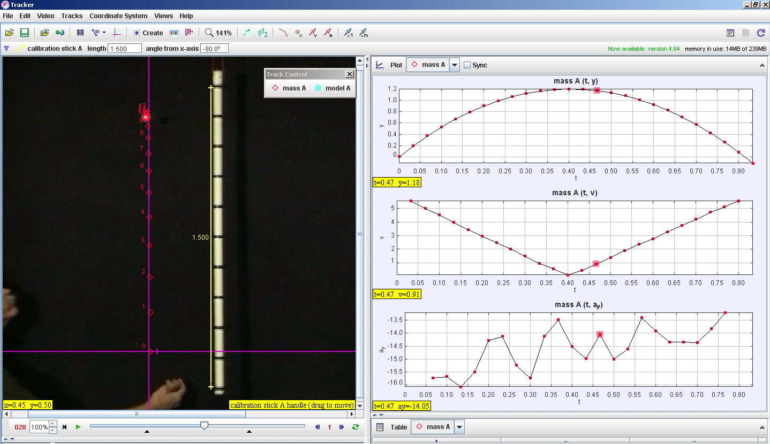
Figure 4

- In this case of a constant overestimation of the correct measurement, what is the sign (positive / negative) and name of this kind of error (none / random / systematic / all of the choices)?

- Test yourself: At the highest point of the motion point B, the velocity is momentarily (negative / zero / positive) and its acceleration is (zero / non-zero).

(E) EXTENDED LEARNING

To model throwing of a larger force on the same mass ball, create a dynamic model with a higher initial speed.

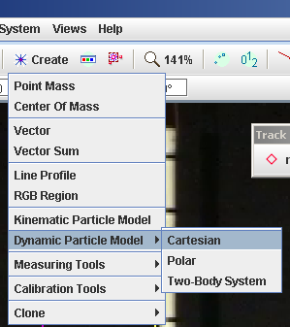
- Go to Tracker Select Create – Dynamic Particle Model – Cartesian and a new Model A is generated.

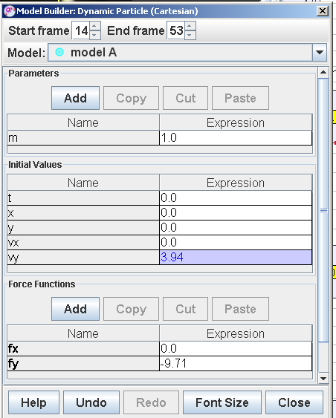
- Key in the values as shown which is initial velocity in y direction v_{y} = 3.94 and Force in the y direction fy = -9.71. recall Newton’s 2nd Law: F = ma, when m = 1 kg, F_{y} = a_{y}

- Key in a slightly larger initial v_{y} say = 5 and run the video and observe the result motion in the world view as well as the vy versus t graph. Note to reset back the calibration length to 1.000 m. To get the view as shown, right click on the right panel as select compare with Model A for all three Plots.
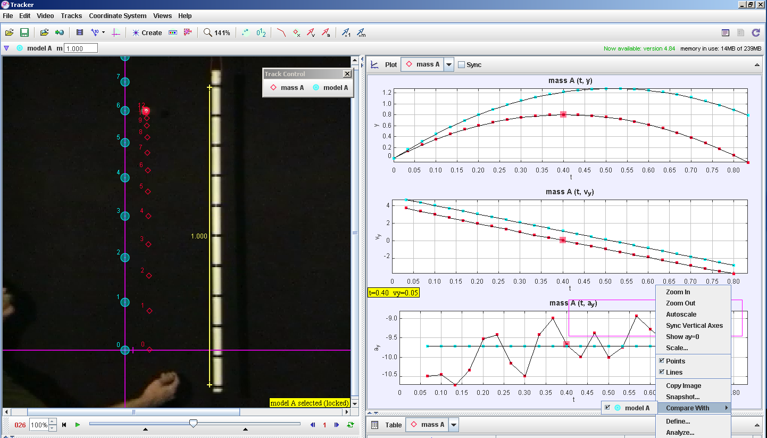

Hence or otherwise, describe the graph of vy vs t for the case when the initial vy is larger than 3.94 ms⁻¹ ( the actual ball) throwing the same ball upwards with larger force? Explain your answer.

_______________________________________________________________________
- To model the gravity on Moon g = 1.67 ms⁻², let’s key in this value into the force in the y direction of this dynamic particle motion A. Run the video and observe the result motion in the world view as well as the v_{y} versus t graph. Check that the calibration length to 1.000 m. To get the view as shown, right click on the right panel as select compare with Model A for all three Plots. 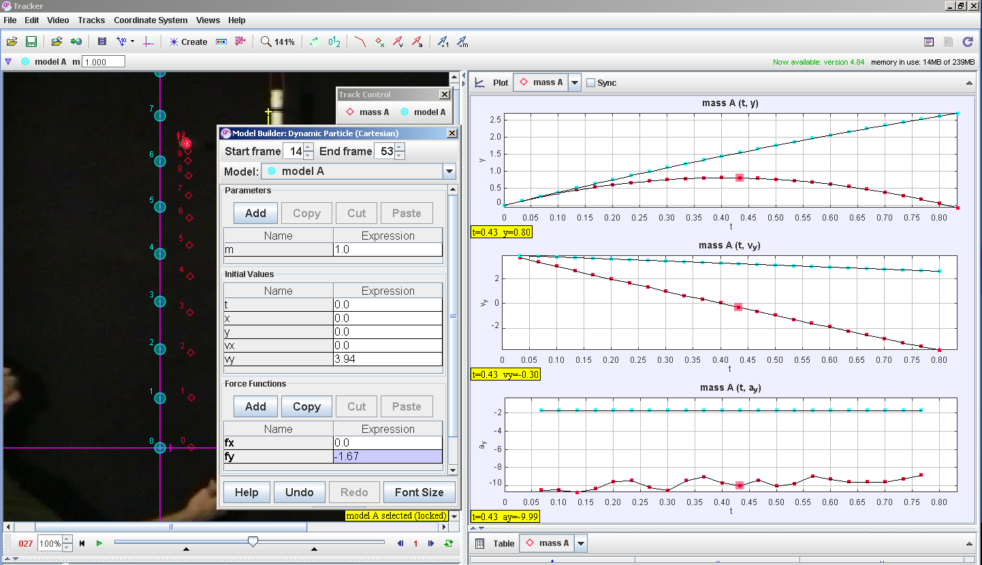

Hence or otherwise, describe the graph of v_{y} vs t for the case when this same ball is thrown on the surface of the moon (the actual ball) throwing the same ball upwards with same force? Explain your answer.

______________________________________________________________________________

- References
The Tracker software, sample videos and Beginners’ Guide for Tracker http://www.cabrillo.edu/~dbrown/tracker/
- Acknowledgement
This lesson package is crafted in collaboration with Educational Technology Division-Curriculum & Planning Division- Evergreen Secondary-National JC.

