Activity 1: Horizontal Motion


Open the Kinematics Simulator on your phone
Alternatively, open Kinematics Car HTML5 on the “Open Source Physics @ SG” website in your browser: http://tinyurl.com/driving-car
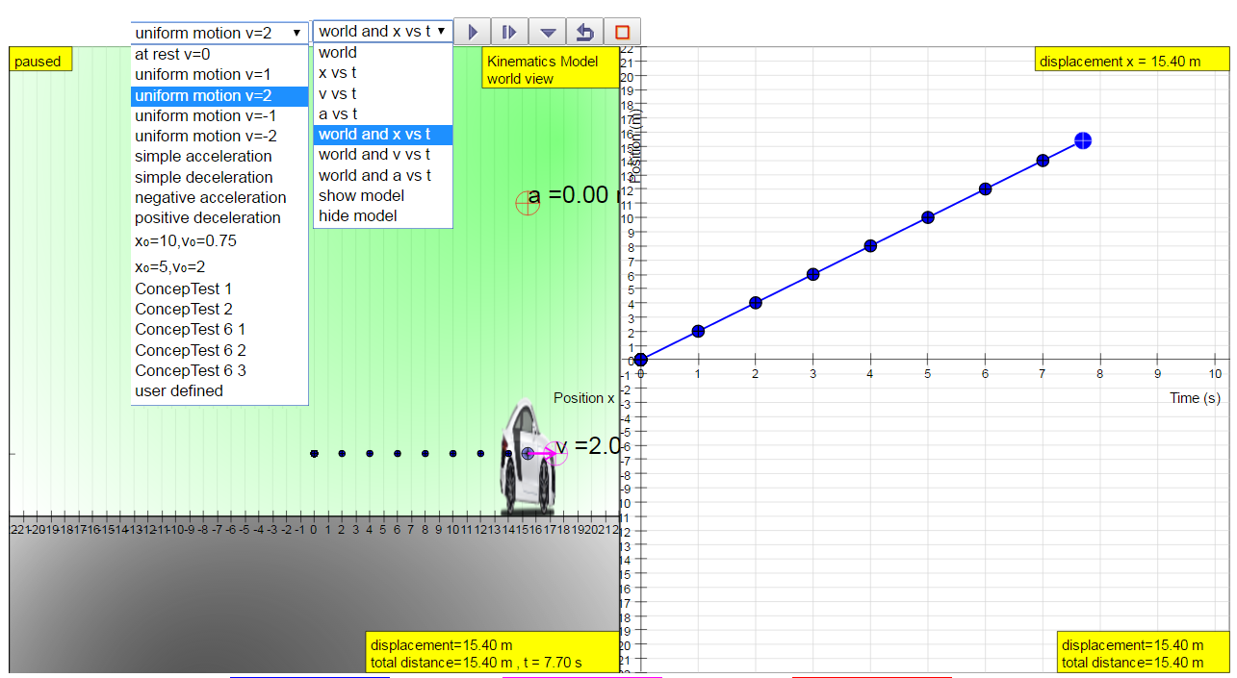
Drag car to vary position, velocity and acceleration

Navigation
At the top, like a menu bar, options are arranged from left to right. The 1st and 2nd dropdown menus are for scenario selection and plot-view selection, while the rest are the usual buttons: play, forward one step, store data, reset and full screen.
The left-hand panel of the simulation is the world view. In this case, it shows the side view of a car that can move horizontally along the x-axis. Pressing play allows time to elapse in the simulation, making the car move according to whatever rules are set for it. The rules are set by the chosen scenario (1st dropdown menu). Examples of pre-set motions are “at rest”, “uniform motion v=1” (which means “moving at a constant speed of 1 m/s) and so on. Alternatively, you can decide on a scenario yourself: you can drag the position, velocity or acceleration graphical elements.
The 2nd dropdown menu allows you to select to show only the world view, only a graph, or the world view and one of the graphs. The graph can be displacement vs. time (x vs t), velocity vs. time (v vs t), or acceleration vs. time (a vs t).

Investigate
Try it now… Choose the view “world and x vs t”, the pre-set motion “uniform motion v=1” and click play. Then watch the car move and see the x-t graph as it is plotted.

- Describe what the x-t graph tells you about the motion of the car.

Choose a different pre-set option; watch the car’s motion and look at the x-t graph.
Write down which pre-set option you chose: ______________
- How did the car’s motion and the x-t graph differ from “uniform motion v=1”?

Adjust on your own: you can put in your own starting values in the simulation by dragging the car and the velocity vector.
Try several different starting values for x and for v. The store data button allows you to save a graph and compare it with that from the next scenario.

- How does changing the initial values of x and of v change what you see in the simulation and in the x-t graph?

v-t Graph
Now show the v-t graph, by choosing “world and v vs t” from the 2nd dropdown menu.

Try the pre-set simulation for “uniform motion v=1” again and compare that with another pre-set, such as “uniform motion v=2”.
- What do the v-t graphs tell you about the motion of the car in these situations?

Experiment with different initial values for x and v. You can drag the car’s position, as well as the velocity arrow in the left panel or the velocity dot in the right panel.
Try several different starting values for x and for v and compare with store data.

- How does changing the initial values of x and of v change what you see in the simulation and in the v-t graph? Discuss the starting point and the steepness of the different graphs.

Please provide equations for the displacement (x) as a function of time.
Equations for speed = 0:_______________________________________________________
Equations for uniform motion: __________________________________________________
You can check your equations by selecting “show model” in the 2nd dropdown menu. It adds a 3rd dropdown menu. For more complex equation, key in your own via the last input field.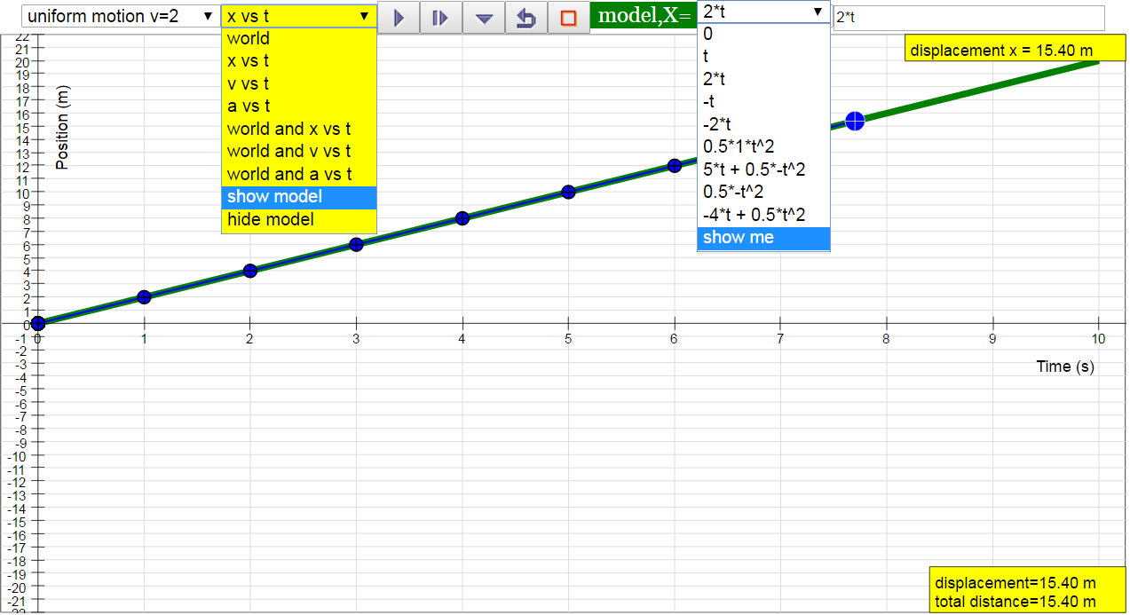
ConcepTests 1 & 2!

Activity 2: Vertical Motion

Open the Free Fall Simulator on your phone
Alternatively, open the Free Fall HTML5 simulation from the “Open Source Physics @ SG” website in your browser: http://tinyurl.com/falling-ball 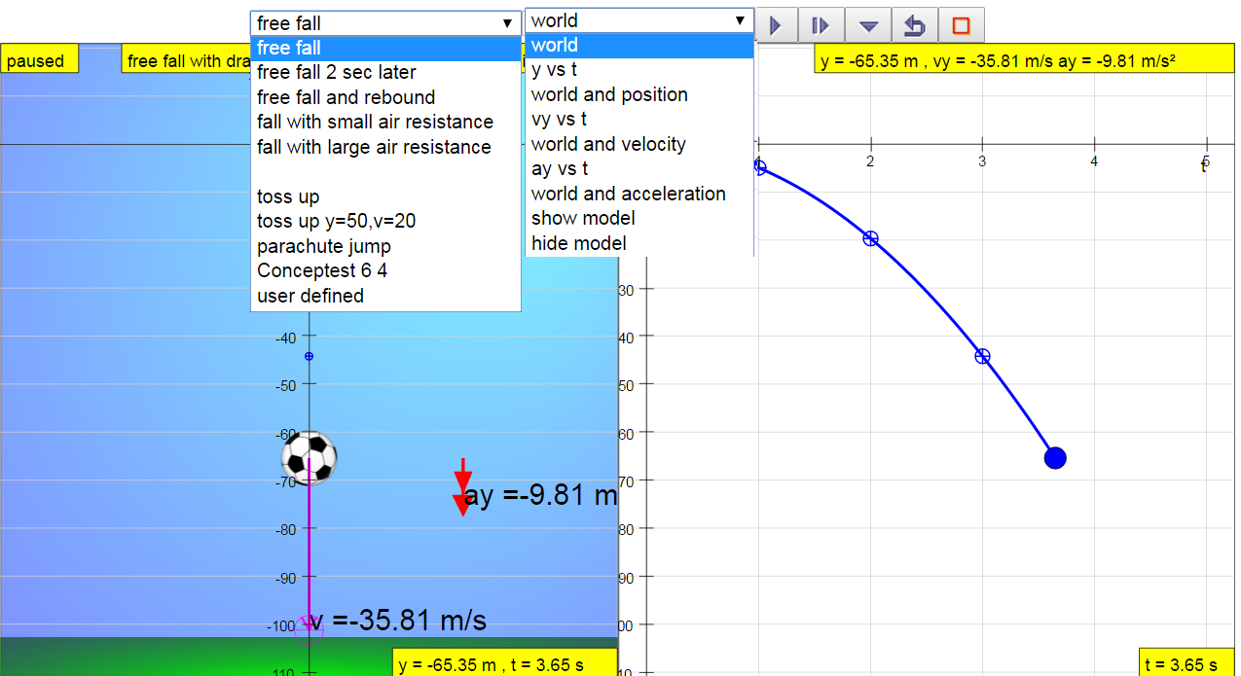

The simulation shows a ball that can be thrown up or dropped down in the left world panel. The right panel can show plots of the motion. This is like the horizontal car simulation, in that playing the simulation allows time to elapse in the simulation. The ball will move upward or downward according to whatever rules are set for it.

Investigate
Try it now … choose the pre-set function for “free fall” and click Play. Then you can watch the ball move and see the y-t graph as it is plotted.
- Describe what the y-t graph tells you about the motion of the ball.

Choose a different pre-set option; watch the ball’s motion and look at the y-t graph.
Write down which pre-set you chose: ______________
- How did the ball’s motion and the y-t graph differ from “free fall”?

Adjust on your own! You can drag the ball to change its vertical position and the velocity and acceleration arrows to change the instantaneous velocity and acceleration. Alternatively, in the respective plots in the right panel, you can drag the position, velocity and acceleration dots to adjust y (vertical position), vy (vertical velocity) and ay (vertical acceleration).
Try several different starting values for y and for vy and one or two variations for ay. Remember you can store data to save plots and compare scenarios.
- How does changing y or vy affect the ball’s motion?

- How does changing ay affect the ball’s motion?

Compare Activity 1 (the car) and Activity 2 (the ball). Discuss whether there are fundamental differences between the horizontal and the vertical motion.

Provide equations for the displacement y and the velocity vy as a function of time.
Displacement: _______________________________________________________________
Velocity: ___________________________________________________________________
ConcepTests 3 & 4!
Activity 3: Projectile Motion

ConcepTest 5!

Open the Monkey and Hunter HTML5 simulation on the on the “Open Source Physics @ SG” website in your browser: http://tinyurl.com/two-cannons
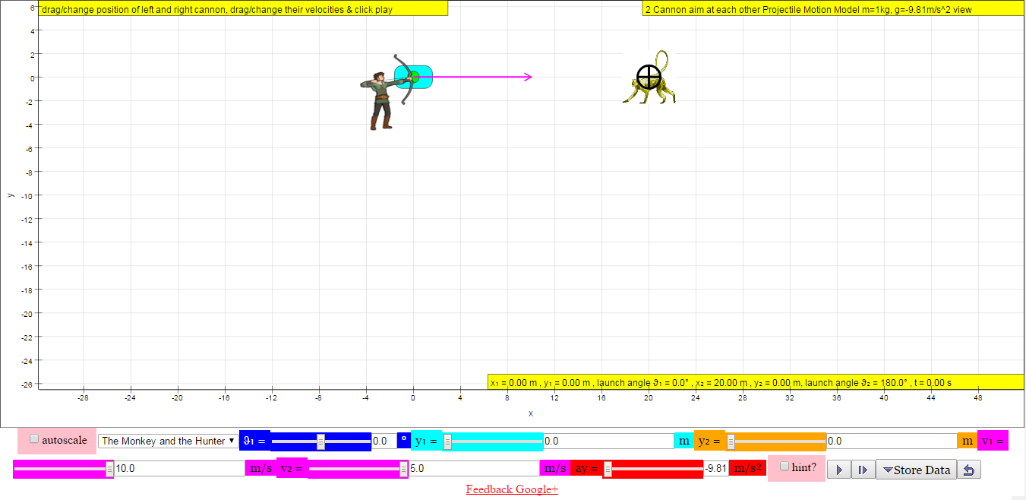
The simulation shows two objects that are thrown at each other while experiencing gravity. The gravity is simulated by an acceleration in the vertical direction: ay = -9.81 m/s². This is the acceleration due to gravity on Earth. It is again possible to change many of the settings, such as the initial velocity of the left projectile (v₁), the velocity of the right projectile (v₂) and the angle with respect to the horizontal at which the left projectile is shot (θ₁).

Investigate
Try it now … reset the applet to its original settings and click play.

- Describe what you observe.

Change the initial velocity of one or both of the projectiles (v₁ and v₂).
Write down which velocities you chose: ______________
- How did the motion vary from the initial case, where both velocities were 10 m/s?

Change the initial angle for the left projectiles (θ₁).
Write down which angle you chose: ______________
- How did the motion vary from the initial case, with θ₁ = 0?

- Leave the angle to the value that you chose. Can you adjust the velocities such that the two projectiles will still hit each other?

Change the setting to “The Monkey and the Hunter” and press Play.
- What do you observe?

Now adjust the settings to make them more “real”. The hunter is probably aiming up at the monkey, who is hanging in a tree. Make sure the monkey starts with zero velocity, unless you want the monkey to jump at the hunter. Perhaps the arrow also travels faster than 10.0 m/s.
- What do you observe?

Now watch the video http://www.tinyurl.com/monkey-and-gun

What happens is this. Note that if there were no gravity, the hunter would definitely hit the monkey: the monkey would not fall and the bullet, being aimed straight at the monkey, would go towards the monkey in a straight line.
However, now we “switch on” gravity. This causes a downward acceleration of 9.81 m/s², the gravitational acceleration. Since this downward acceleration is the same for both the monkey and the bullet, the monkey and the bullet “fall” the same distance.

The monkey was falling straight down: it was following the motion of Activity 2. But the bullet was different! It was moving horizontally and vertically at the same time. Luckily, we can analyse the horizontal and vertical motion completely separately. All we need to know is the initial speed and the initial angle with respect to horizontal.

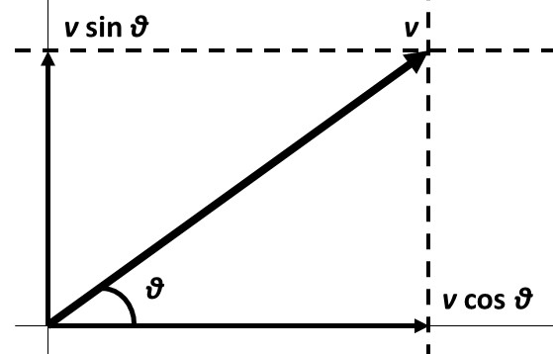
We here have the example of an initial speed v and angle θ. The horizontal initial speed is given by v cos θ. There is no acceleration in the horizontal direction, so the horizontal motion follows Activity 1.
The vertical initial speed is given by v sin θ. There is a uniform acceleration in the vertical direction due to gravity, so the vertical motion follows Activity 2.

See whether you can derive all the equations for projectile motion!
Horizontal displacement: ______________________________________________________
Horizontal velocity: __________________________________________________________
Vertical displacement: ________________________________________________________
Vertical velocity: ____________________________________________________________
Time of flight: _______________________________________________________________
ConcepTest 6!

