Activity 1: Horizontal Motion

Open the Kinematics applet on the “Open Educational Resources @ SG” website: http://tinyurl.com/driving-car
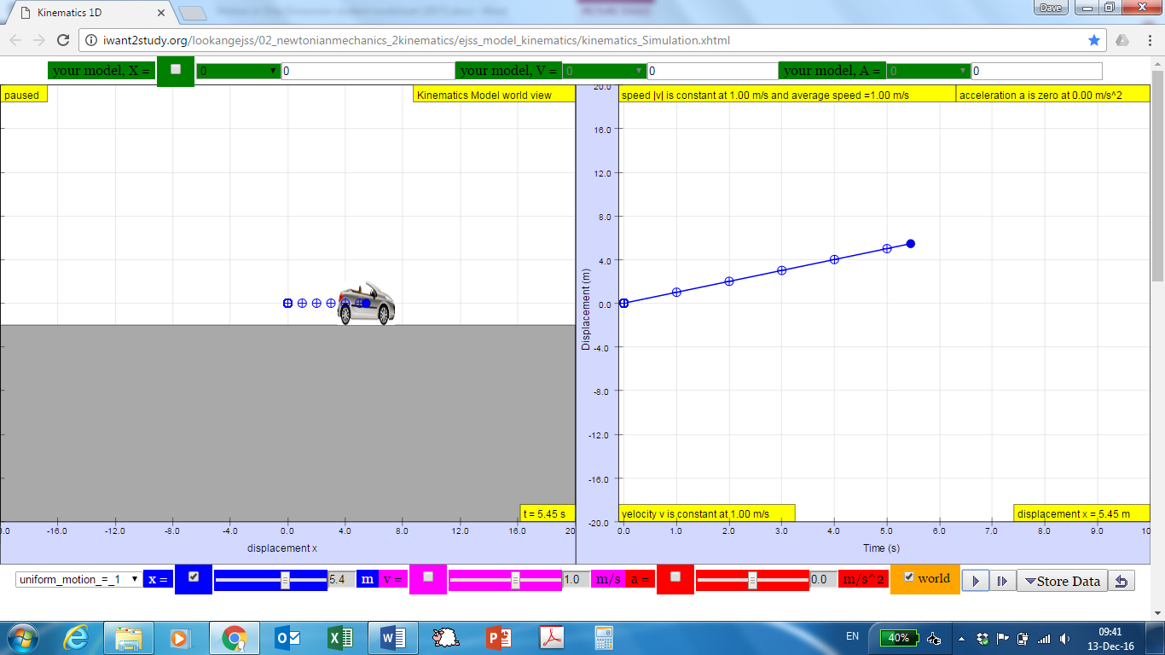
The left-hand panel of the simulation shows a car that can move horizontally along the x-axis. Playing the simulation allows time to elapse in the simulation, and the car moves according to whatever rules are set for it—either by a pre-set function or values you can set yourself.
As time elapses, the simulation makes plots in the right-hand panel. By default, only the displacement-versus-time (x-t) graph is plotted. Time is plotted horizontally and the car’s displacement is plotted vertically. As the plot is created, the simulation also shows one dot each second on the plotted line—the time interval between consecutive dots is always the same, even if the distance the car travelled was not the same. You can use the check-boxes to show velocity versus time and acceleration versus time (the v-t and a-t graphs).
You can select some pre-set motions using the drop-down menu at the bottom left of the figure. Some examples include “at rest,” “uniform motion 1” (which means “moving at a constant speed of 1 m/s) and so on.
The grey buttons at the bottom right of the screen do the following:
- : play the simulation continuously
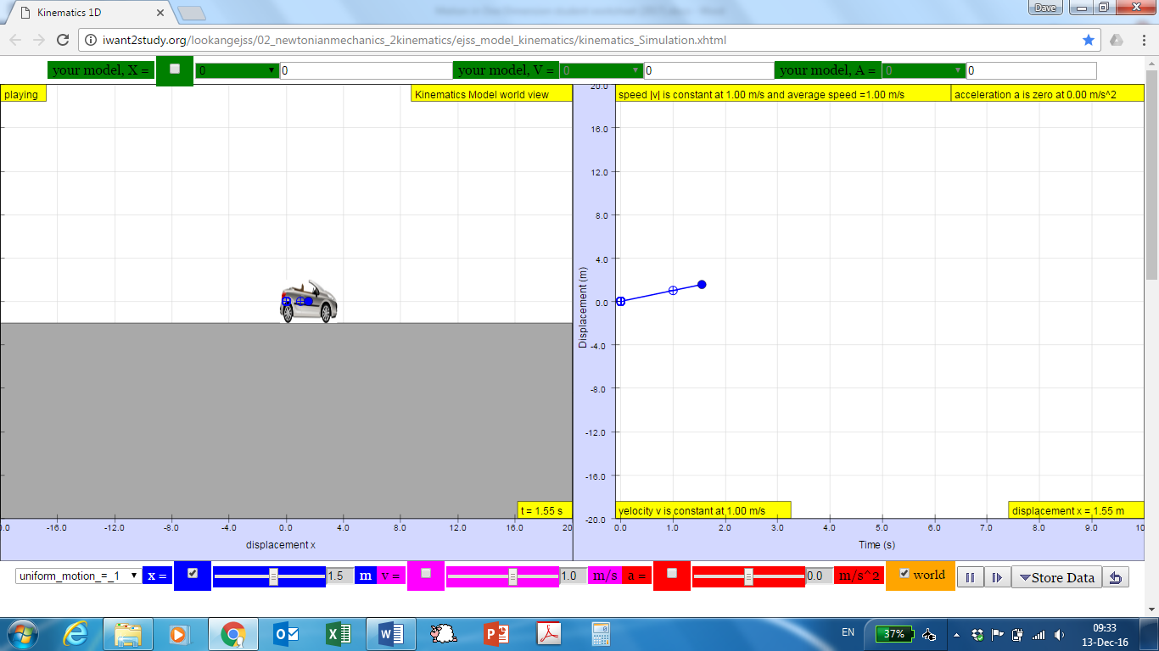: pause the simulation
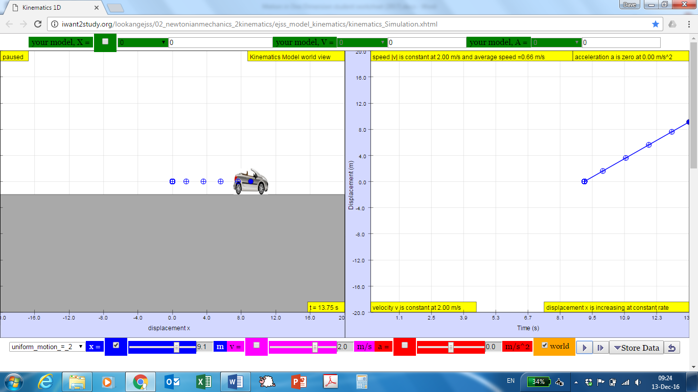: play the simulation step by step, advancing time by 0.05 seconds each time
: store the data from the last plot to compare it with a different scenario later
: reset the simulation
Investigate
Try it now … choose the pre-set for “uniform motion = 1” and click play. Then you can watch the car move and see the x-t graph as it is plotted.

- Describe what the x-t graph tells you about the motion of the car.

Choose a different pre-set option; watch the car’s motion and look at the x-t graph.
Write down which pre-set option you chose: ______________
- How did the car’s motion and the x-t graph differ from “uniform motion = 1”?

Adjust on your own: you can put in your own starting values in the simulation. Change the setting to “user defined,” and then you can adjust the values for x and v — either by using the slider or by typing a number into the textboxes.
Try several different starting values for x and for v. Remember you can store data from each run to make comparison easier.

- How does changing the initial values of x and of v change what you see in the simulation and in the x-t graph?

v-t Graph
Now show the v-t graph, by clicking the checkbox next to “v =” at the bottom of the simulation (see the red circle in the figure below).
Try the pre-set simulation for “uniform motion = 1” again, and compare that with another present, such as “uniform motion = 2”.
- What do the v-t graphs tell you about the motion of the car in these situations?

Adjust on your own again. Change the setting to “user defined,” and then adjust the values for x and for v — either by using the slider or by typing a number into the textboxes.
Try several different starting values for x and for v, and compare with store data.

- How does changing the initial values of x and of v change what you see in the simulation and in the v-t graph?

Equations for speed = 0:_______________________________________________________
Equations for uniform motion: __________________________________________________
ConcepTests 1 & 2!
Activity 2: Vertical Motion
Open another applet on the “Open Educational Resources @ SG” website: http://tinyurl.com/falling-ball
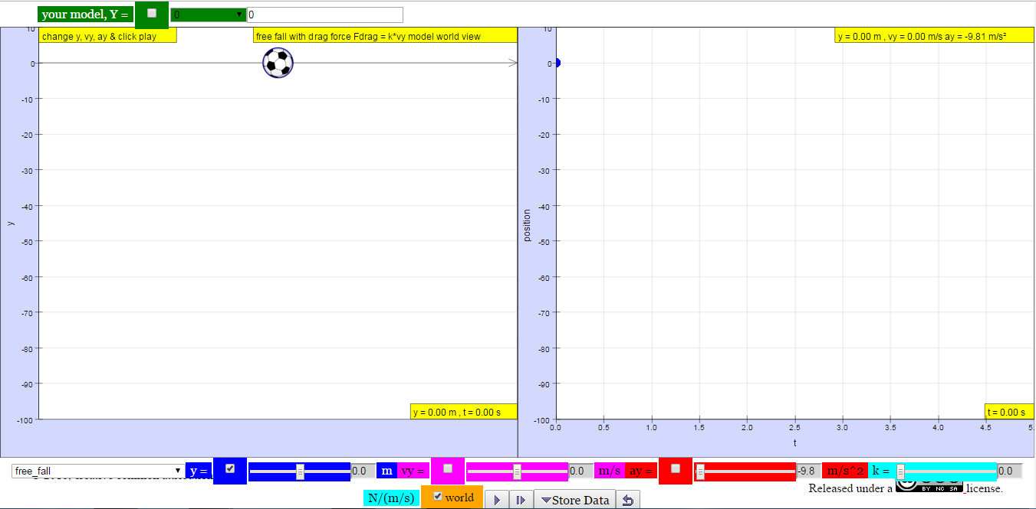
The simulation shows a ball that can be thrown up or dropped down in the left panel. The right panel can show plots of the motion. This is like the horizontal car simulation, in that playing the simulation allows time to elapse in the simulation, and the ball can move upward or downward according to whatever rules are set for it—either by a pre-set function or by values you can set yourself.
As time elapses, the simulation makes plots in the right-hand panel. By default it plots vertical displacement over time (y-t graph): time is plotted horizontally and the ball’s vertical displacement is plotted vertically. Again, you can use the checkboxes to show the vertical velocity or acceleration versus time. The applet again comes with pre-set motions and the buttons operate in the same way as before.

Investigate
Try it now … choose the pre-set function for “free fall” and click Play. Then you can watch the ball move and see the y-t graph as it is plotted.
- Describe what the y-t graph tells you about the motion of the ball.

Choose a different pre-set option; watch the ball’s motion and look at the y-t graph.
Write down which pre-set you chose: ______________

- How did the ball’s motion and the y-t graph differ from “free fall”?

Adjust on your own! Put in your own values in the simulation. Change the setting to “user defined,” and then you can adjust the value for y, vy (y-velocity), or ay (y-acceleration).
Try several different starting values for y and for vy, and one or two variations for ay. Remember you can store data from each run to make comparison easier.

- How does changing y or vy affect the ball’s motion?

- How does changing ay affect the ball’s motion?

In Activity 1, we considered horizontal motion. Now compare Activity 1 and Activity 2 and try to explain what is fundamentally different between horizontal and vertical motion.

Conclusions for vertical motion:
Displacement: _______________________________________________________________
Velocity: ___________________________________________________________________
ConcepTests 3 & 4!
Activity 3: Projectile Motion

ConcepTests 5!

Open yet another applet on the “Open Educational Resources @ SG” website: http://tinyurl.com/two-cannons
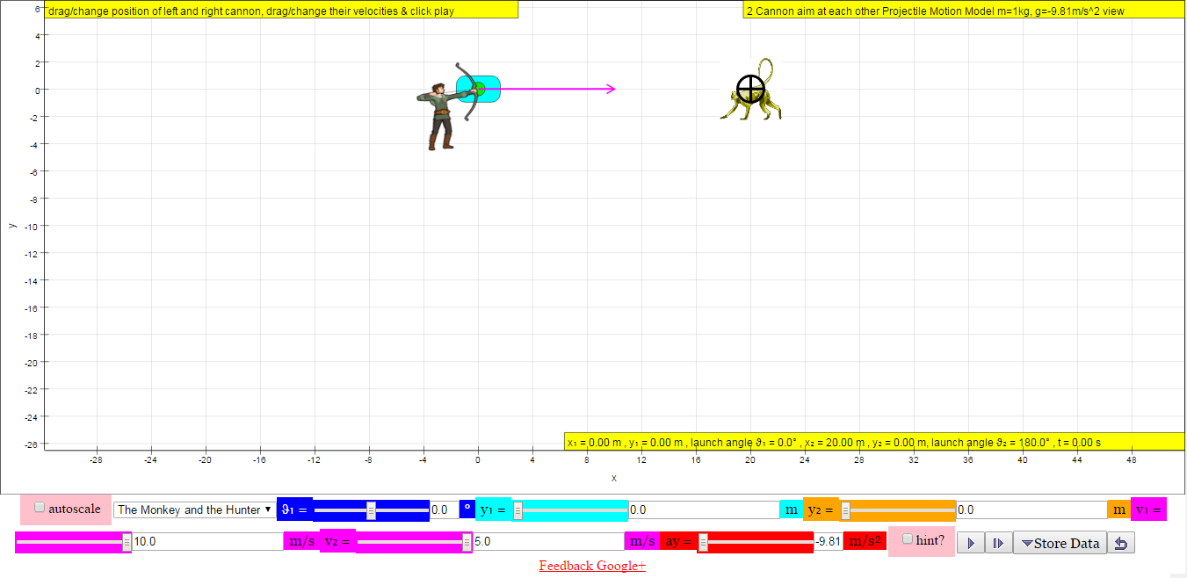
The simulation shows two objects that are thrown at each other while experiencing gravity. The gravity is simulated by an acceleration in the vertical direction: ay = -9.81 m/s². This is the acceleration due to gravity on Earth. It is again possible to change many of the settings, such as the initial velocity of the left projectile (v₁), the velocity of the right projectile (v₂) and the angle with respect to the horizontal at which the left projectile is shot (θ₁).

Investigate
Try it now … reset the applet to its original settings and click play.

- Describe what you observe.

Change the initial velocity of one or both of the projectiles (v₁ and v₂).
Write down which velocities you chose: ______________
- How did the motion vary from the initial case, where both velocities were 10 m/s?

Change the initial angle for the left projectiles (θ₁).
Write down which angle you chose: ______________

- How did the motion vary from the initial case, with θ₁ = 0?

- Leave the angle to the value that you chose. Can you adjust the velocities such that the two projectiles will still hit each other?

Change the setting to “The Monkey and the Hunter” and press Play.
- What do you observe?

Now adjust the settings to make them more “real”. The hunter is probably aiming up at the monkey, who is hanging in a tree. Make sure the monkey starts with zero velocity, unless you want the monkey to jump at the hunter. Perhaps the arrow also travels faster than 10.0 m/s.

- What do you observe?

Now watch the video http://www.tinyurl.com/monkey-and-gun

What happens is this. Note that if there were no gravity, the hunter would definitely hit the monkey: the monkey would not fall and the bullet, being aimed straight at the monkey, would go towards the monkey in a straight line.
However, now we “switch on” gravity. This causes a downward acceleration of 9.81 m/s², the gravitational acceleration. Since this downward acceleration is the same for both the monkey and the bullet, the monkey and the bullet “fall” the same distance.

The monkey was falling straight down: it was following the motion of Activity 2. But the bullet was different! It was moving horizontally and vertically at the same time. Luckily, we can analyse the horizontal and vertical motion completely separately. All we need to know is the initial speed and the initial angle with respect to horizontal.

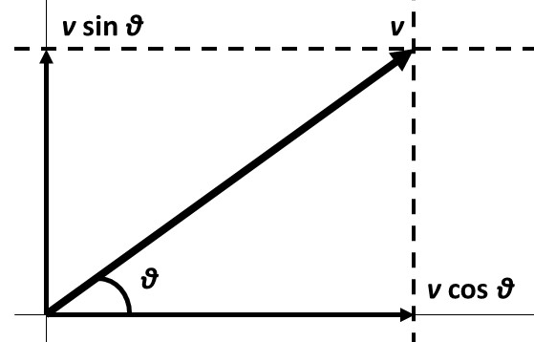
We here have the example of an initial speed v and angle θ. The horizontal initial speed is given by v cos θ. There is no acceleration in the horizontal direction, so the horizontal motion follows Activity 1.
The vertical initial speed is given by v sin θ. There is a uniform acceleration in the vertical direction due to gravity, so the vertical motion follows Activity 2.

Conclusions for projectile motion:
Horizontal displacement: ______________________________________________________
Horizontal velocity: __________________________________________________________
Vertical displacement: ________________________________________________________
Vertical velocity: ____________________________________________________________
Time of flight: _______________________________________________________________
ConcepTest 6!
MODEL
- A car starts at the original position (x = 0 m), travels forward slowly and steadily for 5 seconds, stops for 2 seconds, and then travels backward steadily about twice as fast for 3 seconds. Draw position versus time and velocity versus time graphs to illustrate its travel.

- A car starts at the original position (x = 0 m), travels backward slowly and steadily for 5 seconds, stops for 2 seconds, and then travels forward steadily about twice as fast for 3 seconds. Draw position versus time and velocity versus time graphs to illustrate its travel.

ANALYZE
- Consider two cars, a 1,700 kg BMW and a 1,500 kg Mercedes-Benz. The BMW is speeding along at 120 km/h and the Mercedes-Benz is going half the speed at 60 km/h. If the two cars brake to a stop with the same constant acceleration,
- is the amount of time required to come to a stop influenced by their initial velocity? Explain your answer using diagrams, equations, or any explanatory rules/principles.

- is the distance travelled prior to stopping influenced by their initial velocity? Explain your answer using diagrams, equations, or any explanatory rules/principles.

EVALUATE
Explain your answer to each of the questions below using diagrams, equations, or any explanatory rules/principles.
- A sky diver jumps out of a hovering helicopter. A few seconds afterwards another sky diver jumps out and they both fall along the same vertical line. Ignore air resistance so that both sky divers fall with the same acceleration.
- Does the difference in their speeds stay the same throughout the fall?

- Does the vertical distance between them stay the same throughout the fall?

- A tennis ball thrown from the top of a building is given an initial velocity of 20 m/s straight upward. The building is 50 m high, and the ball just misses the edge of the roof on its way down. Using t = 0 as the time the ball leaves the thrower’s hand, determine
- the time at which the ball reaches its maximum height

- the maximum height

- the time at which the ball returns to the height from which it was thrown

- the velocity of the ball at this instant

- the velocity and position of the ball at t = 5 s

