Name: ( ) Class:_________ Date:___________

WORKSHEET 1
Chapter 3: FORCES – (3.2) Vector Drawings

Applet instructions
- Open Safari Browser in your iPad
- Go to: http://tinyurl.com/VectorAdditionABC
- Quick instructions on using the applet
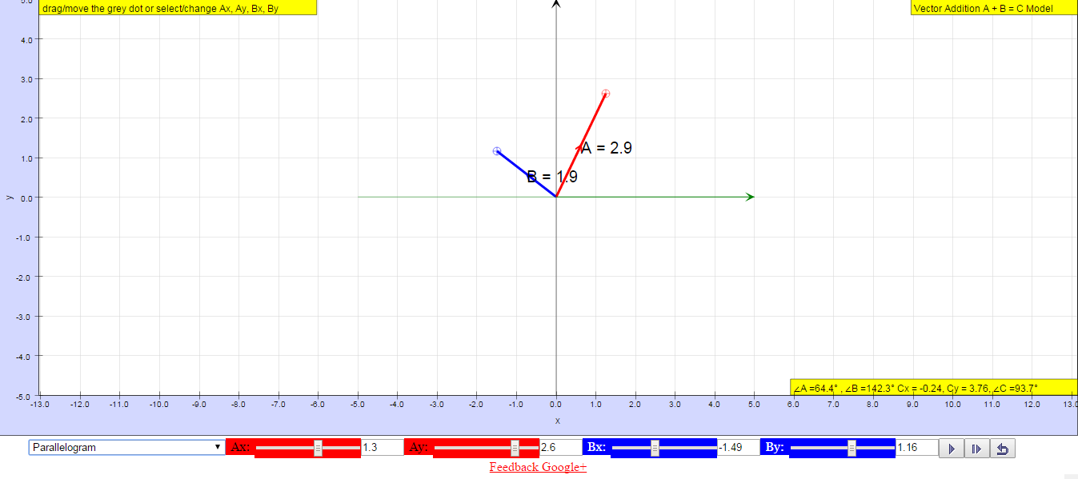
(5) Click PLAY to get the resultant vector C
(3) You can also adjust vectors A (and B) by adjusting the values here
(4) As you drag or adjust the vectors, ensure ∠A and ∠B correspond accordingly
(2) You can drag the circle here to adjust the vectors A and B
(1) Always select either parallelogram or tip-to-tail (depending on question instructions)

(6) Click RESET to key in next vectors A and B. Remember to select (1)

Applet Practice
Input the vectors A & B below, and generate vector C using the 2 different methods.
Complete the 2 figures for the parallelogram and tip-to-tail methods. Draw vector C.
Compare the 2 methods. Do they give the same answer for vector C?
Write down vector C in terms of magnitude and angle. What is the reference for ∠C to be measured?
Input vectors A & B | Parallelogram method | Tip-to-tail method | Resultant Vector C
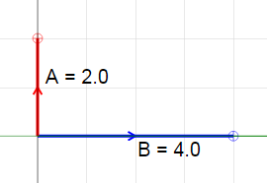
Ax=0, Ay=2.0; Bx=4.0, By=0
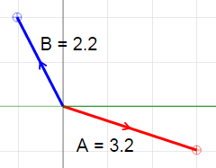
Ax=3, Ay=-1; Bx=-1, By=2
PRACTICE QUESTIONS 1

- Measure the following vectors A and B using your ruler. Write down the measured lengths.
- Using the applet, generate the resultant vector C. Use either the parallelogram or tip-to-tail method.
- Complete the drawing on this worksheet to reflect the correct resultant vector C.
A
B
(a) (b)
B
A
50º

(c)

B
A
30º
120º

- What if we have large vectors A and B? What would be necessary in order to fit the drawing onto your worksheet?

- Find the resultant of the two vectors shown below.

(a) (b)
700 N

5000 N
106º
5000 N

900 N

- A 6.0 N weight W hangs on the end of a string, which is pulled sideways by a force F. The string makes an angle of 30º with the vertical as shown in the diagram below (not drawn to scale). The string supports the weight by exerting a pull known as tension T of 7.0 N. Determine the force F.

W
F
T
30º

BLANK
Name: ( ) Class:_________ Date:___________

WORKSHEET 2

You can use the applet to verify your answers (http://tinyurl.com/VectorAdditionABC).

- The diagrams below show a 3 N force and a 4 N force acting at (a) right angles, and (b) 30º each to the horizontal.
Using vector drawing with clearly defined scale, find the resultant force for each case.

(a) (b)
3N
4N
3N
4N
30º
30º

- A lorry, which has been stuck in muddy ground, is being pulled by two jeeps. Each jeep exerts a force of 3000 N at an angle of 20º to the horizontal as shown in the diagram below. Find, using a scaled drawing, the resultant force pulling the lorry forward.

3000N
20º
20º
3000N
lorry

- The figure below shows a lantern that is held up by two wires. The tension in each wire is 16 N and the angle between the wires is 120º.

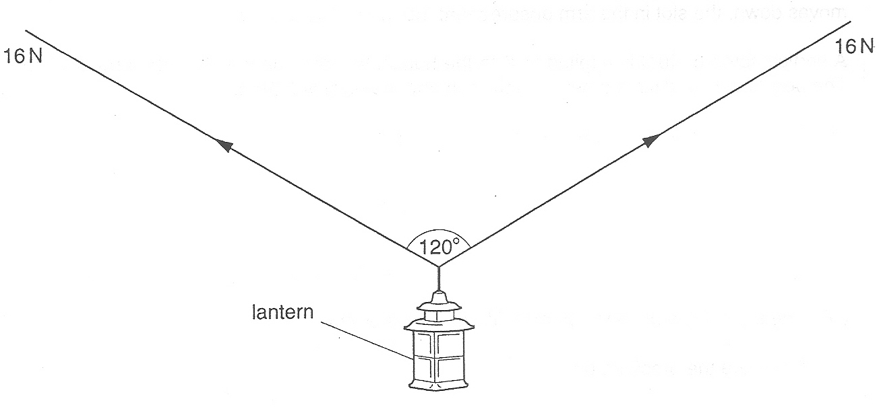
In the diagram above, draw a vector diagram to scale in order to determine the weight of the lantern. State the scale used.

Scale: 1 cm represents

Weight = N

