

College of applied physics and astronomy
Physics for Health Sciences laboratory
Measuring Devices and Density Experiment
using Open Source Physics/ Singapore/ iwant2study.org. Interactive Simulation

Name: ……………………………………. ID: …………………………..

objectives:
- Learn how to use and read instruments such as digital balance, micrometer, and Vernier caliper.
- Calculate the density of unknown regular shapes.
- Estimate the uncertainty of the measured and calculated quantities.
  - Theory:
Density is the amount of matter in a certain volume of an object. It can be calculated by equation:
$ρ=\frac{m}{v}$ …….. (1)
Where ρ (Rho) is the density of the object, m is the object’s mass, and $v$ is the volume. So the density can be represented in g/cm³ or kg/m³.
According to equation 1, to determine density of an object you need to measure the mass using a digital balance, and the volume using the corresponding mathematical equations for the volume of regular shapes. For example, the volume of a cylinder of length $l$and radius r, then the volume is:
$v=πr^{2}l=\frac{1}{4}πd^{2}l$ …… (2)
Where d is the diameter of the cylinder. Here is some common regular shapes and their volume:
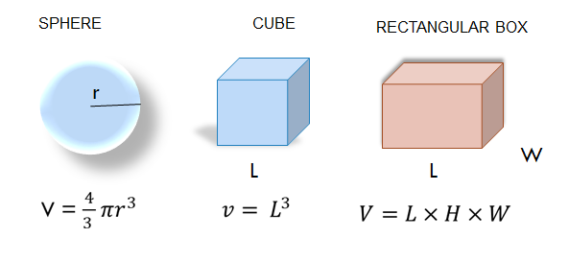

Figure (1)
To calculate the volume of any object accurately, you need to measure the dimensions needed using accurate and precise instrument. Instead of using a regular ruler we will use the Vernier caliper and micrometer for our measurements.
To practice calculating the density you are going to find the density for two objects, which are a cylinder and a sphere.
For a cylinder the density can be determined using the following equation:
$ρ=\frac{4\overline{m}}{π{\overline{d}}^{2}l}$ …… (3)
Using the propagation of error method, the random (standard) error in the density of a cylindrical object is:
$∆ρ=±\left|\overline{ρ}\right|\left(\frac{∆m}{\left|\overline{m}\right|}+\frac{∆l}{\left|\overline{l}\right|}+\frac{2∆d}{\left|\overline{d}\right|}\right)$ …… (4)
For a spherical object, the density can be determined by equation:
$ρ=\frac{6\overline{m}}{π{\overline{d}}^{3}}$ …… (5)
And the random (standard) error for the density of a sphere can be calculated using equation:
$∆ρ=±\left|\overline{ρ}\right|\left(\frac{∆\overline{m}}{\left|\overline{m}\right|}+\frac{3∆d}{\left|\overline{d}\right|}\right)$ ….. (5)
Where m is the mass, l is the length of the cylinder, d is the diameter, Δm, Δd, and Δl are the random (standard) error for the measured quantity of mass, diameter and length respectively.
In the lab we will use more precise instrument to measure the length and the diameter; the micrometer and Vernier caliper. Next instructions on how to use these instruments accurately will be discussed in detail, and learn to determine the error in these instruments.
- Vernier caliper
The Vernier caliper used to accurately measure the length of an object, the outer dimension, the inner dimension, and the depth.
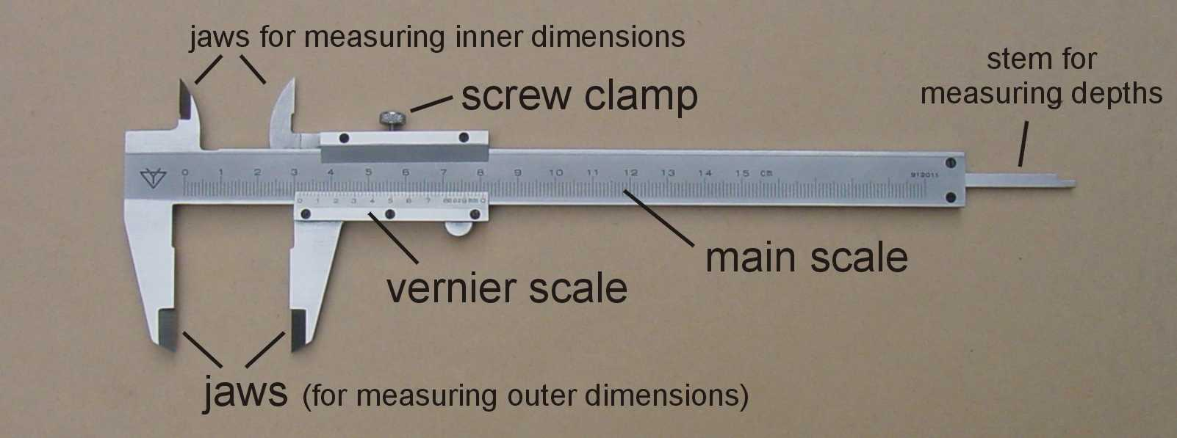

Figure (2)
The Vernier caliper figure (3) has two scales; a fixed main scale (just like a ruler) gives the length in millimeters with a least scale of 1 mm. and a Vernier scale which is a small ruler sliding on the main scale. each 10 divisions on the Vernier scale has the same distance of 19.5 divisions on the main scale see figure (3).To calculate the least count (accuracy) of a Vernier caliper, divide the smallest reading of the main scale by the total number of divisions on the Vernier scale. Accordingly, the accuracy of the Vernier caliper figure (3) is 0.05 mm, which means that each division on the Vernier scale is equal to 0.05 mm.
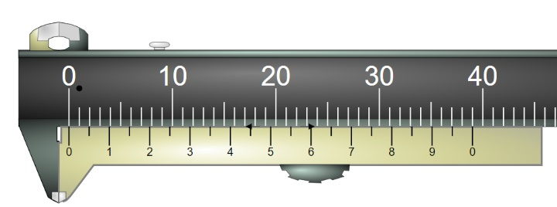

Figure (3)

How to read the length of an object using the Vernier caliper?
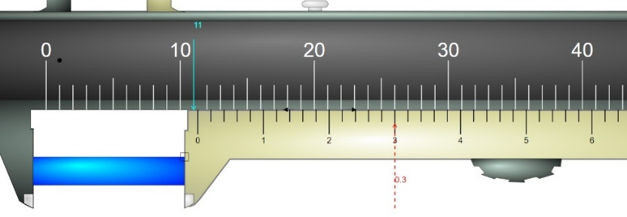

Figure (4)
- Put the object between the jaws for measuring the outer dimension, then slide the movable jaw until it’s tightened around the object.
- Read the main scale by observing the reading opposite to the reading of the zero of the main scale. If the zero on the Vernier scale lined up with a number on the main scale then it’s considered to be the reading of the main scale, while if the zero on the Vernier scale doesn’t lined with any number, then you take the reading main scale to the left of the zero on the Vernier scale. (the reading on the Vernier is 11 mm)
- To read from the Vernier scale, take the reading which lined up with any of the scale lines on the main scale. (0.30 mm)
- Add the reading of the main scale to the reading of the Vernier scale, so it will be the length of the object. (11 mm + 0.30 mm = 11.30 mm)
-Note that the number of the divisions on the Vernier scale are 50 divisions, and the least scale (smallest division) on the main scale is 1 mm, then the least scale ( accuracy) of the Vernier caliper is $\frac{1 mm}{50 divisions}=0.02 mm$
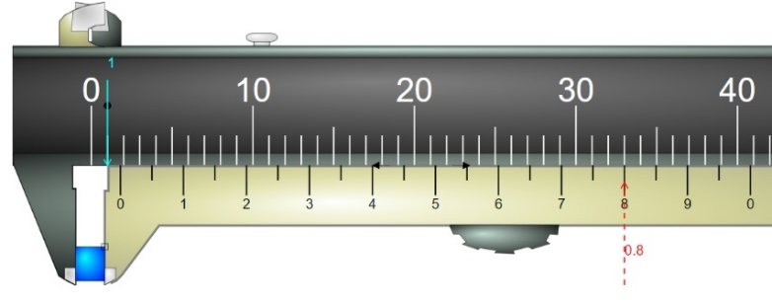
Exercise (1): read the following Vernier calipers.
The accuracy of the Vernier caliper is …………………
The instrumental error (uncertainty) is ……………
The main scale reading …………
The Vernier scale reading is ……….
The length of the object ……………………….
Figure (5)
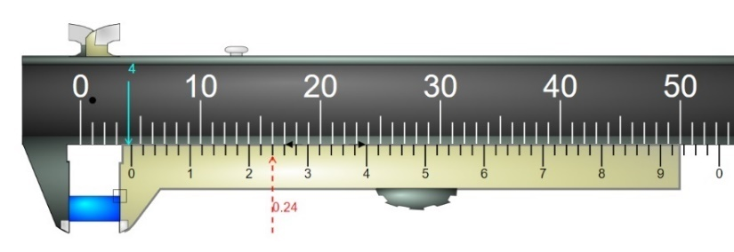
The accuracy of the Vernier caliper is …………………
The instrumental error (uncertainty) is ……………
The main scale reading …………
The Vernier scale reading is ……….
The length of the object ……………………….
Figure (6)

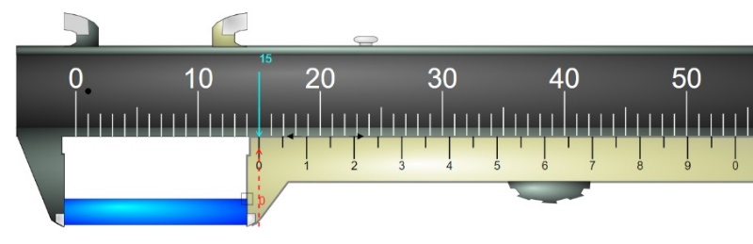
The reading of the main scale …………
The reading of the Vernier scale is ……….
The length of the object ……………………….
Figure (7)
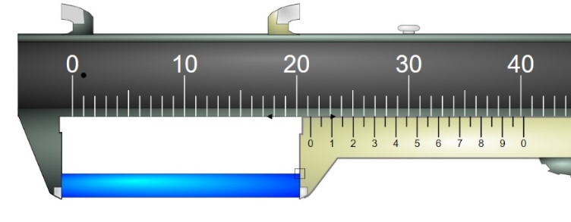
The reading of the main scale …………
The reading of the Vernier scale is ……….
The length of the object ……………………….

Figure (8)
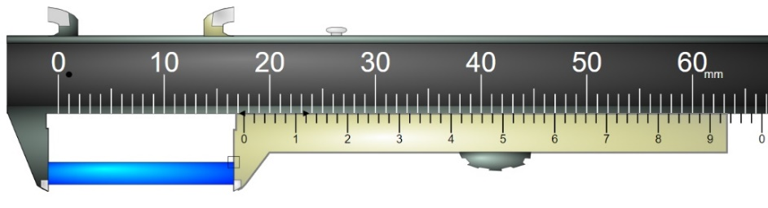
The reading of the main scale …………
The reading of the Vernier scale is ……….
The length of the object ……………………….

Figure (9)
- Micrometer:
A micrometer is a device that can precisely measure small dimensions such as a diameter of a sphere and the thickness of a wire figure (10). It has two faces, anvil (fixed face) and spindle (movable face) where you put the object between them as shown in figure (10). The main scale for the micrometer called the sleeve with smallest division of 0.5 mm, and the Vernier scale called thimble (a rotating scale) and it has 50 divisions. A whole rotation for the thimble causes the thimble to move by 0.5 mm on the sleeve, which means that the least scale (accuracy) of the micrometer is 0.01 mm.

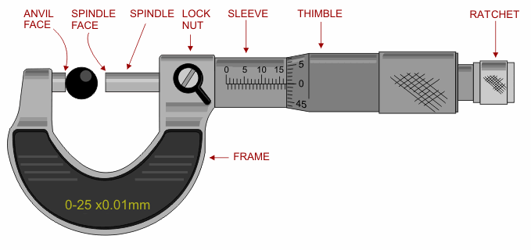
Center line

Figure (10)

How to use and read a micrometer scale?
- Put the object between the two faces, spin the ratchet nub so the spindle face will close on the object and then you can use the lock nut to fix the reading of the micrometer.
- Read the sleeve scale that it’s just to the left of the edge of the thimble. For micrometer shown in figure (10) the reading of the sleeve is 16.5 mm.
- Read the number of hundredths of millimeters on the thimble scale opposite the center line of the sleeve scale. (0 mm)
- The addition of the sleeve and the thimble readings will represent the length the object. (16.5 + 0.00 mm = 16.50 mm).

Exercise (2): a- read the following micrometers and fill the blanks with the proper answer.
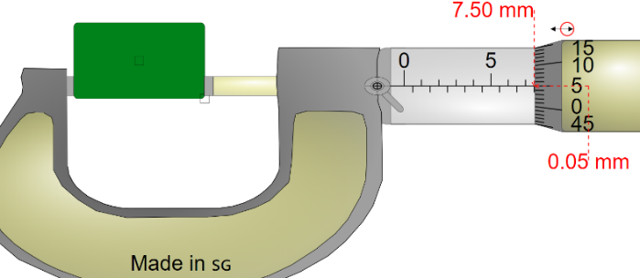
The accuracy of the micrometer is …………………
The instrumental error is ……………
The reading of the sleeve scale …………
The reading of the thimble scale is ……….
The length of the object ……………………….

Figure (11)

b- What is the reading of the following micrometers?

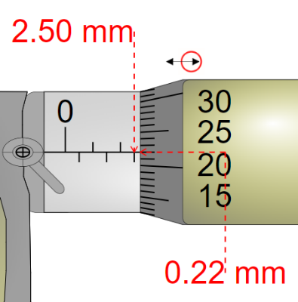
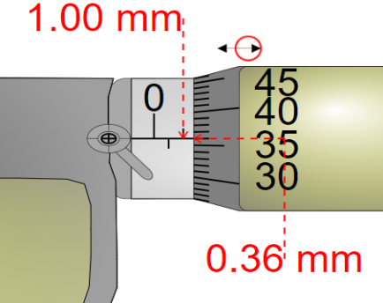

…………………………………………… …………………………………………

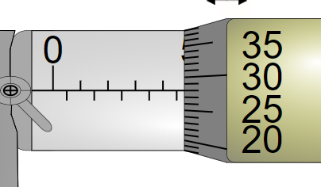
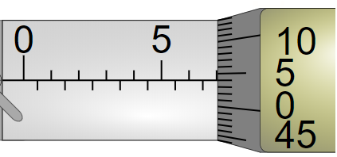

……………………………………………. ………………………………………
To get more practice in reading the Vernier caliper and micrometers you can visit iwan2study.org in the following links:
For the Vernier caliper:
https://iwant2study.org/lookangejss/01_measurement/ejss_model_AAPTVernierCaliper/AAPTVernierCaliper_Simulation.xhtml
For the micrometer: https://iwant2study.org/lookangejss/01_measurement/ejss_model_Micrometer02/Micrometer02_Simulation.xhtml
Measurement of density
To determine the density of a cylinder and a sphere, the mass (m), length (l), and diameter (d) were measured four times independently to reduce the random errors. Use the data in table (1) for the cylinder and the sphere to calculate the density and it’s random (standard) error.
Table (1)
Trial |  | 1 | 2 | 3
Cylinder | Mass (g) | 20.55 | 20.58 | 20.57
Cylinder | Diameter (cm) | 2.564 | 2.568 | 2.570
Cylinder | Length (cm) | 2.888 | 2.884 | 2.880
Sphere | Mass (g) | 10.15 | 10.17 | 10.14
Sphere | Diameter (cm) | 2.542 | 2.546 | 2.542

- The masses were measured by a digital balance with accuracy o.o1 g.
- The length of the cylinder measured using a Vernier caliper of accuracy 0.002 cm (0.02 mm).
- The diameter of both objects measured using a micrometer of accuracy 0.001 cm (0.01 mm).
Calculations and data analysis:
- Calculate the average, the deviation, the random error (average of mean deviation) for each quantity and write your answers in table (2).
Table (2)
Object | Trial | m (g) | Deviation (g) | Diameter (cm) | Deviation (cm) | Length (cm) | Deviation (cm)
Cylinder | 1 | 20.55 |  | 2.564 |  | 2.888
Cylinder | 2 | 20.58 |  | 2.568 |  | 2.884
Cylinder | 3 | 20.57 |  | 2.570 |  | 2.880
Cylinder | Average
Sphere | 1 | 10.15 |  | 2.542
Sphere | 2 | 10.17 |  | 2.546
Sphere | 3 | 10.14 |  | 2.542
Sphere | Average

- Write each quantity in the format $\overline{x }±∆x$.

- Calculate the density of the cylinder and the sphere using equations (3) and (5).

- Determine the density of both object in kg/m³.

- Using equations (4) and (6), calculate the errors in the density for both objects.

- Write the density for both object in the format $\overline{x }±∆x$ for both objects.

- Use Cutnell and Johnson textbook (or search) to find out the type of material for both objects.

- Calculate the percentage error for the density of the two objects.

- Conclusion:

